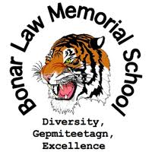
Supply List for Grade 9 Students (2016-2017)
- 1 USB (memory stick)
- Dividers (10)
- 10 pencils
- Pencil crayons
- 1 glue stick
- 2 erasers
- 2 highlighters
- 5 1” binders
- 4 x 200 pages of looseleaf
- 1 pack of 50 pages of graph paper
- French\English dictionary
- 5 blue pens
- 2 red pens
- Scientific calculator
- Ruler
- Scissors
- Becherelle (French Immersion students only)
- 2 correction fluids (white out)
- 2 Hilroy notebooks
- 1 x 300 page notebook (coiled)
- 5 duotangs
- Gym clothes
- Sneakers
- Sun screen (Phys. Ed – outdoor activities)
- Towel (Phys. Ed)
- Unscented deodorant (NO BODY SPRAYS)
- A Positive Attitude

BLMS student fee is $30 for one child or $50 for two or more children.

