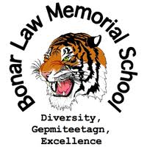
Supply List for Grades 9 -10 (2021-2022)
- 1 USB (memory stick)
- Dividers (10)
- 10 pencils
- Pencil crayons
- 1 glue stick
- 2 erasers
- 2 highlighters
- 5 1” binders
- 3 x 200 pages of looseleaf
- 1 pack of 50 pages of graph paper
- French\English dictionary
- 4 blue pens
- 2 red pens
- Scientific calculator
- Ruler
- Scissors
- Becherelle ( French Immersion students only)
- 2 correction fluids (white out)
- 6 duotangs
- Gym clothes
- Sneakers
- Sunscreen (Phys. Ed – outdoor activities)
- Towel (Phys. Ed)
- Headset or earbuds

BLMS student fee is $40 for one child or $60 for two or more children.

