Human Physiology 110: Factors Affecting Wellness
A Research & Report Project
- Choose a research topic:

Prescription drug abuse Smoking

Alcohol consumption Time Management

The importance of sleep Maintaining positive relationships

Accountability & Responsibility Respect

Energy drink consumption Prayer and Meditation

Unhealthy eating habits Reduce, Re-use, Recycle

Grit & Perseverance Empathy & Compassion

Anxiety & Stress Vitamins and minerals

School Attendance Exercise

Domestic Abuse Setting goals & priorities

Personal Hygiene Getting regular medical checkups

- Chose a reporting format:
Brochure | Power Point & Presentation | Webquest
- Use template provided  - Inform & educate readers  - No “copy & paste” plagiarism  - All sources for information and photos must be included | - 20-20-20 format  - No “copy & paste” plagiarism  - All sources for information and photos must be included | - 20 online scavenger-hunt style questions & answers  - Minimum 3 website sources (must be provided)  - Varying levels of questions

Reporting Choice 2: Power Point & Presentation
You will create a Power Point presentation (or other similar digital software presentation, such as SMART Notebook) on the factor affecting wellness of your choice.
You will be limited to a 20-20-20 format. In this format, you can use:
- A maximum of 20 slides
- A maximum of 20 words per slide
- A maximum of 20 minutes when presenting your slides.

Your slides should include a title slide, and a slide for citing your resources at the end.
Absolutely no “cut & paste” plagiarism will be accepted – take the time to write everything in your own words!
Keep track of the websites you use – all sources for information and photos must be included. (Photo credits, or photo sources should be provided directly under each photo, text information can be cited on the last slide of your presentation).

You will be responsible for presenting your presentation in front of the class at a date determined by you and the teacher, so make sure to take the time to practice your presentation ahead of time!

Reporting Choice 3: Webquest
You will create an online “scavenger hunt” by coming up with 20 questions related to the factor affecting wellness of your choice. You must also find and provide the answers to the questions you create.
The questions you create must take players to at least 3 separate websites. You should provide the necessary websites at the start of the game, though you don’t have to tell players which specific questions can be answered on each site.
You should provide a variety of styles and types of questions – for example, all questions should not start the same way (“What is…”) and not all questions should simply require a basic reading of the web text in order to retrieve a specific piece of information.
Ways to engage your players for a deeper level of understanding:
- Have them interpret information: What does it mean? How can it be used?
- Have them make judgements: What do they think about a particular subject?
- Have them organize information: How would you group or arrange information or data?
- Have them summarize: What are the key ideas presented?
- Have them solve a problem: What would they do in a given situation?
- Have them justify their point of view: What is your opinion and why?
- Have them compare and contrast: What are the similarities & differences?

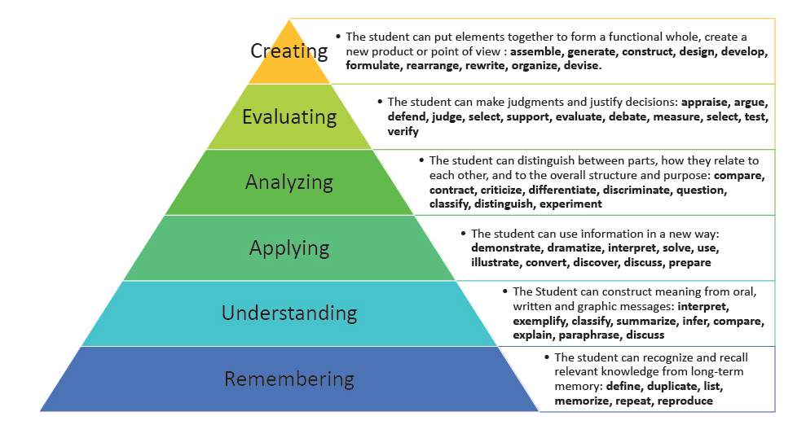
Reporting Choice 1: Brochure

You will research a factor affecting wellness of your choice, and create a brochure designed to inform & educate the general public about your topic.
Your brochure should follow a tri-fold format, which gives you 6 boxes for information. Find a way to organize and present your information in a logical way and use subtitles to introduce each box.
If you are using Microsoft Word, you can use the template provided on Mrs. Ketch’s school website, or go to https://templates.office.com/ for other templates (click “Brochures” for choices).
You may use a maximum of one photo per box, but each box should be mostly filled by content. The photos used must be relevant and must help the reader understand the information presented, or emphasize the visual appeal of your brochure.
Your brochure may be made in colour, but it will be printed in black & white. You can submit a digital copy of your colour brochure for evaluation.
Keep track of the websites you use – all sources for information and photos must be included. (Photo credits, or photo sources should be provided directly under each photo, text information can be cited on the back of your brochure, near the bottom).

