Chemistry 11-2
Course Syllabus
Bonar Law Memorial School
Ms. Wilson
Course Description*
This course explores the structure of matter and the fundamentals of atomic bonding. It also introduces students to a quantitative aspect of chemistry through an examination of molecular mass and stoichiometry.
Key Topics of Discussion
- Classification and structure of matter
- Naming and classification of elements and compounds
- VSEPR theory
- Bonding (e.g. types of bonding and intermolecular forces)
- The Mole
- Stoichiometry and solubility
Key Skills
- Initiating and planning
- Performing and recording
- Analysing and interpreting
- Communication and teamwork
Evaluation
Evaluations will be based on an overall weighting of 35% knowledge, 35% skills and the remaining 30% will evaluate the learning of objectives relating to science, technology, society and the environment. Students will be evaluated with a combination of products and observations (e.g. tests, quizzes, lab reports and assignments) as well as with conversation (e.g. in-class participation and group discussion). There will be a final exam in this course weighted 30%, unless the exam incentive applies, in which case, it will be weighted 15%, 30% or 50%.
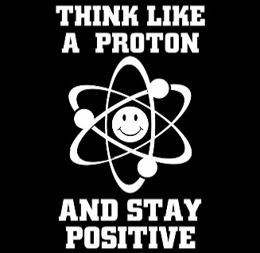
*subject to change

