NAME: ____________________
In the margins of the article, please complete the following:
- 6 detailed notations (AT LEAST ONE text-to-self, text-to-world, text-to-text)
- Circle 2 new/challenging words AND write their definitions
On loose-leaf, answer the following questions:
- Who was the author? AND, what was her purpose for writing this article?
- What province had the greatest number of snowmobile deaths since 2012? Why do you think that is the case?
- In your opinion, what can be done to prevent these deaths and injuries? Give 3 specific suggestions that YOU think would make an impact.
New Brunswick records highest number of ATV, snowmobile deaths
Karissa Donkin · CBC News · Posted: Nov 05, 2018 6:00 AM AT

New Brunswick has seen more people die as a result of ATV and snowmobile crashes than any other province in Atlantic Canada over the past six years, a CBC News investigation has found. At least 64 people from all corners of the province, including young teenagers and an 85-year-old woman, have died since 2012. That's a death rate of 8.4 per 100,000 people, second-highest in the region. They are dying from rollovers, from losing control and from striking trees, among other causes.

In a months-long investigation, CBC News has compiled information on every fatal crash in the region, building a database of information from police, news clippings, obituaries and interviews with family members of victims. The project was prompted by what seemed a steady stream of press releases from police in recent years, each one letting newsrooms know of another death on a recreational vehicle. The goal was to dig deeper into the reasons why people are dying.
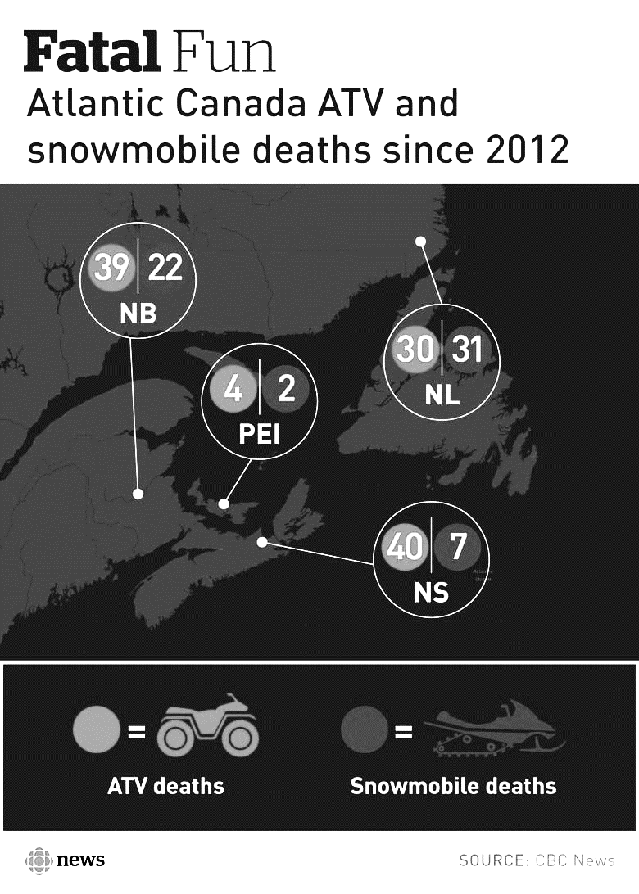
The deaths continued after CBC News completed its analysis of the numbers. Just last Saturday, 13-year-old Marc-André Gionet suffered fatal injuries when he lost control of his ATV and crashed in a quarry near his home in Haut-Lamèque.

Most victims are men
An analysis reveals that most of New Brunswick's off-road crash victims are men, with a median age of 43. Most have died on ATVs, and alcohol was a suspected factor in at least 59 per cent of crashes. But the true percentage of crashes involving alcohol could be higher. No one appears to be keeping track of how many people die impaired on off-road vehicles. At least a quarter of off-road vehicle crash victims weren't wearing helmets.

That includes 15-year-old Elizabeth Landers. Her mother, Suzanne Landers, attributes her daughter's decision to teenage invincibility. But those feelings of invincibility go beyond teenagers. Most of the victims confirmed to have gone riding without a helmet were adults.

'If she was wearing a helmet, she would have lived'
Elizabeth was an experienced ATV rider. The whole family would go on challenging rides together through water and deep mud past the tires. Her parents, both retired police officers, preached safety, and most of the time Elizabeth was cautious. But on July 11, 2016, she and two friends climbed on an ATV that was only meant for one person. They didn't plan to go far, just down a hill to swim at Meenans Cove, at the edge of the Landers's Quispamsis property.

The machine was equipped with one seatbelt, which wasn't used by any of the girls. Something went wrong during the short drive and the machine tipped over. Elizabeth's friends were thrown off the machine, but Elizabeth was trapped. The roll bar came down on her head. Landers doesn't understand why her daughter chose not to wear a helmet that day, after all those years of safe riding. The helmet was sitting on the seat of the machine.

It could be because Elizabeth was used to challenging ATV rides, her mother said. A trip down to the water didn't feel like a ride "so it didn't really count," Landers said. "Bottom line, if she was wearing a helmet, she would have lived."

More than 65,000 registered machines
ATVs and snowmobiles are treated differently from cars under provincial legislation but they can go just as fast. They're also very popular: New Brunswick has more than 65,000 registered ATVs and snowmobiles.

"An ATV will bring you places in New Brunswick where you'd otherwise never see," said Roger Daigle, president of the New Brunswick ATV Federation. The province has turned snowmobiling into a tourist attraction and has plans to do the same with ATVing. Both federations tout the benefits of the sport — the jobs created, the people who visit for the sport, and the businesses that make money from those visits. But the popular New Brunswick pastime has also taken a toll.

More than 1,100 traumatic injuries in 3 years
The 64 lost lives don't take into account people who have been badly injured in New Brunswick. Between April 2014 and March 2017, at least 1,183 people suffered traumatic injuries on ATVs or snowmobiles that significantly affected their ability to function. The majority of the injuries — 854 — happened on ATVs. And they weren't just scrapes and bruises.

"Injuries have a wide variety of types, ranging from sprains to fractures to brain bleeds, like subdural hematomas, or hemorrhage," said Dr. Richard Louis, an injury prevention specialist with NB Trauma, a program working partly through research and education to reduce injuries.

An $18 million price tag
As of 2010, ATV and snowmobile injuries were estimated to cost New Brunswick about $18 million a year, according to a report from Parachute, a charity aimed at "preventing serious and fatal injuries." That includes health-care costs but also indirect costs such as productivity lost because of hospitalization. It doesn't include the emotional cost families like the Landers pay every day. Suzanne Landers, Elizabeth's mother, estimates she lost 10 pounds in five days after her daughter died. She couldn't eat and "shook for days and days." She can't remember large portions of the four months after the crash. "The amount of trauma it causes to your life is beyond comprehension," Landers said. "It's the equivalent of getting hit by a freight train emotionally."

Mandatory training a tough sell
Some family members interviewed by CBC News support mandatory training for anyone who uses an off-road vehicle, something already in place in Nova Scotia for anyone born after April 1, 1987. New Brunswick only requires safety training for riders under 16 or adults who will be supervising underage operators, meaning Landers should have taken a safety training course. Her mother says the most effective way to force people to take training would be to have it as a requirement to insure an off-road vehicle. (ATVs and snowmobiles must be registered and insured to operate in New Brunswick.)

"If we can even save a few people per province in a year just by implementing something like that, I'm all for it," Landers said. It's not a new recommendation. A 2001 provincial task force on the ATV industry recommended mandatory training for everyone. But it never happened. It's a tough sell and does not have support from the ATV federation.

'Always looking to blame somebody'
Both groups representing ATVers and snowmobilers argue the problem isn't a lack of rules. It's the riders who don't follow the rules. "We're always looking to blame somebody," said Ross Antworth, general manager of the New Brunswick Federation of Snowmobile Clubs. "That's crazy. Why should it be government responsible to get an individual not to open a beer while on a snowmobile or an ATV? Why should it be the snowmobile federation?"

"By design, off-road vehicles do not provide significant occupant protection, and therefore they do pose an element of risk," spokesperson Geoffrey Downey wrote. "This is why we strongly encourage operators to follow all safety regulations, respect any posted speed limits and to never drive while impaired."

