Manitoba Olympian's dad helped her face down racism and become a role model

It was a long, hard road to the Canadian Olympic hockey team for Brigette Lacquette, from tiny Mallard, Man.
Janice Grant · CBC News · Posted: Feb 09, 2018 5:00 AM CT | Last Updated: February 9

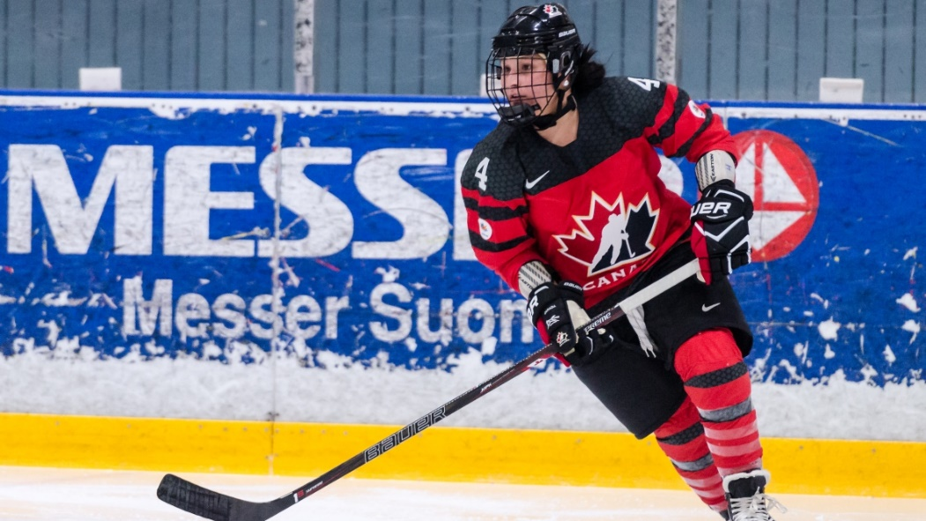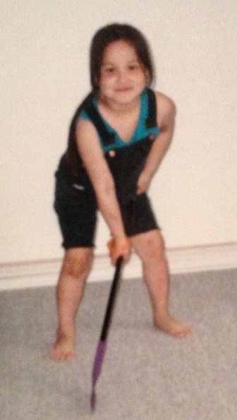
Brigette Lacquette plays in a women's Four Nations Cup match against Finland in November 2016. (Riku Laukkanen/Hockey Canada Images). And Brigette Lacquette, 7, shows off her stickwork at home in Mallard, Man. (Family photo)

A few days before Christmas, Terance Lacquette couldn't concentrate on work at his construction company — he was waiting to hear whether his daughter had achieved her Olympic dream.
Brigette Lacquette, 25, had an 11:30 a.m. meeting with Hockey Canada.
"All her first text said was 'Dad' with exclamation marks — five or six exclamation marks. She said 'I'll call you in a bit,' and I knew at that point she was on the team."
It was a long, hard road to the Canadian Olympic hockey team for the defencewoman from tiny Mallard, Man., who showed hockey talent at a young age but faced adversity and disappointment on the way to realizing this dream.
She was crying and laughing at the same time when she called her dad about a minute after that exclamatory first text was sent.
"My first words to her were, 'Congratulations, my girl. You definitely earned it. You deserve it.' And tears definitely began to fall on my face, for sure," he said.
His daughter not only made the team, she made history. Brigette Lacquette is the first First Nations woman to play on Canada's women's Olympic hockey team. Terance Lacquette is of Métis and First Nations heritage and Anita, Brigette's mom, is a member of the Cote First Nation in Saskatchewan.
The family's pure joy was a relief after months of uncertainty, Terance said. Brigette had been down this road before, and it ended abruptly. She was a late cut for the Olympic team that won gold in Sochi.
"It's definitely been a roller-coaster ride," he said. "You look at the beginning of the year when she didn't make the world's team — it's been fun, but you're also being stressed because you are worried about her not making it and all this work that she's put in."
Brigette showed hockey talent at a young age. Terance laughs when he recalls it was others who noticed it first.
"The very first time was six or seven years old, at a hockey tournament in Brandon," he said. "This couple was sitting beside Anita and they said: 'Look at that little girl. Look at how smart she is. Look how she knows what to do and knows exactly where to be!'"
As Brigette got older, hockey also provided refuge from a difficult skin disease.
"She had eczema at a young age. It was pretty bad. It flared up quite often. When you're sitting in class, it would get itchy, and she'd sweat and it would get itchy. It wasn't a really good thing," he said.
"When she got onto the ice, she was able to hide her arms and scars and everything with her hockey equipment and she felt like she was just another person out there.…
"It was definitely a challenge she had to overcome."
But it wasn't the only one.
At her first big tournament in Winnipeg, she faced racist taunts. She was 12 and playing spring hockey with a team from western Manitoba. Her dad remembers it well. He was on the bench.
"We played one of the city teams there and we got into the final game that was really close. And girls that age, you know, sometimes they get nasty and say things they don't mean. And on this occasion the one girl — actually a couple of them — started saying something about Briggie and calling her a 'dirty Indian,' 'Go back to the reserve,' and comments like that," he said.
"I could see when she came to the bench that something was bothering her, and she would have tears in her eyes, and it wasn't the same joy that she had. When she hits the ice, there's always a smile on her face, but this time around there was something up."
He asked her what was wrong, and she told him about the comments.
"And I just said, 'You know what, just beat them on the ice. There's not a whole lot that we can do. Some people are going to be like that. They're going to make comments like that.' And that's what she did. She just put her mind to it that you know, 'I'm not going to let anybody take this away from me,' and she did it. She persevered and she's overcome it," he said.
He's proud of her perseverance.
"A lot of First Nations people have walked away and said, 'To heck with this. I don't need this,' and then they'll go back and you'll never hear from them again. She could have easily said, 'You know what? I don't want to go through this again,' and never go play hockey in the city again or go on a rink again," he said.
"She basically kicked that door over and knocked it down and it's not a barrier anymore in her life, and that's something that's important for not only her but anybody who's faced a barrier in their life."
Brigette developed into a powerful defencewoman, and the hockey world noticed.
She played with the University of Manitoba Bisons and then NCAA hockey at the University of Minnesota-Duluth. She was chosen for national teams at every age level.
Brigette admired the women who played for Canada, such as Hayley Wickenheiser and Caroline Ouelette, but she didn't have any First Nations female players to look up to.
Now she is that role model.
Her dad has seen it first-hand.
"Every place she goes, whether she goes to a mall, or a hockey rink, or a baseball diamond … girls are constantly coming up to her and asking if [they] can take a picture together," he said.
"I'm just honoured to be the father of a girl who's going to be doing that for First Nations people. I don't take it lightly. It's quite an accomplishment."

- Please mark 8-10 notations in the text to show close reading.
- Describe two challenges that Brigette faced playing hockey.
- Who is a role model in your life and why?

