Rick’s Rant: Time to Reboot
I can’t tell you how many times in my life I have been in awe of modern technology. High speed internet, smart phones; we live in amazing times. The advancements have been incredible to watch. But you know what? I think we should stop now. I think we were heading in the right direction, but somewhere we made a U-turn. It used to be that you turn on your computer, you use your computer, it was great and that was that. Now I turn on my computer, the first thing it does is it tells me it's going to turn itself off, reboot and then download a system upgrade which will take 20 minutes to an hour, depending on its mood.

Phones are worse. If you have an iPhone it needs to be updated more often than a baby needs to be changed. My phone threatens me like a mob boss. It tells me if I don't accept the upgrade bad things will happen. So you accept the upgrade, next thing you know your battery doesn’t last as long and you’re getting traffic updates you never wanted.

Everything about technology that was supposed to help us is now starting to torture us. Remember when Siri first came along? She was helpful and interesting. She liked my questions. Now she's like a drunk who makes no sense. She gets angry and defensive if you ask her what the date is.

Yes, technology is more efficient now than it ever was but instead of giving us more free time, its original purpose, it's more demanding on our time. It's enslaving us. And really, I don't know what we’re going to do about it because, honestly, I can't imagine living any other way.

From: http://www.rickmercer.com/rick-s-rant.aspx
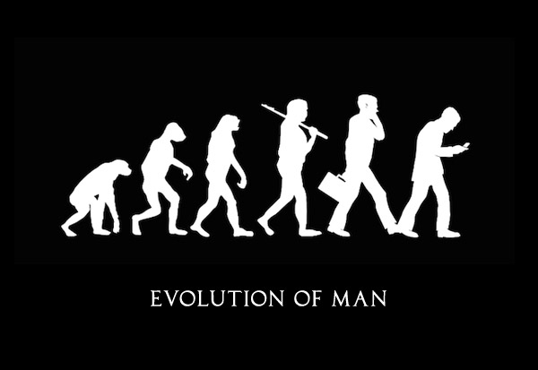
Questions
- Mark 5-7 notations to show close reading (/5)
- What frustrates Rick about technology? Briefly describe 3 things. (/3)
- Find one example of figurative language (hint: simile). (/1)
- Sketch or describe the next figure in the “Evolution of Man” image. Defend your idea. ( /3)
- Read the definition of addicted below. In your opinion, are YOU addicted to your phone? Please explain why or why not. (/3)

“addicted” (adjective): physically and mentally dependent on a particular substance or object, and unable to stop [using it] without negative effects

