Two way conversation with Micro:bits Your objective is to have a short conversation with your partner with the minimum of two responses for both people.
- Pick a partner
- Plug in the Micro:bit to your computer.
- Open File folder. Click the Microbit file.
- Open the HTM file.
- Click on lets Code, Scroll down to the JavaScript Blocks Editor. Press the “let’s code” button. (TIP: All you need is Input and basic)
- Click the Basic tab.
- Drag the show string block in to the on start block in the workspace. Type in Hi or Hello as your first message.
- Go back to the Basic tab and find the show string block, drag it to the on start block and type in your name.
- Go to the Input tab and find on button A pressed block and drag it under the code you already wrote.
- Go back to the Basic option and grab a show string button and drag it under the on button A pressed button. Type in a message as part of your conversation with your partner.
- Go to Input, drag on button A pressed into the workspace. Click where it says A and change it to B.
- Go to Basic, drag in show string, drag it into your on button B pressed code and type a message.
- Go to Input, drag on button A pressed into the workspace. Click where it says A and change it to A+B.
- Go to Basic, drag show string into your on button A+B pressed code and type a message
- Then Boom, you’re done! Now you can “talk” to your partner.
- Click download at the bottom of your page. It should automatically download to your Download files. Copy that file into to the Microbit folder. Now use the microbit buttons to talk to your partner.
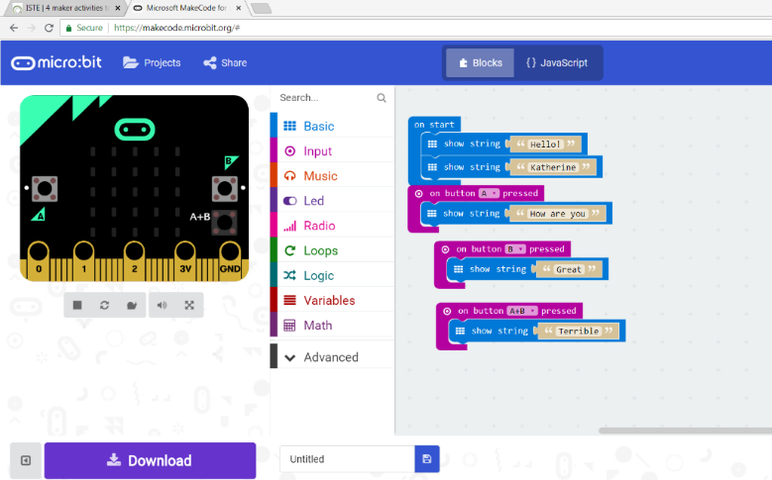
Rock Paper Scissors with Micro:bit
- Plug in the Micro:bit to your computer.
- Open File folder. Click the Microbit file.
- Open the HTM file.
- Scroll down to the JavaScript Blocks Editor. Press the “let’s code” button.
- Go to basic find on start and add show string three times and write in “Rock”, “Paper” and “Scissors” in each string.
- Go to basic and add two show leds and one show icon.
- Fill in the led boxes to look like my example.
- Choose the scissors in icon drop down menu.
- Add three on button A pressed blocks. Leave one as A. Change one to B and one to A+B
- Add the show led blocks and fill them in like the example.
- (Add dynamite like the example if you like with the on shake block)
- Download to your Download folder. Copy that new file to your Microbit folder.
- Play with a partner, have fun
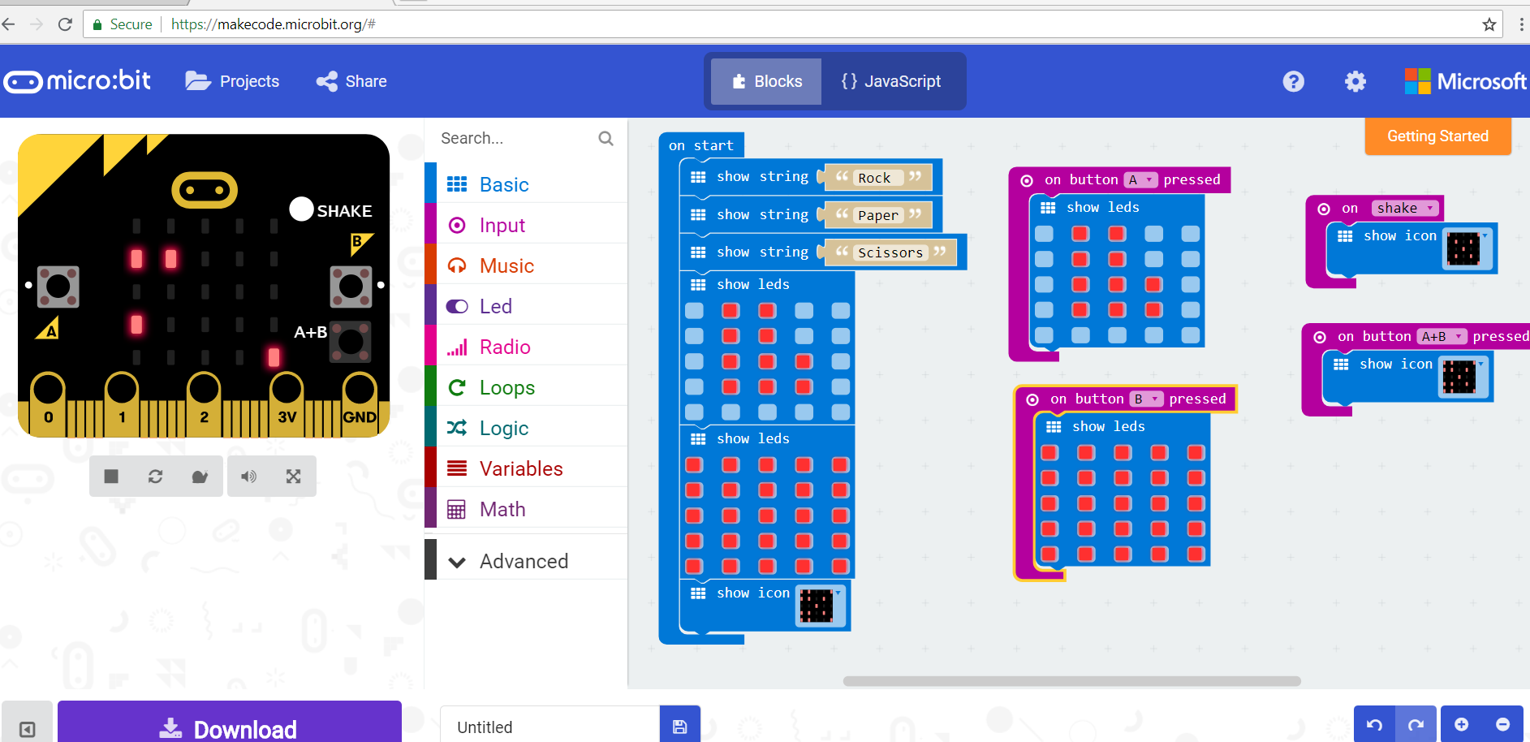
IMAGINE – Idea wall
My project is…
My reflection:
Learn:

Like:

Change:

Feel:

Next:
What is special about the role of the facilitator?

What is special about the role of materials and technology?

What did I do?

What did I learn?

DAILY CLASSROOM EVALUATION
Date

PROJECT
A1. Creativity | 1 2 3 4 5 6 | 1 2 3 4 5 6 | 1 2 3 4 5 6 | 1 2 3 4 5 6 | 1 2 3 4 5 6
A2. Persistence | 1 2 3 4 5 6 | 1 2 3 4 5 6 | 1 2 3 4 5 6 | 1 2 3 4 5 6 | 1 2 3 4 5 6
A3. Curiosity | 1 2 3 4 5 6 | 1 2 3 4 5 6 | 1 2 3 4 5 6 | 1 2 3 4 5 6 | 1 2 3 4 5 6
A4. Collaboration | 1 2 3 4 5 6 | 1 2 3 4 5 6 | 1 2 3 4 5 6 | 1 2 3 4 5 6 | 1 2 3 4 5 6
S1. Problem-solving | 1 2 3 4 5 6 | 1 2 3 4 5 6 | 1 2 3 4 5 6 | 1 2 3 4 5 6 | 1 2 3 4 5 6
S2. Record keeping | 1 2 3 4 5 6 | 1 2 3 4 5 6 | 1 2 3 4 5 6 | 1 2 3 4 5 6 | 1 2 3 4 5 6
S3. Skills | 1 2 3 4 5 6 | 1 2 3 4 5 6 | 1 2 3 4 5 6 | 1 2 3 4 5 6 | 1 2 3 4 5 6
S4. Communication | 1 2 3 4 5 6 | 1 2 3 4 5 6 | 1 2 3 4 5 6 | 1 2 3 4 5 6 | 1 2 3 4 5 6
B1. Diligence and safety | 1 2 3 4 5 6 | 1 2 3 4 5 6 | 1 2 3 4 5 6 | 1 2 3 4 5 6 | 1 2 3 4 5 6
B2. Follows instructions | 1 2 3 4 5 6 | 1 2 3 4 5 6 | 1 2 3 4 5 6 | 1 2 3 4 5 6 | 1 2 3 4 5 6
B3. Cleans up station and charges equipment, prevent waste/conserve materials | 1 2 3 4 5 6 | 1 2 3 4 5 6 | 1 2 3 4 5 6 | 1 2 3 4 5 6 | 1 2 3 4 5 6
B4. On task | 1 2 3 4 5 6 | 1 2 3 4 5 6 | 1 2 3 4 5 6 | 1 2 3 4 5 6 | 1 2 3 4 5 6

M A K E 120
Katherine Halas Moulton

By the end of this course the student is expected to be able to meet the curriculum goals listed below. Students will use evidence of their learning in their assignments, journal and research to prove which level they have achieved.

Objectives to be challenged in the course:

Attitude | Creativity - thinks creatively, solves problems and experiments  - Persistence - willingness to fail forward – accepts failure as part of learning and improving  - Intellectual curiosity – ability to wonder, explore new ideas and experiment  - Collaboration – sharing ideas, negotiating group work and supporting others
Skills | Project-based problem solving – asks, imagines, creates and improves  - Record keeping - maintains an accurate journal with project plans and thoughts  - Development of skills (soldering, coding, wiring, vinyl cutting….)  - Communication – communicates effectively as part of a team. (Also no swearing - workplace language)
Work habits | Diligence and safety – careful measurement, attention to details and safe handling of equipment  Follow instructions – both written and oral  Cleans up station and charges equipment, prevent waste/conserve materials  Stays on task

6 (Expert High): I excelled in this area, and fully applied the skills related to this outcome. 90-100% | 5 (Expert Low): I was strong in this area and consistently apply skills related to this outcome. 80-89%
4 (Apprentice High): I showed that I am capable in this area and I was usually able to demonstrate the skills related to this outcome. 70-79% | 3 (Apprentice Low): I showed that I am capable in this area most of the time, but sometimes I need support to demonstrate skills related to this outcome. 60-69%
2 (Novice High): I began to gain limited ability in this area but struggled to demonstrate the skills related to this outcome. 50-59% | 1 (Novice Low): I have not yet gained proficiency in this area and require a great deal of help. 40-49%

Attitude
Goal | Evidence | Score 1-6
A1. Creativity – how well can you think outside the box |  | Teacher  1 2 3 4 5 6
Student

1 2 3 4 5 6
A2. Persistence – the willingness to fail forward – accepts failure as part of learning and finding new solutions |  | Teacher  1 2 3 4 5 6
Student

1 2 3 4 5 6
A3. Intellectual curiosity – ability to wonder, explore new ideas and experiment |  | Teacher  1 2 3 4 5 6
Student

1 2 3 4 5 6
A4. Collaboration – sharing ideas, negotiating group work and supporting others |  | Teacher  1 2 3 4 5 6
Student

1 2 3 4 5 6

