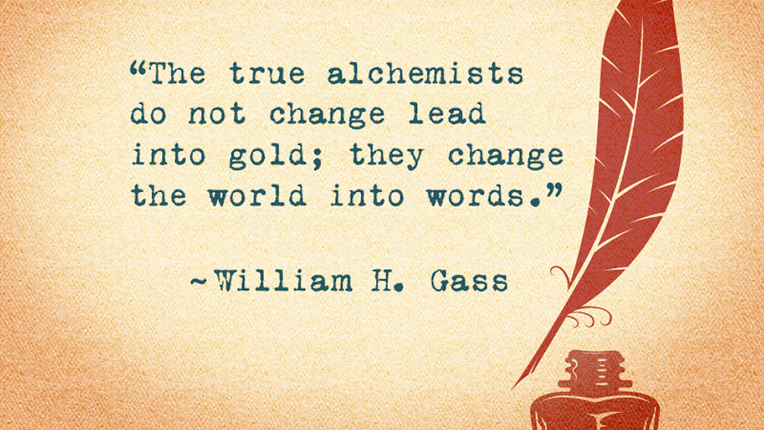

Table of Contents
- Schedule
- Example of MLA essay
- Checklist
- Thesis statements
- Avoiding plagiarism
- Outline
- Editing Tools
- Formatting
- Self- and Peer-Assessment

1-Schedule
16  Introduction  AoW 4 | 17  How to write thesis statements  & research | 18  Research | 19  Research | 20  THESIS STATEMENTS DUE & research
23  AoW 4 DUE & researching | 24  OUTLINE DUE & researching & draft writing | 25  Draft writing  AoW 5 | 26  Draft writing | 27  Draft writing
30  DRAFT DUE | 1  Editing | 2  Editing | NO SCHOOL | NO SCHOOL
7  Formatting  AoW 5 DUE | 8  Formatting | 9  FINAL ESSAY DUE | 10 | 11

3-Checklist

PLANNING PROCESS & DRAFT
- Thesis statement
- Develop outline
- Do research & record reference
- Complete a rough draft
REVISE AND PROOFREAD AND PROOFREAD AND PROOFREAD…
- Does your flow make sense? Do your paragraphs each cover an independent idea?
- Check sentence structure. Do you have run-on sentences?
- Check spelling, capitalization and conventions
FORMATTING
- Formatted your work as MLA
REFERENCES
- Be certain your work has 2 reliable sources (one can be Indian Horse)

4-Thesis Statements
Your thesis statement is YOUR opinion on the topic. It is the point you want to prove. The more specific you can make it, the easier it will be to do research and to write your essay.

Your thesis statement should be DEBATABLE and SPECIFIC.

EXAMPLE 1:
Resiliency is an important theme in the life of Richard Wagamase and in his novel “Indian Horse.”

EXAMPLE 2:
Community service (volunteer work) should be mandatory for all high school students, and should take place during school hours.

EXAMPLE 3:
“Regulation is needed because drivers using phones are seriously impaired and because laws on negligent and reckless driving are not sufficient to punish offenders,” (Daly 1).

5-Avoiding Plagiarism
What is plagiarism?
Using someone’s work as your own with giving proper credit!!

How to avoid it:
Summarizing: Write a shortened, condensed version of the source in YOUR OWN WORDS. You still need to give credit!!
Paraphrasing: Rewrite a portion of the original text in YOUR OWN WORDS. This is usually the same length as the original and may follow the source closely. You still need to give credit!!
Quoting: You CAN copy words/sentences/paragraphs directly from the original source. However, you must put in quotation marks (“ “) and give credit!!
NOTE: You do not need to provide documentation for ideas you come up with on your own OR familiar provides, famous quotations or common knowledge.

YOU NEED AT LEAST 2 SOURCES FOR THIS REPORT
ONE of your sources MUST be The Canadian Encyclopedia http://www.thecanadianencyclopedia.ca/en/
- The other source can be:
  - “Indian Horse” by Richard Wagamase
  - A newspaper article
  - A film or other approved source

6-Outline I - EXAMPLE
What is your claim?  What are you trying to prove?  Be SPECIFIC and DEBATABLE! |  | THESIS STATEMENT
 |  | Resiliency is an important theme in the life of Richard Wagamase and in his novel “Indian Horse.”
Give one or two sentences to support your thesis. | REASON(S)
 | Resiliency is the ability to bounce back. In the novel, Saul was able to overcome addiction and come back to his family and start to coach hockey. Richard Wagamese overcame addiction in his life and was a successful author.
MAIN IDEA 1 |  |  | MAIN IDEA 2
Supporting detail 1  - Talk about how Saul was able to play hockey despite all the racism (Reference: Indian Horse)  Supporting detail 2  - Talk about how Saul overcame his addiction (Reference: Indian Horse)  Supporting detail 3  - Talk about Saul’s experiences at the residiential school. |  |  | Supporting detail 1  - Richard Wagamese had a rough growing up. His parents were addicts (see reference Canadian Encylopedia) – they abandoned him when he was 3 years old…  Supporting detail 2  - Richard Wagamese…  Supporting detail 3
What other things should you consider? Remaining thoughts? Call to action for reader |  | CONCLUDE/RESPOND

6-Outline I EXAMPLE
What is your claim?  What are you trying to prove?  Be SPECIFIC and DEBATABLE! |  | THESIS STATEMENT
Give one or two sentences to support your thesis. | REASON(S)
MAIN IDEA 1 |  |  | MAIN IDEA 2
Supporting detail 1  Supporting detail 2  Supporting detail 3 |  |  | Supporting detail 1  Supporting detail 2  Supporting detail 3
What other things should you consider? Remaining thoughts? Call to action for reader |  | CONCLUDE/RESPOND

6-Outline II
- Introduction
- Main heading/idea of paragraph #1
- Supporting detail 1
- Supporting detail 2
- Supporting detail 3
- Main heading/idea of paragraph #2
- Supporting detail 1
- Supporting detail 2
- Supporting detail 3
- Conclusion

7-Editing
Spelling & Common Synonyms
Sentence Structure
Rules of Capitalization

8-Formatting

9-Self-Assessment
Category |  | 1 | 2 | 3 | 4 | 5
WRITING | Introduction – ideas and organization | There is no clear introduction of the thesis/structure of the paper |  | The introduction states the thesis and previews the structure of paper. |  | The introduction states the thesis and previews the structure of the paper. Grabs the reader’s attention!
 | Body – ideas and organization | Details are not in logical order. |  | Details are placed in logical order. |  | Details are placed in logical order and presented effectively.
 | Conclusion – ideas and organization | Lack of conclusion. |  | Conclusion is lacking. Restates introduction only. |  | Conclusion ties up loose ends and reiterates the thesis.
 | Grammar and Spelling | 20+ errors |  | 5-10 errors |  | Fewer than 5 errors
 | Evidence and Examples | Nonsense. |  | Paragraphs contain minor evidence.  Most evidence is specific and relevant. |  | Paragraphs contains strong evidence.  Evidence is specific and relevant.
PRESENTATION | MLA Formatting | Incorrect |  | A few errors in formatting |  | Correct title  Paper is double spaced and 12 pt font
 | References | 1 or no references |  | 2 references from reliable sources  May be errors in citation |  | 2 references – one from The Canadian Encyclopedia  Properly cited
PARTICIPATION | Effective Use of Time | Wasted significant time |  | On task the majority of time |  | On task all the time

Comments:

