Chemistry 18.1
Rates of Reaction
The heat given off by the corrosion reaction of an iron-magnesium alloy with salt water can produce a hot meal. The rate of reaction is increased by adding salt water, so heat is produced rapidly. You will learn some ways in which the rate of a reaction can be increased.
Collision Theory
How is the rate of a chemical change expressed?
In chemistry, the rate of chemical change, or the reaction rate, is usually expressed as the amount of reactant changing per unit time.
A rate is a measure of the speed of any change that occurs within an interval of time.
Rates of chemical reactions are often measured as a change in the number of moles during an interval of time.
According to collision theory, atoms, ions, and molecules can react to form products when they collide with one another, provided that the colliding particles have enough kinetic energy.

Effective Collision

Ineffective Collision

The minimum energy that colliding particles must have in order to react is called the activation energy.
An activated complex is an unstable arrangement of atoms that forms momentarily at the peak of the activation-energy barrier.
The activated complex is sometimes called the transition state.

Factors Affecting Reaction Rates
What four factors influence the rate of a chemical reaction?
The rate of a chemical reaction depends upon temperature, concentration, particle size, and the use of a catalyst.
Temperature
Storing foods in a refrigerator keeps them fresh longer. Low temperatures slow microbial action.
Concentration
a. In air, a lighted splint glows and soon goes out.
b. When placed in pure oxygen (higher oxygen concentration), the splint bursts into flame.
Particle Size
The minute size of the reactant particles (grain dust), and the mixture of the grain dust with oxygen in the air caused the reaction to be explosive, destroying the grain elevator.
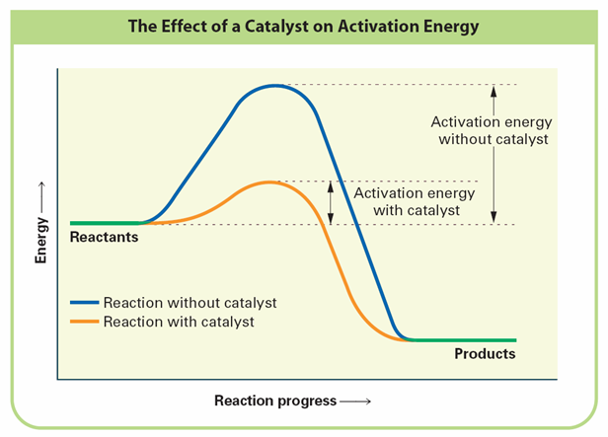
Catalysts

An inhibitor is a substance that interferes with the action of a catalyst. Antioxidants and antimicrobials used in drying fruits and preserving fruit juices slow the action of microbes and limit contact with air.

