Answers – 12A – Inverse Relations/Functions
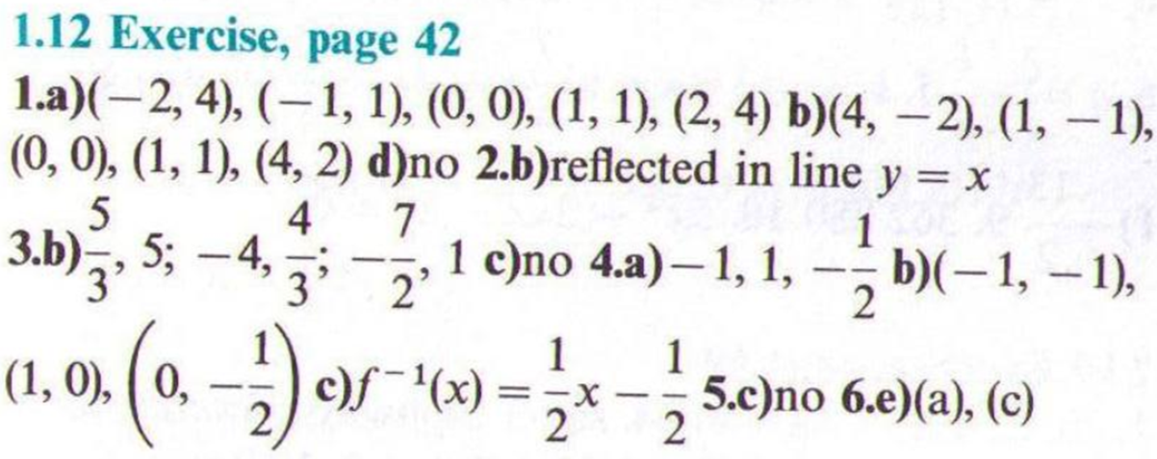
- Sketches will be provided on Monday…

Answers – 12B – Arithmetic Sequences
