Biology 122 name: _______________________
Take-Home Test: The cell cycle and meiosis date: ________________________

Important note:
- Please do not write on the test. Complete all your work on your own paper.
- Plagiarism of any kind will not be accepted. You may not copy your notes, nor any internet or print source directly onto your answer sheet. All answers should be expressed in your own words.

Part A: Short Answer.

- What is the role of the spindle during mitosis? (1 pt)
- If an organism’s diploid number is 12, then its haploid number is: ___________. (1 pt)
- Where in the human body would you find the only cells that undergo meiosis? (1 pt)
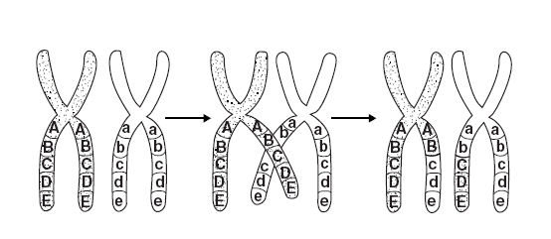
- What is the relationship between DNA and chromosomes? (1 pt)
- What cellular process is shown in the following figure? (1 pt)

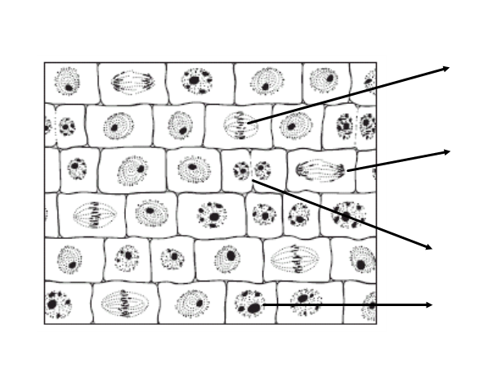

- Label each of the cells below (A-D) with the proper phase of mitosis. (4 pts)
A

B

C

D

Part B: Open Questions

- In your own words, explain homologous chromosomes. (2 pts)

- What effect does cell size have on its ability to efficiently carry out its activities? Give an example. (2 pts)

- How would the cell cycle differ for a cell that doesn’t divide, such as a neuron? (2 pts)

- a) Compare and contrast the process of mitosis and meiosis. What are the similarities? What are the differences? (3 pts)

b) How does the purpose of mitosis and meiosis differ? (2 pts)

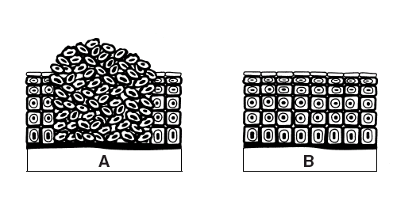
Using the following figure, answer questions 11 & 12.

- Which diagram shows cancer cells? How do you know? (2 pts)

- Look at the cancer cells in the above figure. What can happen if they are left untreated?
(2 pts)

- Why is the process of crossing over necessary in meiosis? (2 pts)

- a) What is non-disjunction? (1 pt)
b) If non-disjunction occurs in meiosis I, how many of the resulting cells will be normal?
(1 pt)
c) If non-disjunction occurs in meiosis II, how many of the resulting cells will be normal? (1 pt)

d) Propose a hypothesis to explain why non-disjunction in meiosis may be of higher concern than non-disjunction in mitosis. (2pt)

- In what ways can a karyotype be used to determine if a person has inherited a chromosomal disorder? (2pts)

Use the following diagram to answer questions 16 & 17.
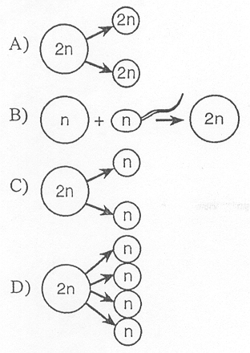

- Which letter represents the process of mitosis? How do you know? (2 pts)

- Which letter represents the process of meiosis? How do you know? (2 pts)

