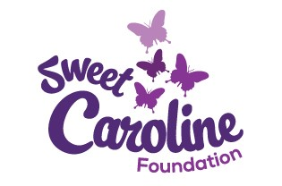

The Sweet Caroline Foundation is offering a scholarship competition open to residents of New Brunswick (regardless of age) who will be enrolled in an accredited post-secondary program for the 2016-2017 academic year.
- The applicant must be enrolled in an accredited institution for the 2016-2017 academic year. The winning essay applicants will be required to provide proof of acceptance and enrollment.
- The applicant does not need to have food allergies to be eligible to apply, however; must have a strong understanding of food allergies and be involved in raising awareness and educating others.
- Selected recipients will demonstrate a strong commitment and creative approach to raising awareness and educating other about life threatening allergies.
- A 500 word essay must be included along with the application and should include how the applicant has raised awareness and educated others about allergies and anaphylaxis, whom the applicant has reached through their efforts and how long the applicant has been involved in raising awareness.
- Submissions must be computer-generated on white paper with double spacing. They must have must have at least 1” margins all around, and use a 12 point font.
- The applicant’s name, address, location or other identifying information MUST NOT be included in the essay. Identifying information should only appear on the application entry form.
- Materials must be postmarked, regular delivery, no later than May 15, 2016.
- Do not contact the judges concerning this competition. Blind judging will be done.
Only submissions that conform to the guidelines will be considered. Submissions may be posted on the Sweet Caroline Facebook Page or Website, or mailed to Sweet Caroline Foundation, PO Box 4582, Rothesay NB,E2E 5X3. Winners will be notified by the end of June 2016. If awarded, proof of enrolment in the 2016-2017 academic year must be provided to receive the scholarship amount.

