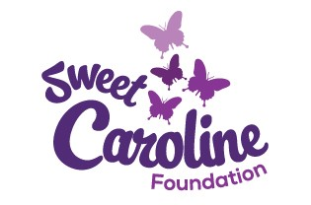

This form is to be completed and attached to the other required information when applying for the 2015-2016 Sweet Caroline Scholarship - Deadline: May 15, 2016
Full Name: |  | Phone: ( )
Address: | Email: | Date of birth:
 |  | Name of Parent or Guardian (if under 19):
How did you hear about the Sweet Caroline Scholarship? |  | Address of Parent/Guardian (if under 19):
High School/Post Secondary Institution currently attending:

Name of Institution you plan to attend 2015-2016:

Degree/Diploma Sought: |  | Length of  Course:
Please provide Sweet Caroline Foundation with 2 references.
Name and Title | Phone Number
1.

2.

I hereby agree to notify the Education Committee Chairperson of changes to my educational plans that would affect my eligibility for this scholarship and certify that the above information is correct. I authorize that my submission may be used as part of Sweet Caroline presentation/education/website materials and that all information submitted become the property of Sweet Caroline Foundation and cannot be returned.
Signature of Applicant:

