Case Study
Population Growth Control in India – Progress, but Not Enough
For over five decades, India has tried to control its population growth with only modest success.
The world’s first national family planning program began in India in 1952, when its population was nearly 400 million. In 2008, after 56 years of population control efforts, India was world’s second most populous country, with a population of 1.1 billion.
In 1952, India added 5 million people to its population. In 2008, it added 18 million. By 2050, the population of India is projected to surpass the population of China.
India faces a number of already serious poverty, malnutrition, and environmental problems that could worsen as its population continues to grow rapidly. By global standards, India’s people are poor. Nearly half of India’s labour force is unemployed or can find only occasional work.
India currently is self-sufficient in food grain production. Still, about 40% of its population and 53% of its children suffer from malnutrition, mostly because of poverty.
Furthermore, India faces serious resource and environmental problems. With 17% of the world’s people, it has just 2.3% of the worlds’ land resources and 2% of the world’s forests. About half of the country’s crop-land is degraded as a result of soil erosion, waterlogging, salinization, overgrazing, and deforestation. In addition, over two-thirds of India’s water is seriously polluted and sanitation services often are inadequate.
Without its longstanding family planning program, India’s population and environmental problems would be growing even faster. Still, to its supporters the results of the program have been disappointing for several reasons: poor planning, bureaucratic inefficiency, the low status of women (despite constitutional guarantees of equality), extreme poverty, and lack of administrative and financial support.
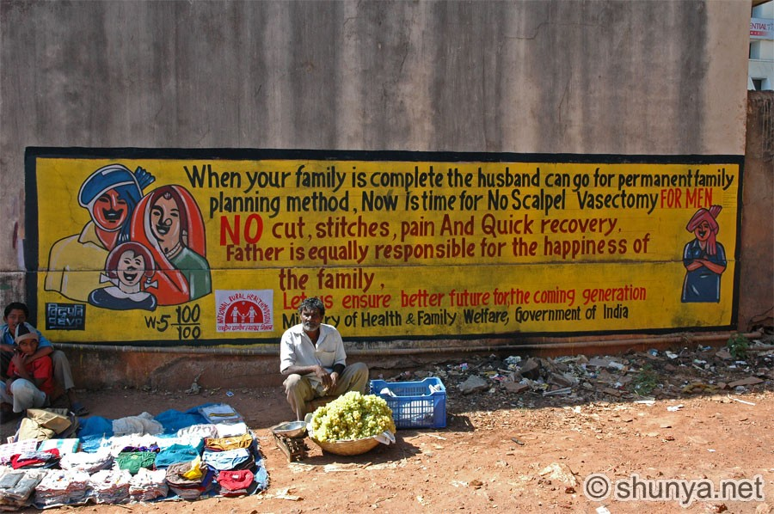
The government has provided information about the advantages of small families for years. Yet Indian women still have an average of 2.8 children. Once reason is that most poor couples believe they need many children to do work and care for them in old age. Another is the strong cultural preference for male children, which means some couples keep having children until they produces one or more boys. These factors in part explain why even though 90% of Indian couples know of at least one modern birth control method, only 49% actually use one.
Figure 1:
Family planning ad in India.

Case Study taken from “Living in the Environment” (Miller & Hackett).

