Chemistry 19.1
Acid-Base Theories
Bracken Cave, near San Antonio, Texas, is home to twenty to forty million bats. Visitors to the cave must protect themselves from the dangerous levels of ammonia in the cave. Ammonia is a byproduct of the bats’ urine. You will learn why ammonia is considered a base.

Properties of Acids and Bases
What are the properties of acids and bases?
Acids
Acids taste sour, will change the color of an acid-base indicator, and can be strong or weak electrolytes in aqueous solution.
Citrus fruits contain citric acid. Tea contains tannic acid.
Bases
Bases taste bitter, feel slippery, will change the color of an acid-base indicator, and can be strong or weak electrolytes in aqueous solution.
Antacids use bases to neutralize excess stomach acid. The base calcium hydroxide is a component of mortar.

Arrhenius Acids and Bases
How did Arrhenius define an acid and a base?
Arrhenius said that acids are hydrogen-containing compounds that ionize to yield hydrogen ions (H⁺) in aqueous solution. He also said that bases are compounds that ionize to yield hydroxide ions (OH–) in aqueous solution.
Hydrochloric Acid – H⁺ Cl⁻
Arrhenius Acids
Acids that contain one ionizable hydrogen, such as nitric acid (HNO₃), are called monoprotic acids.
Acids that contain two ionizable hydrogens, such as sulfuric acid (H₂SO₄), are called diprotic acids.
Acids that contain three ionizable hydrogens, such as phosphoric acid (H₃PO₄) are called triprotic acids.
Arrhenius Bases
Hydroxide ions are one of the products of the dissolution of an alkali metal in water.
Milk of magnesia is a base used as an antacid.

Brønsted-Lowry Acids and Bases
What distinguishes an acid from a base in the Brønsted-Lowry theory?
The Brønsted-Lowry theory defines an acid as a hydrogen-ion donor, and a base as a hydrogen-ion acceptor.

Why Ammonia is a Base
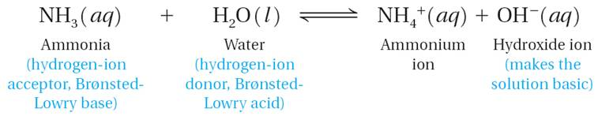

Conjugate Acids and Bases
A conjugate acid is the particle formed when a base gains a hydrogen ion.
A conjugate base is the particle that remains when an acid has donated a hydrogen ion.
A conjugate acid-base pair consists of two substances related by the loss or gain of a single hydrogen ion.
A substance that can act as both an acid and a base is said to be amphoteric.
A water molecule that gains a hydrogen ion becomes a positively charged hydronium ion (H₃O⁺).

Lewis Acids and Bases
How did Lewis define an acid and a base?
Lewis proposed that an acid accepts a pair of electrons during a reaction, while a base donates a pair of electrons.
A Lewis acid is a substance that can accept a pair of electrons to form a covalent bond.
A Lewis base is a substance that can donate a pair of electrons to form a covalent bond.
Compare the three important definitions of acids and bases.
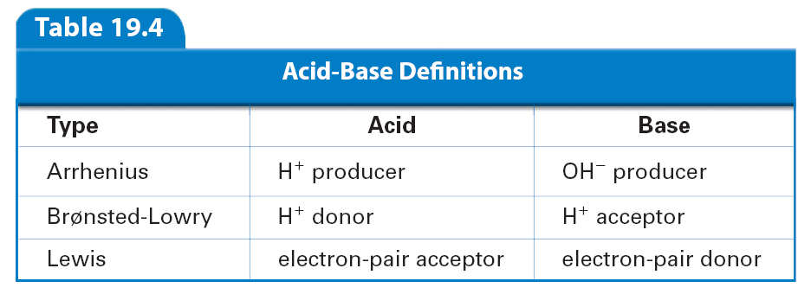

Hydrogen Ions and Acidity
To test a diagnosis of diabetic coma, a doctor orders several tests, including the acidity of the patient’s blood. Results from this test will be expressed in units of pH. You will learn how the pH scale is used to indicate the acidity of a solution and why the pH scale is used.
Hydrogen Ions from Water
The reaction in which water molecules produce ions is called the self-ionization of water.

In the self-ionization of water, a proton (hydrogen ion) transfers from one water molecule to another water molecule.

Ion Product Constant for Water
How are [H⁺] and [OH⁻] related in an aqueous solution?
For aqueous solutions, the product of the hydrogen-ion concentration and the hydroxide-ion concentration equals 1.0 × 10⁻¹⁴.
Any aqueous solution in which [H⁺] and [OH⁻] are equal is described as a neutral solution.
The product of the concentrations of the hydrogen ions and hydroxide ions in water is called the ion-product constant for water (K_{w}).
An acidic solution is one in which [H⁺] is greater than [OH⁻].
Unrefined hydrochloric acid, commonly called muriatic acid, is used to clean stone buildings and swimming pools.
A basic solution is one in which [H⁺] is less than [OH⁻]. Basic solutions are also known as alkaline solutions.
Sodium hydroxide, or lye, is commonly used as a drain cleaner.

The pH Concept
How is the hydrogen-ion concentration used to classify a solution as neutral, acidic, or basic?
The pH of a solution is the negative logarithm of the hydrogen-ion concentration.

Calculating pH
A solution in which [H⁺] is greater than 1 × 10^{–7} M has a pH less than 7.0 and is acidic. The pH of pure water or a neutral aqueous solution is 7.0. A solution with a pH greater than 7 is basic and has a [H⁺] of less than 1 × 10^{–7} M.
Calculating pOH
Same as above but [OH⁻]

Measuring pH
What is the most important characteristic of an acid-base indicator?
An indicator is a valuable tool for measuring pH because its acid form and base form have different colors in solution.
Phenolphthalein changes from colorless to pink at pH 7–9.

Acid-Base Indicators

Universal Indicators

pH Meters

Strengths of Acids and Bases
Lemons and grapefruits have a sour taste because they contain citric acid. Sulfuric acid is a widely used industrial chemical that can quickly cause severe burns if it comes into contact with skin. You will learn why some acids are weak and some acids are strong.

Strong and Weak Acids and Bases
How does the value of an acid dissociation constant relate to the strength of an acid?
An acid dissociation constant (K_{a}) is the ratio of the concentration of the dissociated (or ionized) form of an acid to the concentration of the undissociated (nonionized) form.
Weak acids have small K_{a} values. The stronger an acid is, the larger is its K_{a} value.
Strong acids are completely ionized in aqueous solution.
Weak acids ionize only slightly in aqueous solution.
In general, the base dissociation constant (K_{b}) is the ratio of the concentration of the conjugate acid times the concentration of the hydroxide ion to the concentration of the base.
Strong bases dissociate completely into metal ions and hydroxide ions in aqueous solution.
Weak bases react with water to form the hydroxide ion and the conjugate acid of the base.

Calculating Dissociation Constants
How can you calculate an acid dissociation constant (K_{a}) of a weak acid?
To find the K_{a} of a weak acid or the K_{b} of a weak base, substitute the measured concentrations of all the substances present at equilibrium into the expression for K_{a} or K_{b}.
Acid Dissociation Constant
The dissociation constant, K_{a}, of ethanoic acid is calculated from the equilibrium concentrations of all of the molecules and ions in the solution.
Base Dissociation Constant
The dissociation constant, K_{b}, of ammonia is calculated from the equilibrium concentrations of all of the molecules and ions in the solution.
Concentration and Strength

Neutralization Reactions
Excess hydrochloric acid in the stomach can cause heartburn and a feeling of nausea. Antacids neutralize the stomach acid and relieve the pain of acid indigestion. You will learn what a neutralization reaction is.

Acid-Base Reactions
What are the products of the reaction of an acid with a base?
In general, the reaction of an acid with a base produces water and one of a class of compounds called salts. Reactions in which an acid and a base react in an aqueous solution to produce a salt and water are generally called neutralization reactions.

Titration
What is the endpoint of a titration?
The process of adding a known amount of solution of known concentration to determine the concentration of another solution is called titration.
The point of neutralization is the end point of the titration.
When an acid and base are mixed, the equivalence point is when the number of moles of hydrogen ions equals the number of moles of hydroxide ions.
The solution of known concentration is called the standard solution.
Indicators are often used to determine when enough of the standard solution has been added to neutralize the acid or base.
The point at which the indicator changes color is the end point of the titration.

Salts in Solution
The chemical processes inside a living cell are very sensitive to pH. Human blood is normally maintained at a pH very close to 7.4. You will learn about chemical processes that ensure that the pH of blood is kept near 7.4.

Salt Hydrolysis
When is the solution of a salt acidic or basic?
In general, salts that produce acidic solutions contain positive ions that release protons to water. Salts that produce basic solutions contain negative ions that attract protons from water.
In salt hydrolysis, the cations or anions of a dissociated salt remove hydrogen ions from or donate hydrogen ions to water.
To determine whether a salt solution is acidic or basic, remember the following rules:
Vapors of the strong acid HCl(aq) and the weak base NH₃(aq) combine to form the acidic white salt ammonium chloride (NH₄Cl).

Buffers
What are the components of a buffer?
A buffer is a solution of a weak acid and one of its salts, or a solution of a weak base and one of its salts.
The pH of a buffer remains relatively constant when small amounts of acid or base are added.
The buffer capacity is the amount of acid or base that can be added to a buffer solution before a significant change in pH occurs.
Buffer of Ethanoic Acid and Sodium Ethanoate
Adding H⁺ produces additional ethanoic acid.
Adding OH⁻ produces additional ethanoate ions.
The pH changes very little.

