Biology 112 – Exam Review Answers
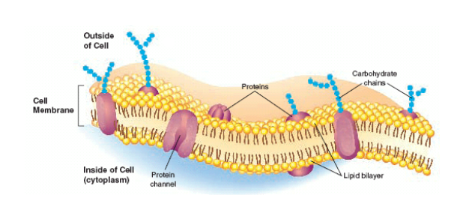
Exam Review Sheet #2

- Protein Channels allow in and out certain molecules, making their movement across the cell membrane easier and quicker.
- Carbohydrate chains acts as “ID” tags for the cell, allowing cells to recognize one another and also recognize foreign invading cells.

- Small molecules with little ionic charge have the ability to diffuse through the cell membrane with the concentration gradient without energy. Ex: Water

- Concentration is a type of measurement where the weight of a solute is calculated per the volume of solvent. It’s unit of measure is the g/mL.

- Diffusion occurs when, due to the random movement of particles, molecules spread out until they reach equilibrium. This means that molecules do not “clump” naturally, but rather spread out until evenly distributed, even across membranes.

- Osmosis is a type of diffusion related specifically to the movement of water across a cell membrane AGAINST the concentration gradient of a particular solute. It occurs when the solute molecules are too large or too ionically charged to cross the cell membrane.

- Hypertonic solutions have MORE solute (higher concentration) than their counterpart.
Hypotonic solutions have LESS solute (lower concentration) than their counterpart.
Isotonic solutions have the same concentration of solutes as each other.

- If a cell is placed in a hypertonic solution, water will travel OUT of the cell and into the environment. The cell will shrink.
If a cell is placed in a hypotonic solution, water will travel INTO the cell from the environment. The cell will expand and could burst.
If a cell is placed in an isotonic solution, the amount of water entering the cell will be equal to the amount of water exiting the cell and the cell’s size will not change.

- Facilitated diffusion differs from diffusion because it does not rely on the random movement of particles. Instead, molecules can use protein channels to enter or exit the cell, making the process quicker.

- Active transport required energy. Molecules are pumped in or out by protein channels AGAINST the concentration gradient. Facilitated diffusion uses no energy and molecules move through protein channels WITH the concentration gradient.

- Facilitated diffusion allows in small molecules that are required for the immediate survival of the cell, such as glucose, Na⁺, K⁺, etc…

- Endocytosis is the movement of large molecules INTO the cell by the infolding of the cell membrane. Liquids move in by a process called pinocytosis and solids move in by a process called phagocytosis.

- The cell’s mitochondria are responsible for the creation of energy through a process called cellular respiration. Glucose and Oxygen are combined in the organelle to form water, energy and carbon dioxide.

- The cell’s chloroplasts are responsible for the creating of GLUCOSE in plants through a process called photosynthesis. Sunlight is used to combine water and carbon dioxide in order to produce glucose and oxygen.

