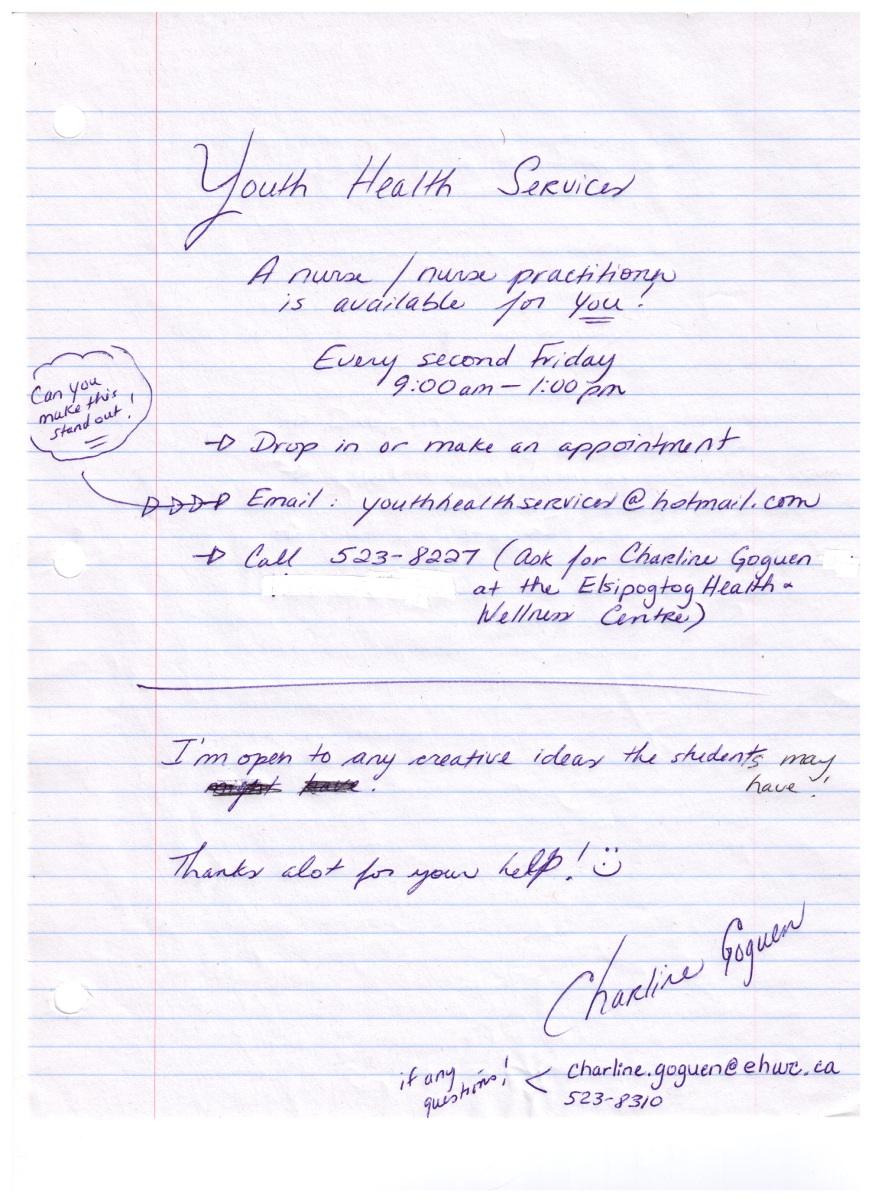

The Youth Health Center will be open on the following days:

Thursday, April 4th, 2013

Friday, April 19th, 2013

Friday, May