News Release
Natural Resources

Wildlife officer of the year recognized
10 April 2012
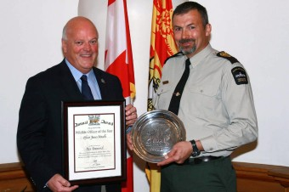
Anne Bull, communications, Department of Natural Resources, 506-453-2614, anne.bull@gnb.ca.
FREDERICTON (GNB) – James Mundle, a conservation officer with the Department of Natural Resources, was honoured as wildlife officer of the year at a ceremony at the legislative assembly today.
Natural Resources Minister Bruce Northrup recognized Mundle as the Shikar-Safari Wildlife Officer of the Year for 2011.
“Mundle's professionalism and commitment to wildlife conservation and enforcement have made him a superb role model for all conservation officers in the department,” said Northrup. “We are proud to have him on our staff to serve the people of New Brunswick and protect our natural resources.”
Mundle, who has been with the department for 25 years, works in Region 2, based in Richibucto. He serves as a firearms' range officer, helping other officers to qualify to carry handguns, and has taught Grade 4 students about the importance of natural resources. He has also been involved with Crime Stoppers, which is an important partner of with the department in dealing with poaching and wood theft, and has participated in the Law Enforcement Torch Run, which raises awareness and funds for the Special Olympics.
The Shikar-Safari Club International, an organization that promotes wildlife conservation and protection, sponsors the award. The organization recognizes and honours officers from Canadian provinces and territories and from the United States who have shown exemplary performance of their duties in the protection of wildlife, enforcement of game laws and implementation of conservation programs. The award has been presented to a New Brunswick conservation officer each year since 1982.
10-04-12

