Alkali Metals
Name | Symbol | Bohr Diagram of Element | Number of Valence Electrons | Bohr Diagram of stable ion | Ionic Charge
lithium | Li | Li | Li⁺¹  1 |  | +1
sodium | Na | 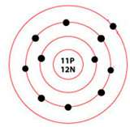 | 1 | 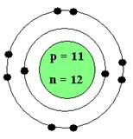 | +1
potassium | K | 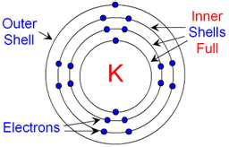 | 1 | 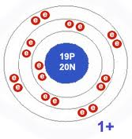 | +1

Alkaline Earth Metals
Name | Symbol | Bohr Diagram of Element | Number of Valence Electrons | Bohr Diagram of stable ion | Ionic Charge
beryllium | Be | 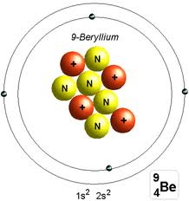 | 2 | 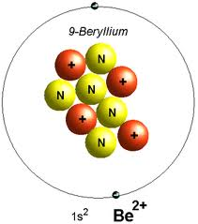 | +2
magnesium | Mg | 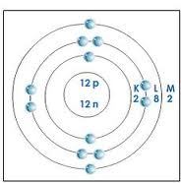 | 2 | 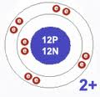 | +2
calcium | Ca | 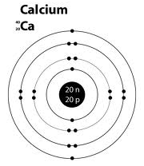 | 2 | 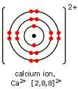 | +2

Halogen
Name | Symbol | Bohr Diagram of Element | Number of Valence Electrons | Bohr Diagram of stable ion | Ionic Charge
fluorine | Fl | 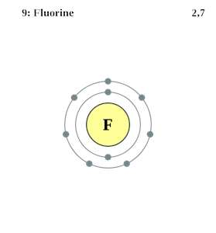 | 1 | 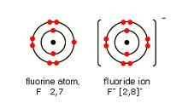 | -1
chlorine | CL | 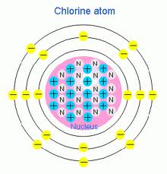 | 1 | 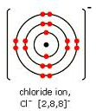 | -1

Nobel Gas
Name | Symbol | Bohr Diagram of Element | Number of Valence Electrons | Bohr Diagram of stable ion | Ionic Charge
helium | He | 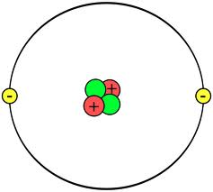 | 0 |  | 0
neon | Ne | 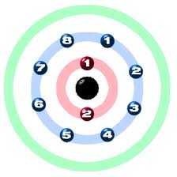 | 0 |  | 0
argon | Ar | 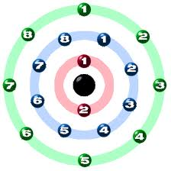 | 0 |  | 0

Part C: Metallic Elements
Name | Symbol | Bohr Diagram of Element | Number of Valence Electrons | Bohr Diagram of stable ion | Ionic Charge
sodium | Na |  | 1 |  | +1
magnesium | Mg |  | 2 |  | +2
aluminum | Al | 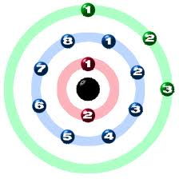 | 3 | 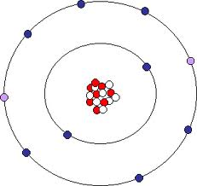 | +3

Part C: Non Metallic Elements
Name | Symbol | Bohr Diagram of Element | Number of Valence Electrons | Bohr Diagram of stable ion | Ionic Charge
nitrogen | N | 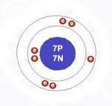 | 3 | 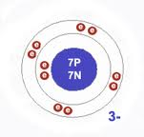 | -3
oxygen | O | 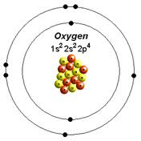 | 2 | 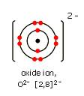 | -2
fluorine | F |  | 1 |  | -1

