Chapters 9 & 10 - Test Review (Human Body Systems)

Human Systems (General):
- Organization within the body (cell - tissues - organs - systems)
- Homeostasis

Nervous system:
- response to stimuli
- 3 types of neurons + parts of the neurons
- nerve impulses
- divisions of the system
Brain: meninges, cerebrospinal fluid, cerebrum, cerebellum, brain stem, thalamus, hypothalamus
Spinal Cord
Peripheral system
- Problems of the nervous system

Endocrine System:
- Hormones, glands and target cells
- Types of glands
- 7 main glands and jobs
- 2 types of hormones
- local hormones
- negative feedback control mechanism
- complimentary hormone action control mechanism

Digestive system:
- types of digestion
- Organs of the system and functions
- Problems of the system

Review Questions

Textbook:

Ch. 35 (p. 917) MC: # 2 - 7
# 11 - 16, 27, 30

Ch. 39 (p. 1027) MC: # 1 - 4
# 11 - 14, 30

Ch. 38 (p. 993) MC: # 2 - 6, 8
# 16, 17, 19 - 21

Ch. 35: The Nervous System #2. b #3. a #4. d #5. a #6. c #7. b
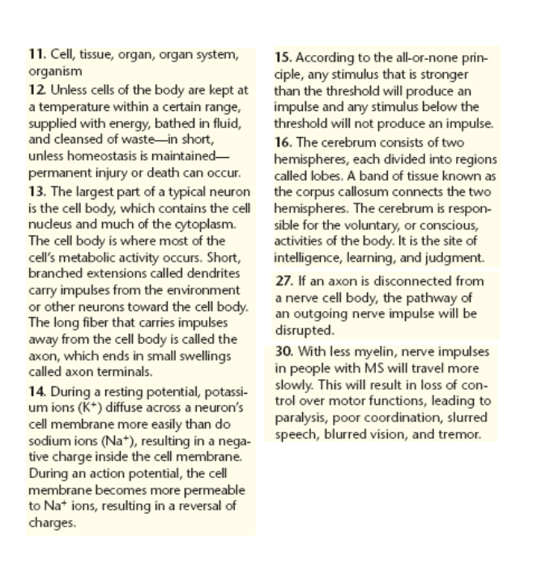
Ch. 39: The Endocrine System #1. b #2. b #3. b #4. d
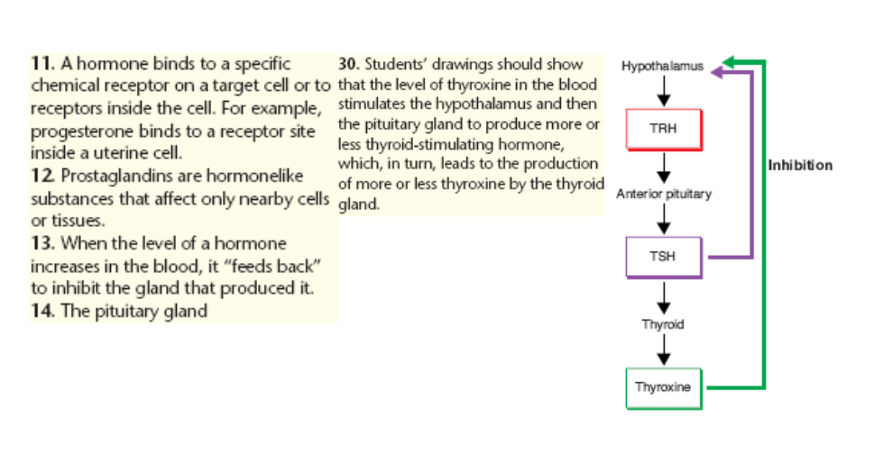

Ch. 38: The Digestive System

#2. c #3. b #4. c #5. c #6. b #8. d
