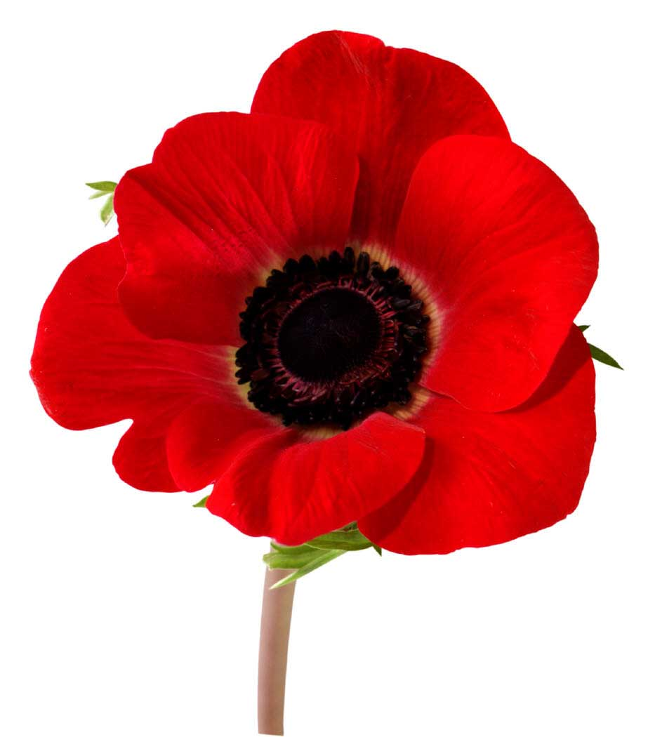
REMEMBERANCE DAY POETRY ASSIGNMENT
STEP #1:
How do you remember? Why do we fight? What is peace, freedom, justice and bravery? Your job is to reflect and share your thoughts on these questions through poetry. The form and length of your poem is entirely up to you. Below you will find some suggestions if you are having a difficult time getting started.
- ...IS POEMS
Writers describe what something is or what something means to them. Each line begins with ______is_____.
ex. War is fighting in a cold wet field
Peace is lying in a cozy warm bed.
War is not knowing if you will live through the day.
Peace is happiness. etc....

- 5 W's POEM
Each line contains information about either who, what, when, where or why.
ex. Canadian Soldier
Crouching in a tunnel
Waiting for a bomb to drop
In the dead of night
Protecting our country

- ACROSTIC POEMS
Each line begins with a specific letter so it vertically spells a word.

STEP #2:
Every year BLMS has a Remembrance Day Ceremony. We are going to be sharing our poems with the school. Don’t panic! You won’t be standing up in front of the whole school reading your poem. We are going to record our voices reading them and then Mrs. Halas Moulton’s Digital Tech. class will add photos and music to it. This will be part of your mark.

WHAT YOUR FINISHED ASSIGNMENT WILL CONSIST OF:
- 4 poems about Remembrance. Please try to answer the questions mentioned in Step #1 within your poem.
- Each poem will be on a separate sheet of white paper, neatly written and appealing to the eye. (I have fancy paper with a suitable background on it if you want to write your good copy on this.)

