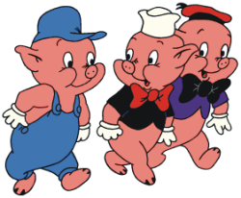
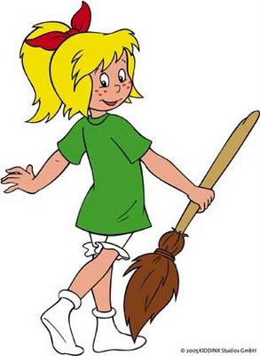
Perspective Writing – Fairytales
Comic Strip Assignment
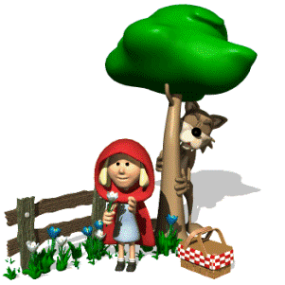

What is perspective?
When writing, it is important to know the perspective you are trying to portray. Perspective is how the narrator of the scene views what is happening and therefore shapes how they portray what they have seen to the reader. Also known as point of view, perspective can be shaped by distance and relation to the actual event and/or the character or narrators own feelings towards the scene at hand or their state of mind leading up to the event. Ultimately, perspective can either help and/or hinder the telling of the story.
What to do:
- Choose one of the following fairytales: Little Red Riding Hood, Three Little Pigs, or Goldilocks.
- Tell the story from a different character’s perspective. (Ex. The bad wolf rather than Little Red Riding Hood)
- Represent your story in comic strip format.
  - You comic should be, but is not limited to, 16 boxes. Each box will include an illustration, speech bubbles, and an explanation at the bottom.
  - Paper will be provided for your final copies.
  - Use class time! Bring necessary items.
- I expect your work to be well done and of good quality, not put together in a hurry. You are in grade 11/12, not elementary school. Drawings will be completely colored. I want neat work. It must be evident that you put a lot of effort into this project.
- We will be working on this in class on October 13th, 14th and 15th .

Due: Wednesday, October 20th

