Unit Test Review
Section 1 (These will be multiple choice on your test)
- Rewrite 4x + 2y = 10 in slope-intercept form (y = mx + b)
- Rewrite 2x + 3y + 6 = 0 in slope-intercept form (y = mx + b)
- Find the y-intercept (b) and the slope (m) of this line: 2x + 5y = 10
- Find the y-intercept and the slope of the this line: 2x – y + 3 = 0
- What is the slope of 6x + 3y = 9?
- If you graph y = -1/3x + 3, which one of these points would be on the line?
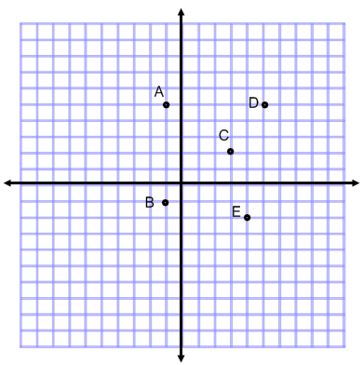
- Using the graph above, if you graph a line with a slope of 1, and passes through the origin, which two points will be on the line?
- What is the y-intercept of the line 2x – 4y + 8 = 0?
- What is the x-intercept of the line 3x + y – 4 = 0?
- Sketch a graph (you can use the grid above) of the line y = 3/2x – 5
- Write the equation of the line with a slope of -3 and a y-intercept of 4.
- Does the line y = 2x + 1 contain the point (3,7)?
- What is the slope of the line connecting these two points: (2,4) and (8,4)?
- What is the slope of the line joining (10,4) and (10,2)?
- What is the slope of the line joining (3,3) and (6,3)?
Section 2 – Short Answer
- Solve the following equations for x:
  - 10x – 33 = 4x + 39 d. 4x + 1 = 3x + 7
  - 3x = 10 + 2x 2 4
  - 3x + 2 = x e. 3x – 8 – 1 + 2x = 1 – 3x
6 6 2 3 4
- Blockbuster has a yearly membership of $25 plus $4/DVD rental. Rogers has a membership of $50 plus $2/DVD.
  - Write an equation for each member ship.
  - If you wanted to rent 10 DVDs, which would you pick?
  - After how many DVDs are both companies the same?
- Draw the graph of each line:
  - y = 1/2x + 2 b. y = -3x + 4 c. y = -3
- What is the x and y intercept of each line?
  - y = 2x + 4 b. 4x + 2y = 6 c. 2x – y + 3 = 0
- Find the equation of each line:
  - A slope of 4 and a y-intercept of 3
  - A slope of -1/2 and a y-intercept of -2
  - A line that goes through the point (2,5) with a slope of 4

