Values, Beliefs & Perspectives
A civic issue (or political issue) is a topic or subject that people speak about because it affects society as a whole and, often there are multiple opinions on various sides of any given issue.
Opinions and Perspectives
- An opinion is your belief about a particular issue or topic.
Opinions are personal, subjective and formed by our values, knowledge and perspectives.
  - Not everyone will have the same opinion about the most important issue facing the school community, but there is no right or wrong opinion
- A perspective is a viewpoint or an outlook, a way of looking at things. Our perspectives are shaped by who we are and our environment.
  - High school students may have a different perspective about life priorities than their parents
Your Values and Worldview
Your worldview is your outlook on life and the world, and how you interpret events on a daily basis.
Your worldview relates to your values, which are your principles or standards of behaviour and priorities in life.
The Political Spectrum
Political perspective is a political thinking concept that looks at the way in which a person’s beliefs and values can affect his or her position on, or response to, civic issues.
Your perspective is shaped by who you are and your current situation or environment. Your perspective impacts your beliefs.
For example, your opinion about increasing minimum wage may differ if you are an employee who is paid minimum wage versus a small business owner who has to pay their employees minimum wage.
What is a political ideology?
A political ideology is a set of shared ideas or beliefs about the role of government and how society should work.
What is the political spectrum?
- The political spectrum provides a way to characterize and distinguish between different beliefs, ideologies and public policies.
- The political spectrum can be viewed with two intersecting scales: one for economic/fiscal policies and one for social/personal policies.
  - Key question: To what degree should the government intervene or exert control in these two spheres?
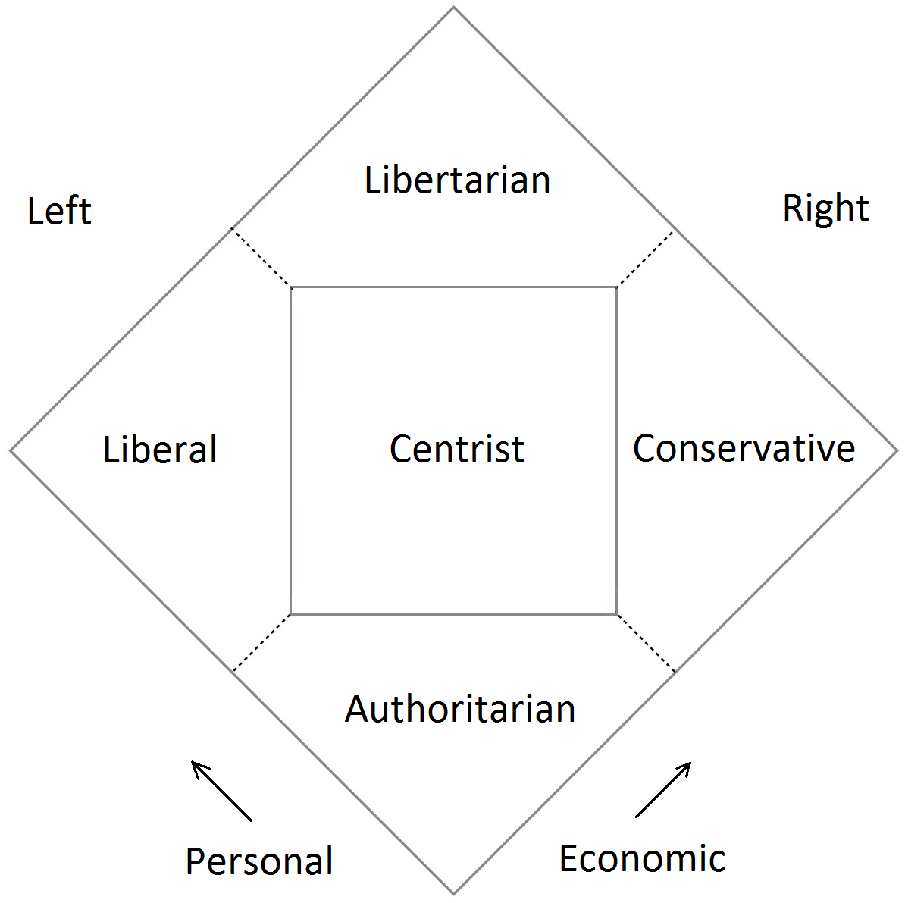
Ideologies (Nolan chart)
- Liberal/Left-leaning people embrace social services and government intervention in the economy.
- Conservative/Right-leaning people support lower taxes, free markets and less government intervention in the economy.
- Libertarians advocate both personal and economic liberty (freedom).
- Authoritarians favour strict obedience to authority and government control, at the expense of personal and economic freedom.
SOCIAL SCALE
Socially conservative
Traditional values, keeping status quo on moral issues including family life
Socially liberal
Progressive values, moving forward on civil liberties
FISCAL SCALE
Fiscally conservative
Low taxes and government spending, less government intervention, free market
Fiscally liberal
Higher taxes and more government spending, more government involvement, more social services
Left-leaning/Liberal views– Fiscal Issues
- The government can play a positive role in managing the economy and creating jobs, as opposed to simply letting the private sector be responsible for creating jobs.
- A large gap between the richest and poorest parts of society should be avoided as much as possible.
- Wealthier individuals and corporations should pay a greater share of taxes than poorer individuals.
- There is good value in government services, such as education and healthcare, and higher taxes and government debt may be necessary to ensure these services are sufficient.
- Policies that might be considered bad for businesses but are intended to alleviate social or environmental problems, like climate change, are important for the greater good.
Right-leaning/Conservative views – Fiscal Issues
- Businesses and individuals should receive as much support as possible in order to create jobs, wealth and innovation.
- Inequality is not a concern. People who are financially successful are being rewarded for their contributions to society.
- Smaller government is the best approach, which means less government influence on the economy and fewer government services.
- Taxes should be as low as possible and the government should avoid going into debt.
- Regulation on businesses is not necessary because the free market provides sufficient incentives for businesses to pursue important social and environmental outcomes.
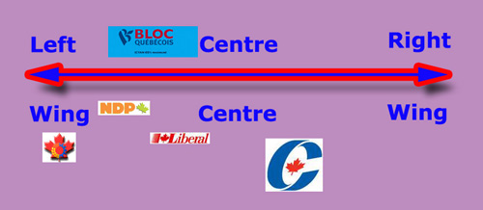
What is an election?
- An election is the process for determining our political representatives and the political direction of our government
- Elections are contests of leadership, ideas, politics and power, where interested groups and individuals campaign for our support and, ultimately, our vote
What is a candidate?
- An individual who seeks public office or competes for the job of elected representative is called a candidate.
- At the federal level and the provincial level, most candidates are associated with a political party.
- Political parties bring together people with similar political views and goals who are seeking to effect change by being elected.
Electoral Systems
An electoral system is the way in which voters are able to express their preferences and how the results are determined.
Different electoral systems exist around the world.
What is our electoral system?
- New Brunswick uses a system called First-Past-The-Post (FPTP) or Single-Member Plurality
- Only one member is elected per electoral district
- The rules:
  - Voters can only choose one candidate on their ballot.
The candidate that receives the most votes wins (this is called plurality).
How does First-Past-The-Post work?
An example of FPTP, in an electoral district with 100 ballots cast:
CANDIDATE NUMBER OF VOTES
Lisa (Banana Party) 40
Mohamed (Pear Party) 15
Emma (Apple Party) 11
Thomas (Independent) 34
Lisa wins because she has the most votes (40). The winning candidate does not need receive support from a majority of voter – just one more vote than any other candidate.
What is an electoral district?
- New Brunswick is divided into smaller electoral districts (or ridings), which are defined geographic areas
- The size of electoral districts is determined by factors such as population size, demographic make-up and geography.
- Urban electoral districts are often smaller and more populous, while rural electoral districts are larger with less dense populations.
How many electoral districts do we have in New Brunswick?

- We have 49 electoral districts in New Brunswick.
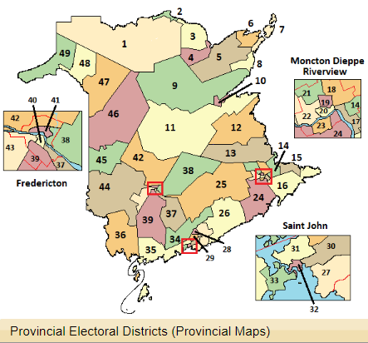
How do political parties work?
- Anyone above the required age (usually 14 years old) can join the party.
- Party members choose their party’s leader and candidates, and help them get elected.
- During elections, parties release a platform which is a series of policy ideas linked to specific issues.

There are 6 registered political parties in New Brunswick:
Liberal Party
Progressive Conservative Party
New Democratic Party
Parti Vert N.B. Green Party
People’s Alliance of New Brunswick
KISS N.B. Political Party
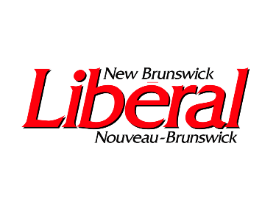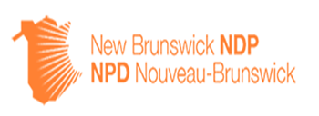
Questions to think about on your own
- Which candidates are running for office in your electoral district? How can you find out?
- How can you learn about the candidates and the parties they represent?

