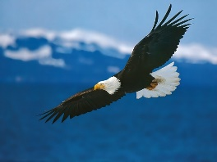
Native Studies 120 Syllabus
Ms.Clair
Unit 1. History –September
- Before Contact
- Contact
- Indian Act
- Struggles
- Residential School
Unit 2. Mi’kmaq History-October
- Traditional lands
- Traditions and costumes
- Grand Council
- Chief and council
- Historical site

Unit 3. First Nation Contributions -November
- Hockey
- Medicine
- Foods
- Petroleum Jelly/Vaseline
Unit 4. Today’s Issues for First nation in Canada-December
- Idle No More
- Shale Gas
- Oka
- Ipperwash
- Bill C-45
Unit 5. Language Culture- January-February
- Writing systems
- Original words
- Names
- Cultural ceremonies
- Music

Unit 6. Arts and Crafts September-February
- Dreamcatchers
- Beadwork
- Drums(depending on supplies)
- Rattles
- Tee Pee building

