Writing to your “POEtential”
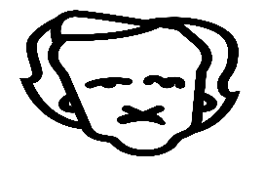
Convert sentences from “basic” to Poefect.
- The old man walked towards the door and opened it.
____________________________________________________________________________________________________________________________________________________________________________

- She could not wait to respond to the question her teacher had asked.
____________________________________________________________________________________________________________________________________________________________________________

- The pub was full of people and the music was too loud to carry on a conversation.
____________________________________________________________________________________________________________________________________________________________________________

- The building was on their right, so they made their way across the road.
____________________________________________________________________________________________________________________________________________________________________________________
- A man ran up behind them, and the girl screamed.
____________________________________________________________________________________________________________________________________________________________________________________

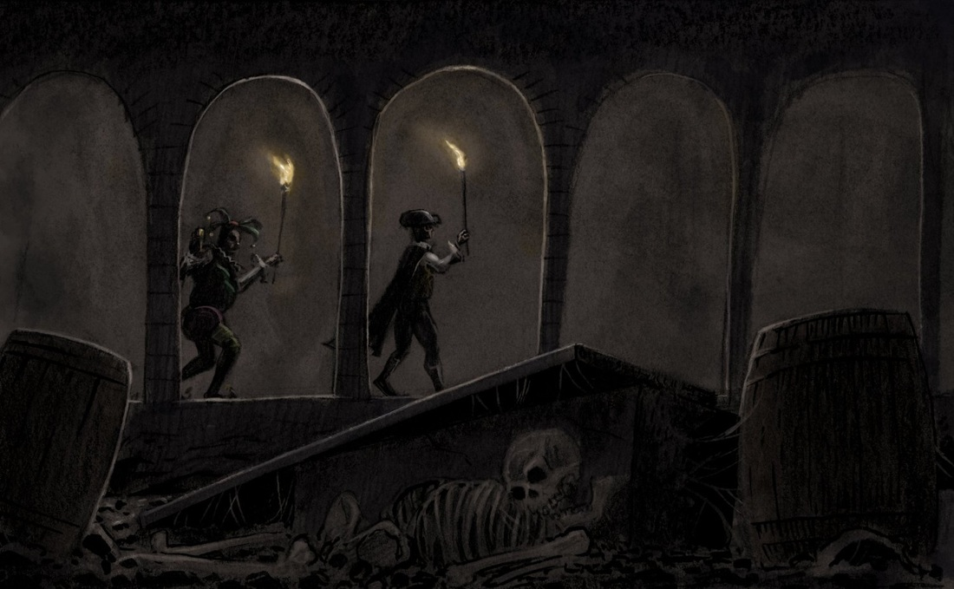

Convert sentences from POEfect to basic.

- The thousand injuries of Fortunato I had borne as I best could, but when he ventured upon insult I vowed revenge.
________________________________________________________________________________________________________________________________________________________________________________________
- It must be understood that neither by word nor deed had I given Fortunato cause to doubt my good will.
____________________________________________________________________________________________________________________________________________________________________________________
- “And yet some fools will have it that his taste is a match for your own.”
____________________________________________________________________________________________________________________________________________________________________________________

- These orders were sufficient, I well knew, to ensure their immediate disappearance, one and all, as soon as my back was turned.
____________________________________________________________________________________________________________________________________________________________________________________

- Its termination the feeble light did not enable us to see.
____________________________________________________________________________________________________________________________________________________________________________________

