Economics 120
S. Hudson
Room 238

Outline:
Economics: is study of how people and society choose, with or without the use of money, to employ scarce productive resources to produce various goods and services, over time, and to distribute them to various people and groups in society.
Units Covered include:
- Comparative Economic Systems • Supply Demand and the Market
- Forms of Business • Labour Unions
- Money and Banking • Public Finance – The Role of Gov.
- Employment/Unemployment • Price Stability
- Economic Growth • International Economics

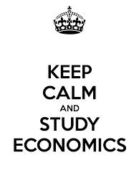
EVALUATION
Unit tests: 25%
Digital Scrapbook/Journal 15%
Class Activities/Assignments 30%
Final Exam 30%
Classroom Expectations:
- Students will do all assigned work to the best of their ability and come for extra help when necessary.
- Students are responsible for being prepared for class, with all materials, and their homework completed.
- Students are responsible for all work assigned, whether or not they were present when the work was given.
- Due dates are to be respected. If there is a problem regarding an assignment being passed in on time, the student is expected to see me before the due date.
- Students are also expected to be polite, respectful and on time.

