How to create your data sheets for Lab 1 (short version – data only)
Step 1:
Enter your data into an Excel spreadsheet (note, these times are made up. Do not copy and paste!):
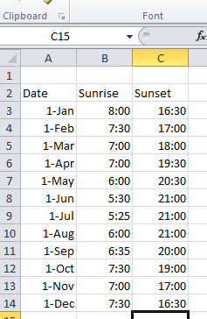
*Note – make sure that your sunset times are written with the 24-hour clock time, or you can enter it as ‘PM’, and it will automatically change for you.
Step 2: find the differences between the times. Use the equation =SUM(C3-B3) to find the answer
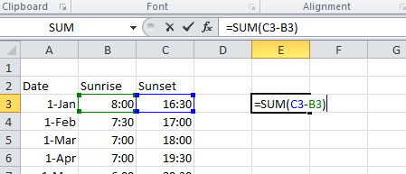
Once you hit the ‘enter’ button, the amount will automatically fill in. Use copy and paste to find the answer for the other sets of data. Then determine which is the shortest ‘day’ and which is the longest (the smallest time would be the shortest, and the largest would be the longest). If you are doing the short lab, you are done!
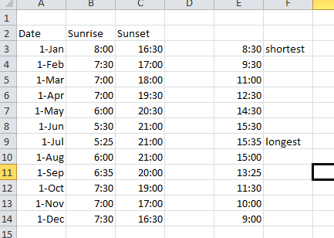

How to create your data sheets for Lab 1 (full version)
Step 1:
Enter your data into an Excel spreadsheet (note, these times are made up. Do not copy and paste!):
*Note – make sure that your sunset times are written with the 24-hour clock time, or you can enter it as ‘PM’, and it will automatically change for you.
Step 2: convert the data that you’ve entered into numbers. First, copy and paste your date into a new column (I used ‘E’). Next, highlight the data, right-click, and select ‘format cells.’
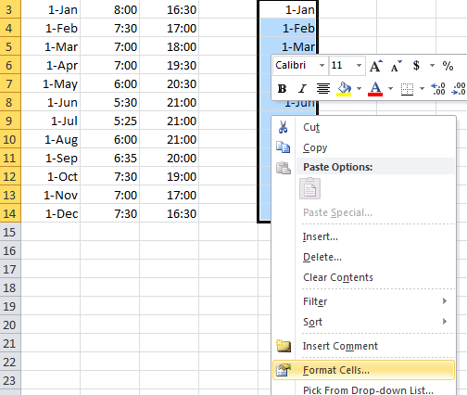
Under ‘category’, select ‘number’ and then click ok. Your dates should change to numbers that look like 42000. You will now do the same thing with your other two columns for sunrise and sunset.
This is what your data should look like:
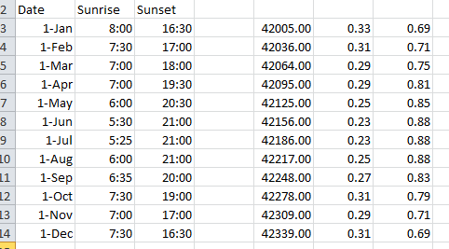
Now, it is time to create your graph. Highlight the your new three columns:
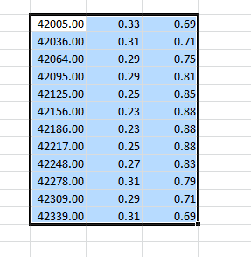
Click ‘insert’, and then select a line graph (I used the one on the left)
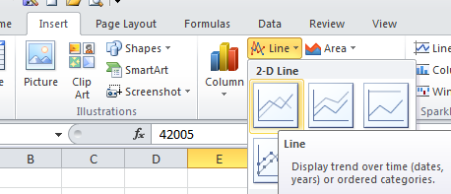
The graph you get will look like this:
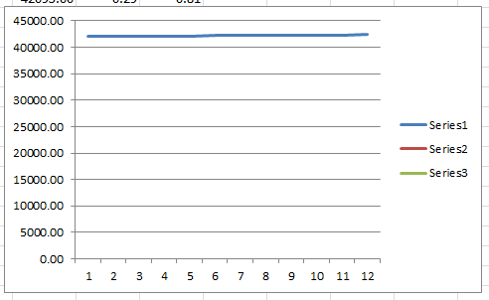
Right-click on the bottom set of numbers, and select ‘format axis.’ Click ‘number’, then ‘date’. You can format it to m/d in the ‘format code’ box:
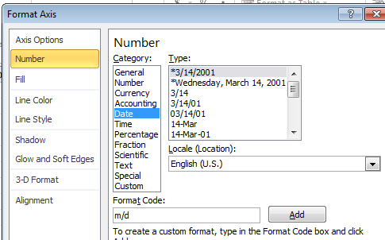
Do the same thing for the vertical axis, but change it to ‘time’ instead of date. You also need to change values under the ‘axis options’ option. Change the minimum to 0, and the maximum to 1:
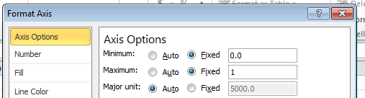
Your graph will now look like this:
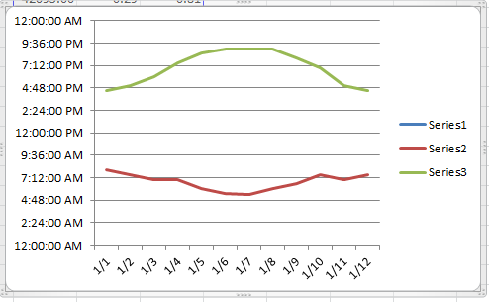
Next, we are going to change the values of the x-axis, and the labels on the lines. Right-click on the legend, and select ‘select data’:
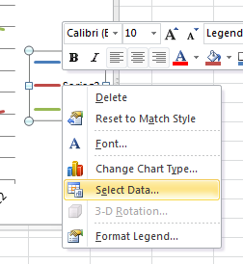
First, we’ll change the x-axis. Under the ‘horizontal axis labels’, click edit:
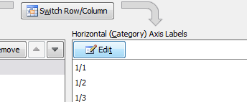
Right click on the first box where the data starts, hold the ‘shift’ button, and press the ‘down’ button, until you have all of the data points selected.
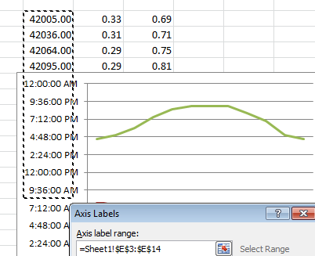
Select ‘ok’. Now to change the labels on the red and green lines. Click on ‘series2’, and then click edit.
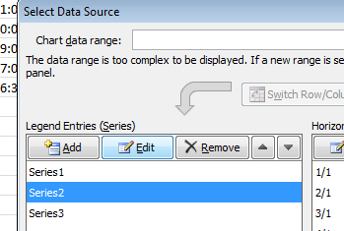
Under ‘series name’, put in ‘Sunrise’. Put in ‘Sunset’ for ‘series3’. Hit ok. Finally, click on ‘series1’, and press the ‘delete’ button to get rid of the label. It should look like this when you’re all done:
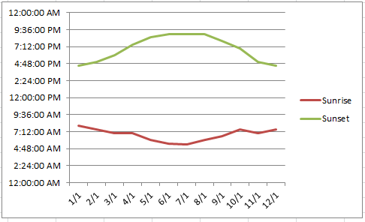
The last thing that you’ll have to do is find your longest day and shortest day. Follow ‘step 2’ on page one of this tutorial to find that.
**For your lab report, copy and paste the both the graph and the table with your original values into your lab report.

