Angles of Elevation and Depression Worksheet
Section 1: Warm up – find the value of x.
a.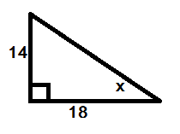b. 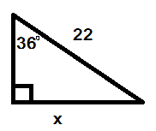c. 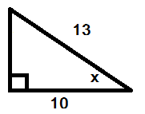
Section 2: Angles of Elevation – The angle of elevation is the angle that is created from the ground up, for example, the angle that a guywire makes with the ground. Find the angle of elevation in the following questions. Draw a picture of each scenario.
d. A store is making a ramp for its customers. The door is 3 ft above the ground. If the ramp is 10 feet long, what is the angle of elevation from the ground?

e. A plane is taking off with an angle of elevation of 45⁰. If it moves 1.2km along the ground, how high up in the air will it be?

Section 3: Angles of Depression – The angle of depression is the angle that is created from a point in the air looking down, like the descent of an airplane. Find the angle of depression for the following questions. Draw a picture of each scenario.
f. You stand on a cliff and see a boat in the water. The angle of depression from you to the boat is 55⁰. If you know that the cliff is 300m high, how far out in the water is the boat?

g. A bungee-jumping platform is secured with wires. The platform is 1500ft in the air. If the wires are 100ft from the base of the platform, what is the angle of depression that the wires make with the platform?

