Customizing the classroom to meet the needs of all learners
Katherine Halas Moulton, August 26-17, 2013
Bring your curriculum documents, a charged laptop, one test from previous years, and one assignment with marking rubric if you have one.
Objective: To have all learners actively explore techniques for differentiation in outcomes, processes, use of resources, and assessment.

1-2pm – Introduction and discussion | Appendix
- 7 ramps of brain-based insights (Katz, 2012)  - School mission statements – BLMS and EWG  - Can all students learn? Do they all want to learn? Is there a need for us to change?  - Creating a non-stigmatizing learning environment through Universal Design for Learning (UDL) and flexible groupings  - Look at Tomlinson’s examples | A, B  C
2-3pm – Differentiating essential outcomes
- Work in subject teams to review the essential outcomes established in district teams in 2008 (handed out as you came in). Develop several essential questions that are linked to the standard. If you have time consider how these essential questions could be developed cross-curricular.  - If you have trouble try “Bump in the road”  - Katz (2012) uses the following questions to choose her outcomes: (1) What is it I want my students to understand, in a deep and profound way? (2) What are the big ideas from this unit that they will carry with them across disciplines and will retain years from now? (3) Why do we bother to teach this? (p. 66)  - Discuss with a peer from another group how your discussion went and any concerns that you may still have.  - Fill out exit-slip | D, E  F  G
Homework
- Do multiple intelligences inventory http://www.bgfl.org/custom/resources_ftp/client_ftp/ks3/ict/multiple_int/
- Jot down notes on a student that you know that you did not reach – list the characteristics, learning needs and strengths

9-10am – Respect for Diversity Program and differentiating the process
- Respect for Diversity program  http://www.threeblockmodel.com/respecting-diversity-program-videos.html  - Work with others who have the same intelligence strength for a new way to present any agreed upon course content as a way of making teaching more accessible to the different intelligences. Be creative – your presentation of this content should reflect your “intelligence,” and engage your audience – participatory fun anyone??  - Present (if you are willing) to the larger group | H
10-11 – Differentiating resources
- Work in groups to find materials that you would actually like to use in your classroom if the technology was available.  - Discuss as a group how to successfully implement the technology in your classroom, and be prepared to share your findings with a jigsaw group.  - Assistive Technology http://atto.buffalo.edu/registered/ATBasics.php , Resource For the Identification and Teaching of Students with Specific Learning Disability: High School Program, New Brunswick page 41  - Search: Your special population + assistive technology/educational software  - To explore another day – http://cast.org/ with http://udlexchange.cast.org/home (UDL lesson sharing website); http://assist-tech.ednet.ns.ca – great NS site for assistive technology; http://k5di.pottsgrove.wikispaces.net/ - excellent sharing site with elementary level materials; http://www.caroltomlinson.com/otherresources.html from the guru of differentiation; and http://differentiationcentral.com/  - Have a snack  - Share with jigsaw group. | I
11-12 – Differentiating products and assessments with higher order thinking for all
- Improve the test example in pairs - “I do, and you watch. Then we all do together. Then you do, and I watch” (Katz, 2012, p. 17)  - Work in subject teams to create a matrix or a tiered, menu or otherwise differentiated product or assessment that meets the needs of various learners. Consider multiple intelligences, Bloom’s Taxonomy, learning styles preferences, and design criteria. Need to consider the big ideas of accessibility for all. Reminder – all activities need to meet the outcomes, be respectful, and promote higher order thinking (remember the Tomlinson example from yesterday)  - Also consider how this assessment will be used to inform teaching and what criteria will be used to assess the work done here – will you write a rubric?  - Would the “Bus Stop” idea be helpful?  - Fill out exit slip | J, K  L  L

Appendix A
Graduation Statistics

The following data is from Winshcool July 2013.

Grade 9 Year | 2004-2005 | 2005-2006 | 2006-2007 | 2007-2008 | 2008-2009 | 2009-2010
Grade 9 enrolment | 111 | 132 | 118 | 123 | 88 | 100
Transfers in minus transfers out | 15-10 = +5 | 10-13=  -3 | 10-12=  -2 | 8-13=  -5 | 16-10=  +6 | 13-8=  +5
Alternate Ed | -4 | -4 | -7 | -1 | -1 | -1
Other | -2 | -3 | -1 | -4 | -2 | -2
Total Potential Graduates | 110 | 122 | 108 | 113 | 91 | 102
Dropouts | 32 | 34 | 16 | 20 | 19 | 18
Number who graduated in 4 years | 70 | 82 | 85 | 85 | 60 | 73
Number who graduated in 5 years | 6 | 5 | 5 | 4 | 8 | 5 (possible)
Number who graduated in 6 or more | 2 | 1 | 2 | 4 | 4 (possible) | 6 (possible)
Graduates | 78/110=  71% | 88/122= 72% | 92/108=  85% | 93/113=  82% | 68/91=75%  72/91=79% (possible) | 73/102=72%  84/102= 82% (possible)

Table 2: Stats Canada Data for 2009-2010 (McMullen & Gilmore, 2010).

 | 18 to 19 years old | 20-24 year olds
Canada
High school graduate | 13.0 | 89.5
Not a high school graduate, attending school | 81.9 | 2.0
Not a high school graduate, not attending school | 5.0 | 8.5
New Brunswick
High school graduate | 77.0 | 90.2
Not a high school graduate, attending school | 14.9 | 1.6
Not a high school graduate, not attending school | 8.1 | 8.2
Appendix B
From Katherine Halas Moulton’s (2013) “Using technology to customizing learning for all students.”
Current Social Context for Diversity
There is an idealized rhetoric in goals and school mission statements to meet the needs of all students that is not a currently a consistent reality. Jody Carr, the New Brunswick Minister of Education said,
To give those skills to our students whether they're gifted, enriched, disabled, First Nations, rather than pick and choose and say one group of students is better than another group of students — let's make sure all students succeed and that's my goal. (CBC, 2013)
Nonetheless, the research contains many examples of how students with disabilities are still not reaching their potential and face social isolation despite attempts at inclusion (Bennett, & Gallagher, 2013; Canadian Council on Learning, 2007; Capuano et al. 2011; Dalton, 2013, Prior, 2011; Olenchak, 2001; Reid, Reid, & Bennett, 2004). Despite successive governments support of inclusion Carr admits that "We have often, in the past, thrown kids together, expected the teacher to make it work … inclusion is not a one size fits all” (CBC, 2013). For example, only 20% of graduates with disabilities find paid employment and the remainder are in unpaid employment or unemployed (Bennett & Gallagher, 2013). Further, the International Adult Literacy Survey found that only 52% of adults with physical disabilities and 23% of those with learning disabilities have the literacy skills needed for daily tasks (Canadian Council on Learning, 2007). Cognitively proficient, but deaf or hard of hearing children also only reach low levels of literacy which limits their employment and social opportunities (Capuano et al., 2011, p. 57). Even beyond identified physical and learning disabilities there is a real danger posed to students’ futures by disengagement as Willms, Friesen, and Milton (2009) state:
Disengagement from school – whether a student leaves or struggles through to graduation – is also a significant source of inequity in Canadian society, not only because it places a large number of students at a disadvantage as they move into adult roles, but because disengagement is disproportionately experienced by students living in poverty, students with disabilities, and students from ethnic minority and Aboriginal communities. (p. 7)

Appendix C
From Carol Ann Tomlinson’s (1999) The Differentiated Classroom: Responding to the Needs All Learners. Alexandria, VA: Association for Supervision and Curriculum Instruction

Middle school Science

In Mr. Cornell’s science class, students work in a specific cycle: read the text chapter, answer questions at the end of the chapter, discuss what they have read, complete a lab, and take a quiz. Students do the labs and complete their reports in groups of four. Sometimes Mr. Cornell assigns students to a lab group as a way of managing behaviour problems. Often, students select their own lab groups. They read the text and answer the questions individually. Mr. Cornell typically conducts two or three whole-class discussions during a chapter. All students enter the science fair in the spring, with a project based on a topic studied in the fall or winter.
Mrs. Santos often assigns students in her science class to reading squads when they work with text materials. At this stage, group assignments usually are made so students of similar reading levels work together. She varies graphic organizers and learning log prompts according to the amount of structure and concreteness the various groups need to grasp essential understandings from the chapter. She also makes it possible for students to read aloud in their groups or to read silently. Then they complete organizers and prompts together. As students read, Mrs. Santos moves among groups. Sometimes she reads key passages to them, sometimes she asks them to read to her, but she always probes for deeper understanding and helps to clarify their thinking.
Sometimes Mrs. Santos asks students to complete labs, watch videos, or work with supplementary materials before they read the chapter so they have a clear sense of guiding principles before they work with the text. Sometimes they read the text for awhile, do a lab, and go back to the text. Sometimes labs and supplementary materials follow text exploration. Frequently, she will have two versions of a lab going simultaneously; one for students who need concrete experiences to understand essential principles and one for students who already grasp the important principles and can deal with them in complex and uncertain contexts.
Mrs. Santos gives quizzes and diagnostic learning log entries several times in the course of a unit. Thus, she is aware of which students need additional instruction with key understandings and skills and which students need more advanced applications early in the unit. Students have several choices for a major science project:
- Work alone or with peers to investigate and address a problem in the community that relates to the science they are studying.
- Work in a mentorship role with a person or group in the community using science to address a local problem.
- Study scientists past and present who have positively influenced the practice of science in an area they have studied.
- Write a science fiction story based on the science they have studied with the goal of submitting the story to the school’s literary arts anthology.
- Use classroom cameras to create a narrated photo essay that would help a younger student understand how some facet of the science they have studied works in the world.
- Propose another option to the teacher and work with her to shape a project that demonstrates understanding and skill in science.
Middle school English
In Mr. O’Reilly’s 8th grade English class, students read the same novels and have whole-class discussions on them. Students complete journal entries on their readings.
In Mrs. Wilkerson’s 8th grade English class, students often read novels around a common theme, such as courage or conflict resolution. Students select from a group of four or five novels on the same concept, and Mrs. Wilkerson provides classroom sets of the books. Mrs. Wilkerson also makes sure the novels span a considerable reading range and tap into several interests.
Mrs. Wilkerson’s 8th graders meet frequently in literature circles with students reading the same novel. There they discuss what they are reading. Although the various literature circles reflect different degrees of reading proficiency, students in each group take turns serving in one of the five leadership roles: discussion director, graphic illustrator, historical investigator, literary luminary, and vocabulary enricher. There are printed guides for each role to help students fulfill them well. Mrs. Wilkerson also varies journal prompts, sometimes assigning different prompts to different students. Often, she encourages students to select a prompt that interests them. There also are many opportunities for whole-class discussion on the theme that all the novels share, allowing all students to contribute to an understanding of how the theme “plays out” in the book they are reading and in life.
High school languages
In Spanish I, Mrs. Horton’s students complete the same language pattern drills, work on the same oral exercises, read the same passages, and take the same quizzes.
In French I, Mr. Adams’s students often work with written drills at differing levels or complexity and with different amounts of teacher support. Their oral exercises focus on the same basic structures, but completion requires different levels of sophistication with the language. Sometimes students can “opt out” of review sessions to create their own French dialogue or to read a French language magazine. Students often work in teacher-assigned, mixed-readiness pairs to prepare for what the teachers calls “fundamentals quizzes.” Students who wish to do so can, from time to time, select a partner to prepare for a “challenge quiz.” Success on a challenge quiz nets students “homework passes” they can use to be excused from homework assignments when their work on the quiz indicates they have mastered the homework material.

High school Math
In Mr. Matheson’s Algebra II class, students typically complete the same homework, work independently on in-class drills, and take the same tests.
In her Algebra II class, Mrs. Wang helps students identify key concepts and skills in a given chapter. After various chapter assessments, students are encouraged to look at their own assessment results and select homework assignments and in-class mini-workshops that will help them clarify areas of confusion. She encourages students to decide whether they work most effectively alone or with a partner and to make that choice when there are opportunities to do so. Toward the end of a chapter, Mrs. Wang also gives students individual “challenge problems,” which they can tackle along or with a classmate. She designs the problems to be a mental reach. On end-of-chapter tests, students find challenge problems similar but not identical the ones Mrs. Wang gave them earlier. There may be five or six different challenge problems distributed among the tests of 30 students.
High school Physical Education
In physical education, Mrs. Bowen’s students usually all work with the same exercises and basketball drills. Mr. Wharton helps his students diagnose their starting points with various exercises and basketball skills, set challenging goals for personal improvement, and chart their personal progress. He particularly stresses growth in two areas; a student’s best and weakest area.
High school History
In U.S. History, Miss Robertson and her students cover the information in the text sequentially. She lectures to supplement information in the text. Miss Roberson includes a special emphasis on women’s history and African American history during the months designated by the school for those emphases.
Mrs. Washington’s U.S. History students look for key concepts and generalizations that recur in each period of history they study. They also look for concepts and generalizations unique to each period. They study various points of view and the experiences shared by various cultural, economic, and gender groups. They use a variety of text, video, and taped materials of varying degrees of difficulty. Mrs. Washington sometimes lectures, but she always uses overhead transparencies that provide key points of her lecture to help visual learners. She also stops throughout the lecture to encourage students to talk about key ideas in the lecture and to ensure their grasp of those ideas. Essays and projects often ask students to take their understanding of a period in U.S. history and contrast it with what was going on in another culture and in another geographical area during the same period. Project assignments always offer several options for how a student can express his or her understanding. At the end of each quarter, students have the option of taking their whole grade from an exam, or they can take half of it from an alternative assessment proposed by the teacher and modified by the student with teacher guidance and approval.

Appendix D
From Diane Heacox’s (2002) Differentiating Instruction in the Regular Classroom: How to Reach and Teach ALL Learners, Grades 3-12. Minneapolis, MN: Free Spirit Press.
Essential Questions and Unit Questions
Subject: _________________________________
Unit/Theme: ________________________________
Abbreviate the essential outcomes from the district document here:

Star the most important concepts (indicate those that address curriculum standards) and add any concepts you feel are missing from the district outcomes.

Essential questions (indicated those that address curriculum standards and after each question, write the number of the related essential question)
1.
2.
3.
4.
Appendix E
Based on ideas from Heacox’s (2002) Differentiating instruction in the regular classroom: How to reach and teach ALL learners, Grade 3-12; Katz’s (2012) Teaching to diversity: The three-block model of Universal Design for Learning; Larmer and Ravitz’s (2003) Project Based Learning: A guide to standards-focused Project Based Learning for middle and high school teachers; National Center on Educational Outcomes Considerations for the Development and Review of Universally Designed Assessments; and New Technology Foundation Project Development Rubric.
Essential Outcomes
 | Unsatisfactory | Proficient | Advanced
Outcomes | Outcomes do not seem to be tied to any specific content area standards or are not rigorous enough to challenge the students | The outcomes reflect essential, authentic, and life-long learning that are accessible to all students | In addition to the “proficient” criteria, the goals are clearly defined and successful integrate content standards from multiple subject areas.
Essential questions | Questions are not:  - Open-ended  - Challenging  - Real-world  - Consistent with the essential outcomes | Questions are:  - Open-ended  - Challenging  - Real-world  - Consistent with the essential outcomes | In addition to the “proficient” criteria, the questions are provocative and go to the heart of the discipline

Process/Presentation
 | Unsatisfactory | Proficient | Advanced
Planning for presentation | The presentation may be a good idea, but little thought has been put into how to implement the idea in the classroom | Method of presenting material reflects MI and effectively convey intended content | Ideas for presenting materials is engaging, and compels active participation
Presentation | The presentation is very passive. The audience is not engaged. | The presentation holds the attention of the audience | Presentation is dynamic and engaging

Resources
 | Unsatisfactory | Proficient | Advanced
Selection of resources | The choice of resources is not appropriate to the reality of the classroom and little consideration is given to successful implementation. | The resources address specific needs in the classroom and careful consideration is given to successfully implementing these resources | In addition to the “proficient” criteria, specific consideration is given to acquisition of resources, professional development needs, and social inclusion.
Sharing of resources | Presenter is unenthusiastic, unorganized and not able to share effective resources or explain how to implement them in the classroom. | A clear explanation is given about how to implement technology in the classroom to assist students with specific needs. | In addition to the explanation the speaker is enthusiastic, thoughtful, and engages the group in discussion of the possibilities of specific software

Assessment
 | Unsatisfactory | Proficient | Advanced
Rubrics | Rubrics are not developed, or don’t seem to be tied to the essential outcomes | The rubric is designed to clearly lay out the expectations of the final product  Rubrics are easy for students to use in self- and peer-assessment activities | Several rubrics are used to evaluate multiple individual, and group products based on the essential outcomes  Assessment includes input from outside sources.
End product | - End product does not demonstrate understanding and application of content standards  - End product is not authentic  - End product is not age level appropriate | - End product clearly demonstrates understanding and application of content standards.  - End product is authentic and reflects real world work  - End product is tailored to age and skill level of students | - End product is composed of multiple opportunities for students to demonstrate their learning  - End product will be used after the completion of the project  - End product incorporates the use of a variety of media, and intelligences
Test | The test does not:  - Measure what it is supposed to measure  - Respect the diversity of the assessment population  - Have clear format for text  - Have clear pictures and graphics  - Have concise, age-appropriate, and readable text  - Allow for format change (Braille, text-to-speech)  - Have an overall appearance that is clean and organized | The test does:  - Measure what it is supposed to measure  - Respect the diversity of the assessment population  - Have clear format for text  - Have clear pictures and graphics  - Have concise, age-appropriate, and readable text  - Allow for format change (Braille, text-to-speech)  - Have an overall appearance that is clean and organized | In addition to the “proficient” criteria  - the test allows multiple approaches for answering questions  - students may be involved in the test creation
Matrix | The matrix is not sufficiently developed to be of use for differentiating activities in the classroom. Activities do not meet the criteria of Bloom’s Taxonomy and Gardner’s MI. | The matrix contains many “keeper” activities that use a wide variety of strategies for both Bloom’s and MI. | In addition to the “proficient” criteria, the activities chosen are:  - engaging and creative  - consider even more needs like flexible groupings, and learning preferences

Peer Collaboration and Teamwork Rubric
 | Unsatisfactory | Proficient | Advanced
Leadership and initiative | Group members played a passive role, generating few new ideas; tended to do only what they were told to do by others, or did not seek help when it was needed. | Group members played an active role in generating new ideas, took initiative in getting tasks organized and completed, and sought help when needed. | In addition to the “proficient” qualities, the group member provided leadership to the group by thoughtfully organizing and dividing the work, checking on progress, or providing focus and direction for the project.
Facilitation and support | Group member seemed unable or unwilling to help others, made non-constructive criticisms towards the project or other group members or distracted other members | Group member demonstrated willingness to help other group members when asked, actively listened to the ideas of others, and helped create a positive work environment | In addition to the “proficient” qualities, the group member would actively check with others to understand how each member was progressing and how he or she may be of help.
Contributions and work ethic | Group member was often off task, did not complete assignments or duties, or had attendance problems that significantly impeded progress on project. May have worked hard but on relatively unimportant parts of the project. | Group member was prepared to work each day, met the due dates by completing assignments/duties, and worked hard on the project most of the time. If absent, other group members knew the reason and progress was not significantly impeded. | In addition to the “proficient” qualities, the group member made up for work left undone by other group members, demonstrated willingness to spend significant time outside of class/school to complete the project.

Appendix F
From Carolyn Chapman and Rita King’s (2005) Differentiated Strategies: One Tool Doesn’t Fit All/ Thousand Oaks, CA: Corwin Press.

Bump in the Road
The student writes a problem he or she has with the learning at the top of a piece of paper and passes it to three to five classmates to obtain their suggestions. Each person initals his or her suggestions.
Appendix G
Exit slip #1
 | Unsatisfactory | Acceptable | Proficient
Presentation  Content | Content was repetitious, boring, and not useful for my teaching situation | Content met my expectations, and will be applicable in the classroom. | The content was engaging, well prepared, and very useful for my teaching situation
Resources | The resources were not helpful for creating a differentiated classroom. | The resources provided will be useful in differentiating my classroom. | The resources are well chosen to reinforce the concepts of the workshop and will prove invaluable for implementation.
Delivery | Presenter was not animated, did not speak clearly, and did not attempt to engage the audience. | Presenter was animated, well-informed, articulate, and successfully engaged the audience in the presentation. | In addition to the “proficient” criteria, the presenter was dynamic and enthusiastic which was well received by the audience
Comments:
Exit slip #2
Based on Puget Sound Centre for Teaching Learning and Technology
One idea rolling around in my head…

One idea that really squared with me…

Three key points that I will take action on…

Modified from Clear Lake, Iowa’s Professional Development Wikispace http://clearlakeiowa.wikispaces.com/file/view/Admit-Exit+Examples.pdf
Admit slip examples (subject specific) | Exit slip examples (general prompts)
Social Studies  - How would Canada have been different if the French had won the war on the Plains’ of Abraham?  - If you were alive and of age during World War I would you have voluntarily gone to war?  - Were the Americans justified in the use of atomic bombs in WWII? Do Canadians carry equal responsibility for the use of the bomb since they supported the Americans in the construction?  - Name three qualities of a good political leader and explain why they matter. | - What did you learn today?  - How is this unit going for you?  - What was the most difficult or confusing idea we learned today – and why?  - What were the three most important ideas we learned today – and why?  - Pick one quote from today’s class discussion or reading and comment on it.  - What are some questions you have about today’s lesson? Where do you think you can get the answers to those questions?  - Predict what we will need to learn next in this unit and why. (Not just from the textbook contents page, please.)  - What would you like me to review in class tomorrow and why?  - If you were going to teach this to someone else, what would be in your notes? Show me!  - If you were going to make up an essay test question based on today’s class, what would it be (and what would a good answer look like)?  - What do you need to concentrate on to finish this unit successfully? What goals can you set for yourself?  - What would be some good review questions about this material?  - What can I do to help you learn better in this class? Please be specific.  - Summarize today’s lesson in twenty‐five carefully chosen words. Try to get everything in.  - Create a problem based on today's lesson that could be used on a test. Completely work the problem.  - Discuss how today's lesson could be used in the real world.  - Rate your understanding of today's topic on a scale of 1‐10. What can you do to improve your understanding?  - During today’s lesson, I did not understand…  - Name one positive and one negative thing that happened during group work today.
English
- What do you think this character would do if x happened? Why?
- If you could submit one question to the author what would you ask?
- After reading the poem ___ aloud a few times, comment on the poem’s rhyme and rhyme pattern.
- After reading the scoring guide for information pieces, what elements will you need to work on to perform well next week?
Math
- How could this formula be applied in a real‐life situation?
- Find some examples of math or numerical evidence been used in the media and explain.
- Pick one problem on page x and write down in words the steps you’d take to solve it.
- Make up a problem like the ones we have been doing and bring it to class.
- How can you tell whether two sets of data vary directly? How can you tell if a line is the graph a direct variation?
- Which is greater, the sum of ‐219 and 327 or the sum of 219 and ‐327? Explain.
- What do you know about adding and subtracting terms?
- What do you think is true about the rate of change for a horizontal line? Explain.
- Every day a radio station broadcasts a “Question of the Day” concerning the local public school system to which listeners can call in their YES or NO votes. Will the results provide a true representation of the public's opinion? Explain.

Science
- Make a drawing of a plant in or near your house and explain how its structures are similar to some in the textbook.
- Explain the advantages and disadvantages of indicators versus meters.
- On page x, the textbook says that global warming may be caused by human activity or may be part of a natural, random cycle of variations. Which theory do you believe and why?
- Some of the chemical reactions we have been studying also happen in your home every day. Name two and explain.
- Using the genetics we have learned, comment upon the patterns of eye color in your own family tree, as much as you can.

Music
- Explain the difference between jazz and rock.
- What did you notice in yesterday’s practice that we/you needed to improve upon?
Admit Slips Examples (general prompts)
- Write one (or more) things that you already know about____ . (Useful to begin a unit or lesson)
- Write one question that you still have about the activity that we did yesterday.
- Write an explanation of the process you used to solve one problem you did for homework last night.
- What did you learn from yesterday's activity?
- Describe your favorite activity and why it was your favorite activity.

Appendix H
From Jennifer Katz’s (2012). Teaching to diversity: The three-block model of Universal Design for Learning. Winnipeg: Portage and Main Press.
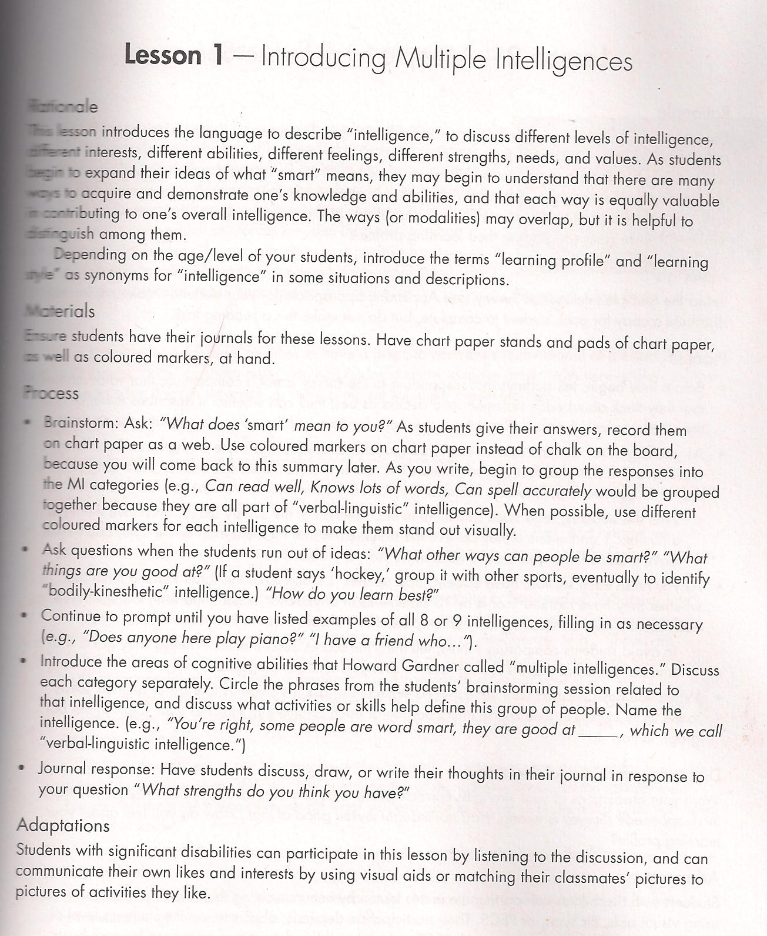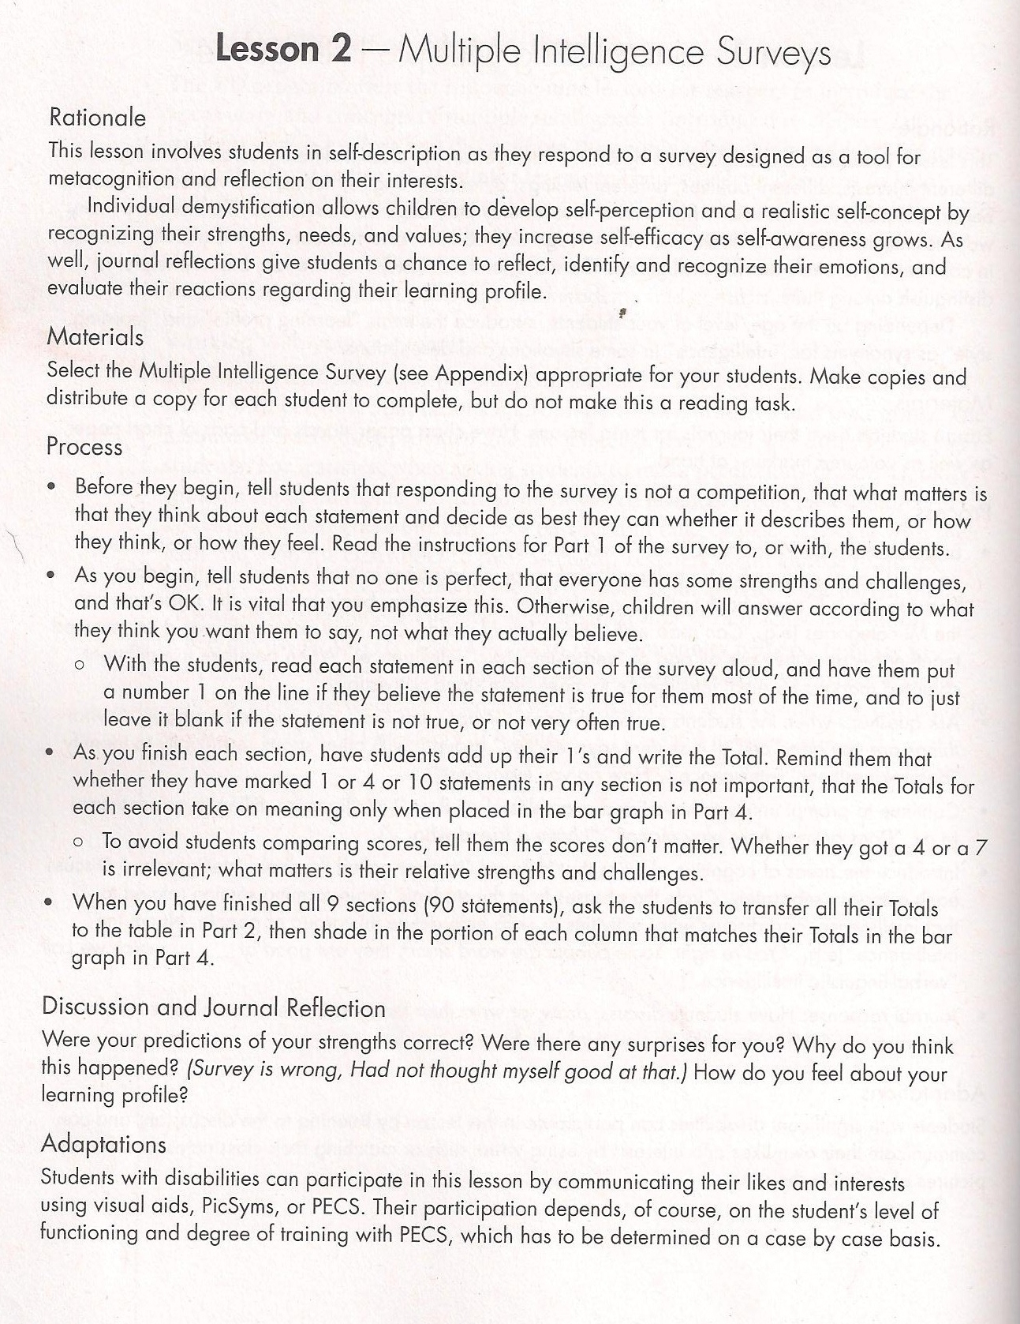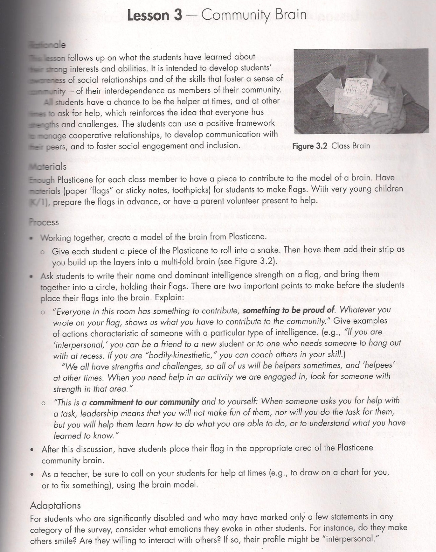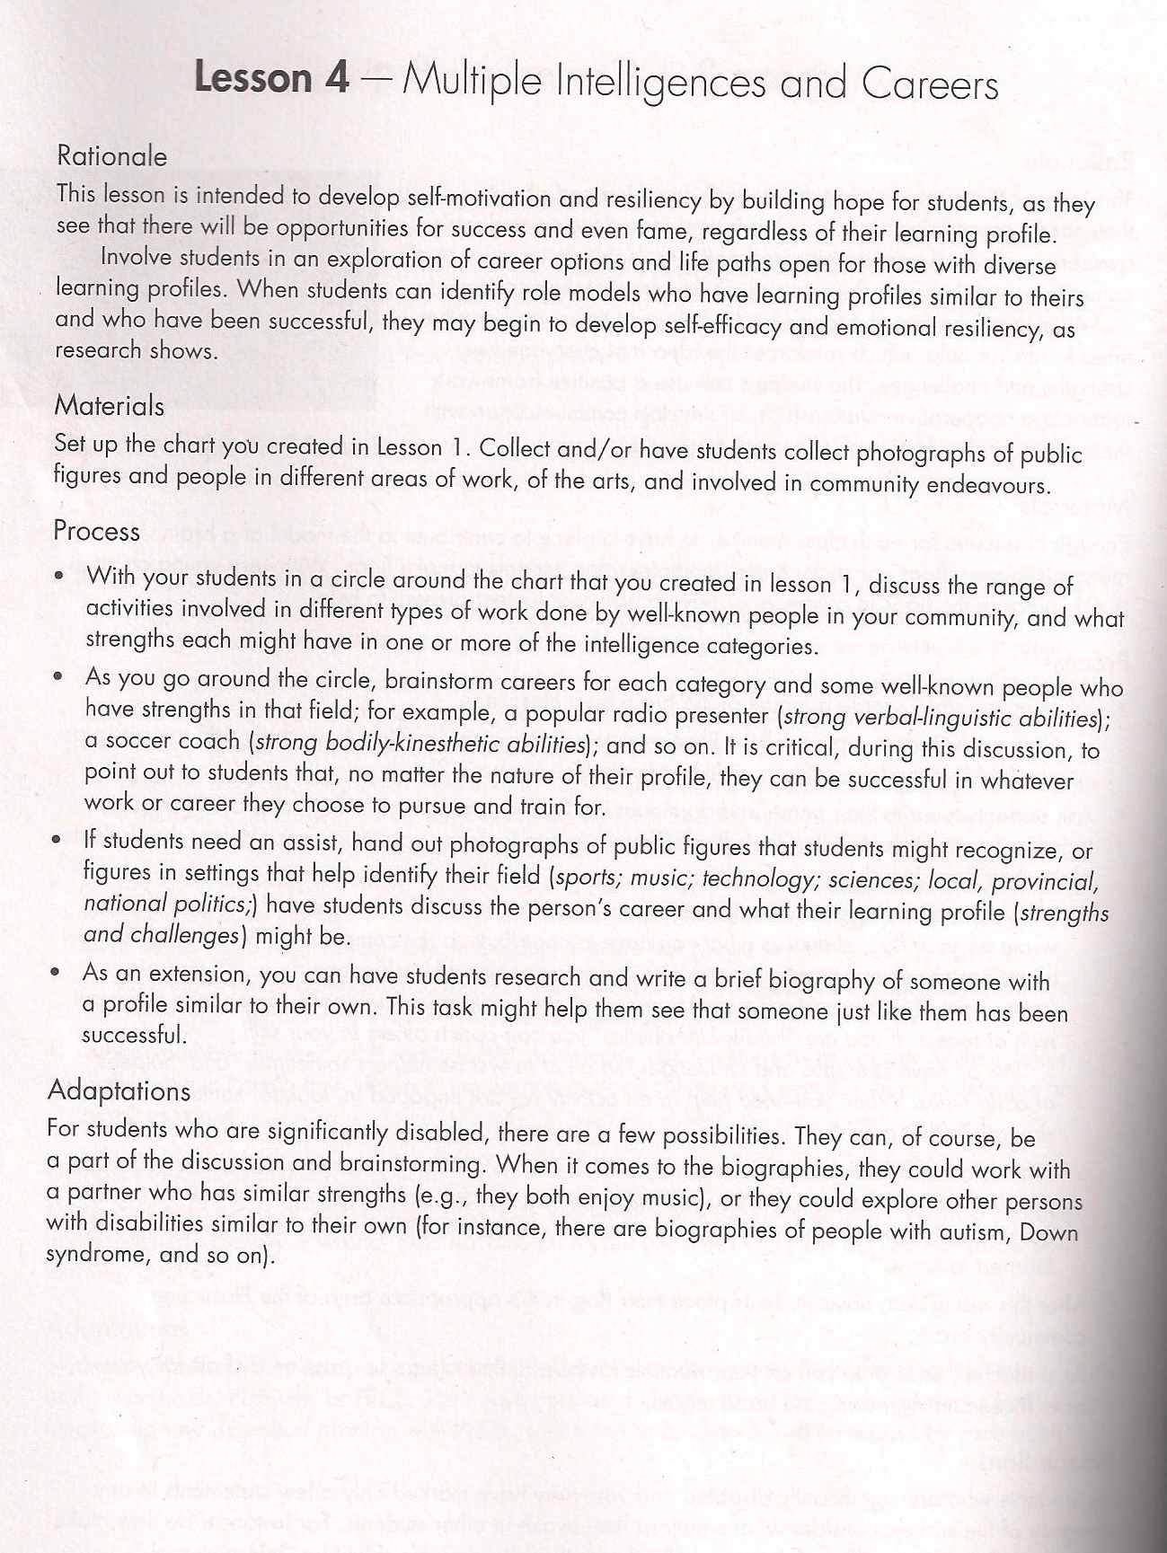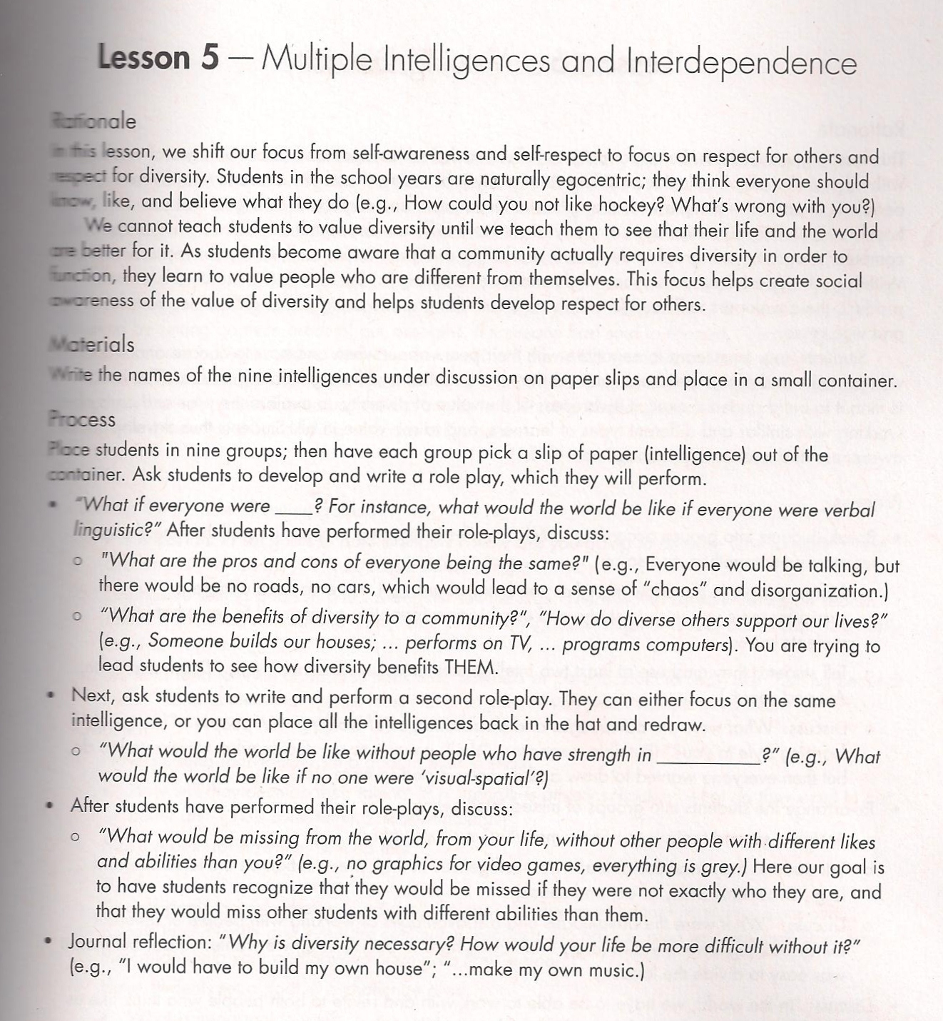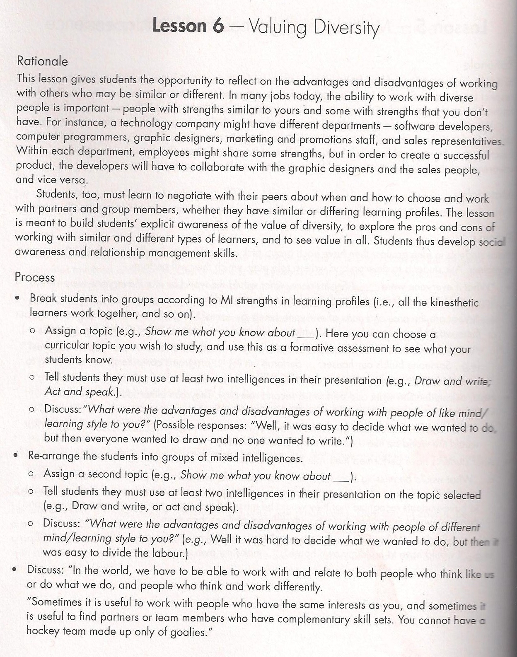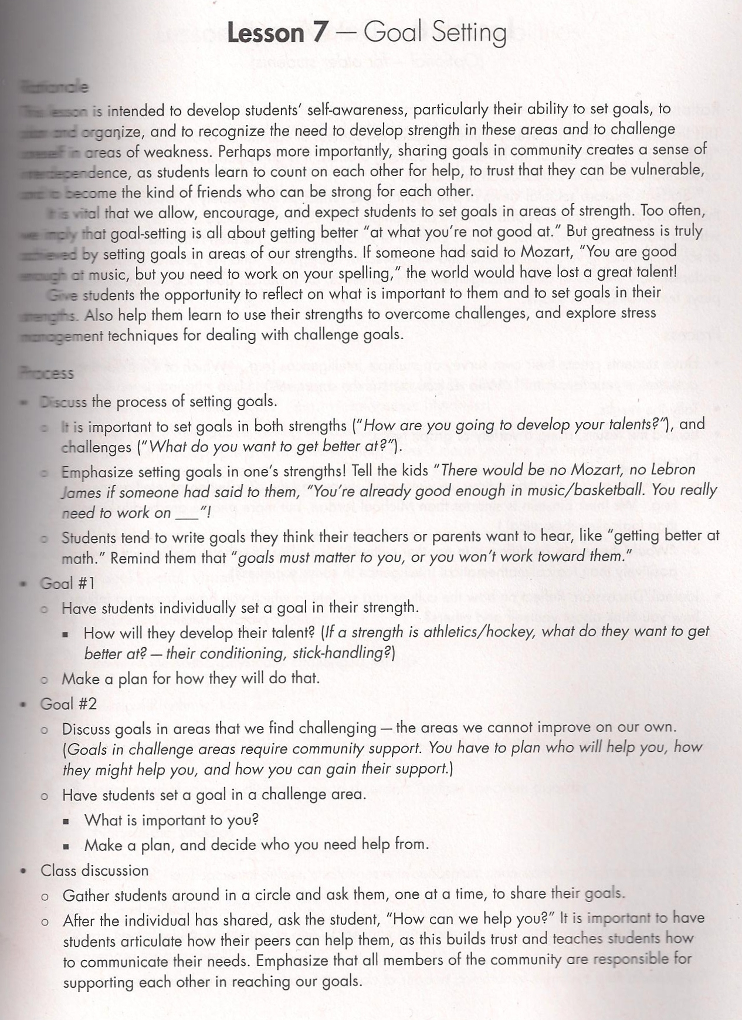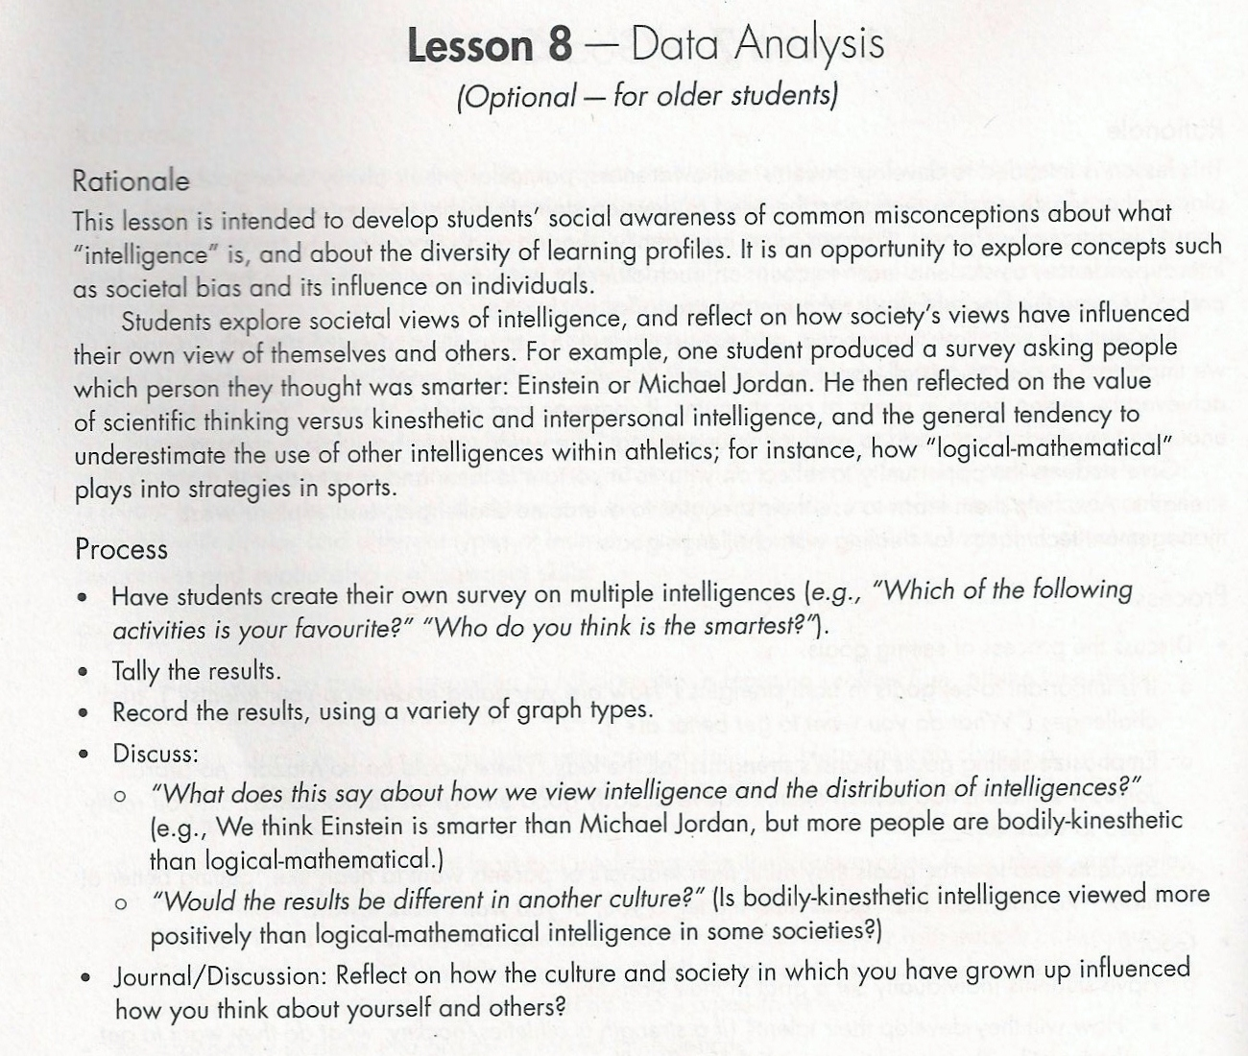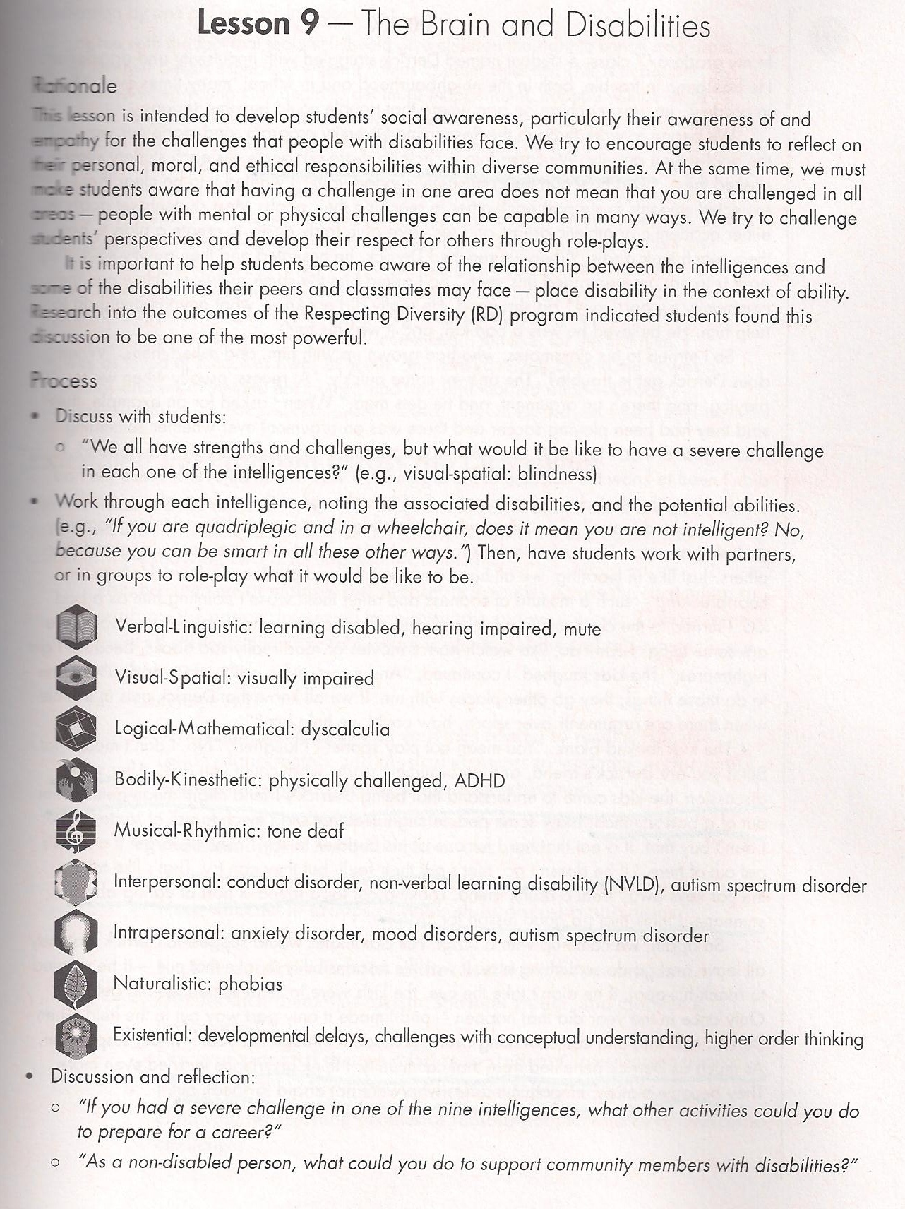

Appendix I
This is a list of available assistive technologies complied by S. M. Bruyère (2002) from her article “Assistive Technology, Accommodations, and the Americans with Disabilities Act” retrieved from http://www.ilr.cornell.edu/extension/files/download/Assistive_Tech.pdf.
Assistive Technology Hierarchy
The following steps can serve as a guide to providing AT accommodations. The steps range from the simplest intervention to the most complex intervention:

- Use no technology - Find an alternative way to do the task. Modify or adapt the task when possible (restructure tasks, activities, and the environment to compensate for functional limitations, including architectural modifications, attendant care arrangements, etc.)
- Use commercially available devices, equipment, aids.
- Use commonly available devices and equipment in creative ways, such as using a wireless doorbell indoors to signal.
- Modify existing commercial devices, equipment, and aids using easily obtainable materials such as Velcro or duct tape.
- Design and fabricate custom devices, equipment, and aids.
What Are Some Typical Accommodations Using AT?
A few examples of the types of AT devices and services that provide reasonable accommodations for various types of disabilities are provided below.

Blindness or Low Vision
- Optical character recognition system (also known as a
- scanner with speech output)
- Text-based web browser with screen reading software or
- Braille output
- Accessible company websites
- Large-print materials
- Audiotapes
- Qualified reader
- Brailler
- Computer with voice output
- Electronic note taker
- Screen magnification product
- CCTV (Closed Circuit Television system)
- Optical magnifier
- Large-print label
- Raised lettering on room labels

Hearing Loss or Deafness
- Certified sign language interpreter
- TTY (Teletype telephone)
- Visual or tactile pagers for communication, instructions,
- and as an alerting system
- Telephones with amplification devices and visual and auditory alerting systems
- Fire alarms with visual and auditory alerting systems
- Assistive listening devices (e.g., FM, infrared, loop
- systems, and/or closed-captioning decoders)
- Captioned video training materials
- Real-time captioning for conferences and audio streaming
- of web teleconferences

Mobility Impairments (Multiple Sclerosis [MS], Paraplegia, Quadriplegia, Post polio, Carpal Tunnel Syndrome, Repetitive Stress Injuries, etc.)
- Trackball for easier mouse manipulation
- Touch screens
- Ergonomic keyboard
- Adjustable keyboard tray
- Portable cart
- Writing and grip aids
- Page turners and book holders
- Stand/lean stools
- Adjustable height desks and work tables
- Speech amplification systems

Cognitive and Developmental Disabilities (Mental retardation, autism, cerebral palsy, neurological conditions, etc.)

- Telephone auto-dialer
- Larger buttons on equipment
- Memory aids (electronic notebook, pop-up timer on computer)
- Communication device
- Voice output with optical character recognition to read documents or use a reading pen
- Learning Disabilities or Attention Deficit Disorders
- Reading template
- Automatic line guide
- Tape recorder
- Computer with voice output
- Floor fan or nature tape played on a stereo for white noise
- Coloured labelling

Psychiatric Disabilities

- Room partitions or enclosed office space to reduce noise and distractions
- Video or audio conferencing meetings
Appendix J
Considerations for the Development and Review of Universally Designed Assessments. NCEO Technical Report 42. Published by the National Center on Educational Outcomes
Table 1: Considerations for Universally Designed Assessment Items
Does the item…
Measure what it intends to measure
• Reflect the intended content standards (reviewers have information about the content being measured)
• Minimize skills required beyond those being measured
Respect the diversity of the assessment population
• Accessible to test takers (consider gender, age, ethnicity, socio-economic level)
• Avoid content that might unfairly advantage or disadvantage any student subgroup
Have clear format for text
• Standard typeface
• Twelve (12) point minimum for all print, including captions, footnotes, and graphs (type size appropriate for age group)
• Wide spacing between letters, words, and lines
• High contrast between color of text and background
• Sufficient blank space (leading) between lines of text
• Staggered right margins (no right justification)
Have clear pictures and graphics (when essential to item)
• Pictures are needed to respond to item
• Pictures with clearly defined features
• Dark lines (minimum use of gray scale and shading)
• Sufficient contrast between colors
• Color is not relied on to convey important information or distinctions
• Pictures and graphs are labeled
Have concise and readable text
• Commonly used words
• Vocabulary appropriate for grade level
• Minimum use of unnecessary words
• Idioms avoided unless idiomatic speech is being measured
• Technical terms and abbreviations avoided (or defined) if not related to the content being measured
• Sentence complexity is appropriate for grade level
• Question to be answered is clearly identifiable

Allow changes to its format without changing its meaning or difficulty (including visual or memory load)
• Allows for the use of Braille or other tactile format
• Allows for signing to a student
• Allows for the use of oral presentation to a student
• Allows for the use of assistive technology
• Allows for translation into another language
Does the test…
Have an overall appearance that is clean and organized
• All images, pictures, and text provide information necessary to respond to the item
• Information is organized in a manner consistent with an academic English framework with a left-right, top-bottom flow

Appendix K
Example test
Experiments - Controls and Variables
- A factor in an experiment that can change is _____
- observation
- variable
- control
- hypothesis

- This is used in an experiment to show that the result of an experiment are actually a result of the condition being tested:

- independent variable
- control
- hypothesis
- dependent variable

- Why do experiments usually test only one variable at a time?
- How does an experimental group differ from a control group?
- SpongeBob noticed that his favorite pants were not as clean as they used to be. Sandy told him to try using a new brand of laundry detergent called Clean-O. SpongeBob washed one pair of pants in plain water and another pair in water with the Clean-O detergent. After washing both pairs a total of three times, the pants washed in the Clean-O did not appear to be any cleaner than the pants washed in plain water.

- What was the problem SpongeBob wanted to investigate?
- What is the independent variable?
- What is the dependent variable?
- What should SpongeBob’s conclusion be?

Appendix L
From http://differentiationcentral.com/examples/DifferentiationCentralLessonTemplate.pdf
Unit Titles: Lesson Titles:
Curriculum Area(s): |  | Author:
Grade Level: |  | Author Contact:
Time Required: |  | Instructional Groupings:  Are you suing whole group, small group, partners, quads, homogeneous, heterogeneous?
Standards: List the curriculum standards that you are using in this unit/lesson.

Materials:

Overview: What is the purpose of the lesson

What will I differentiate? Content Process Product
How will I differentiate? For readiness interest learning profile
affect/learning environment combination
As a result of this lesson/unit students will…
Understand (big ideas, principles, generalizations, rules, the “point” of the discipline or topic within the discipline)

Know (facts, vocabulary, how-to’s, information that is memorisable) | Do (Skills) (thinking skills, skills of the discipline – skills you will assess)
Pre-Assessment (How will you find out about where your students are at for this lesson? What will your pre-assessment look like?)
Steps in the Lesson: Include ideas for whole-class instructions, if any; differentiated activities; sharing, etc.
Closure Activity/Wrap up: This may be in the form of independent practice, a chance to share, or explicit restatement of the goals of the lesson.
Post-Assessment: How will you use this data to inform your next learning experience?
Additional Resources: Any websites or materials that you used?

From “The Art of Differentiation and Enrichment” leadership workshop by L. Orser, A. Howe and C. Loggie. March, 2013.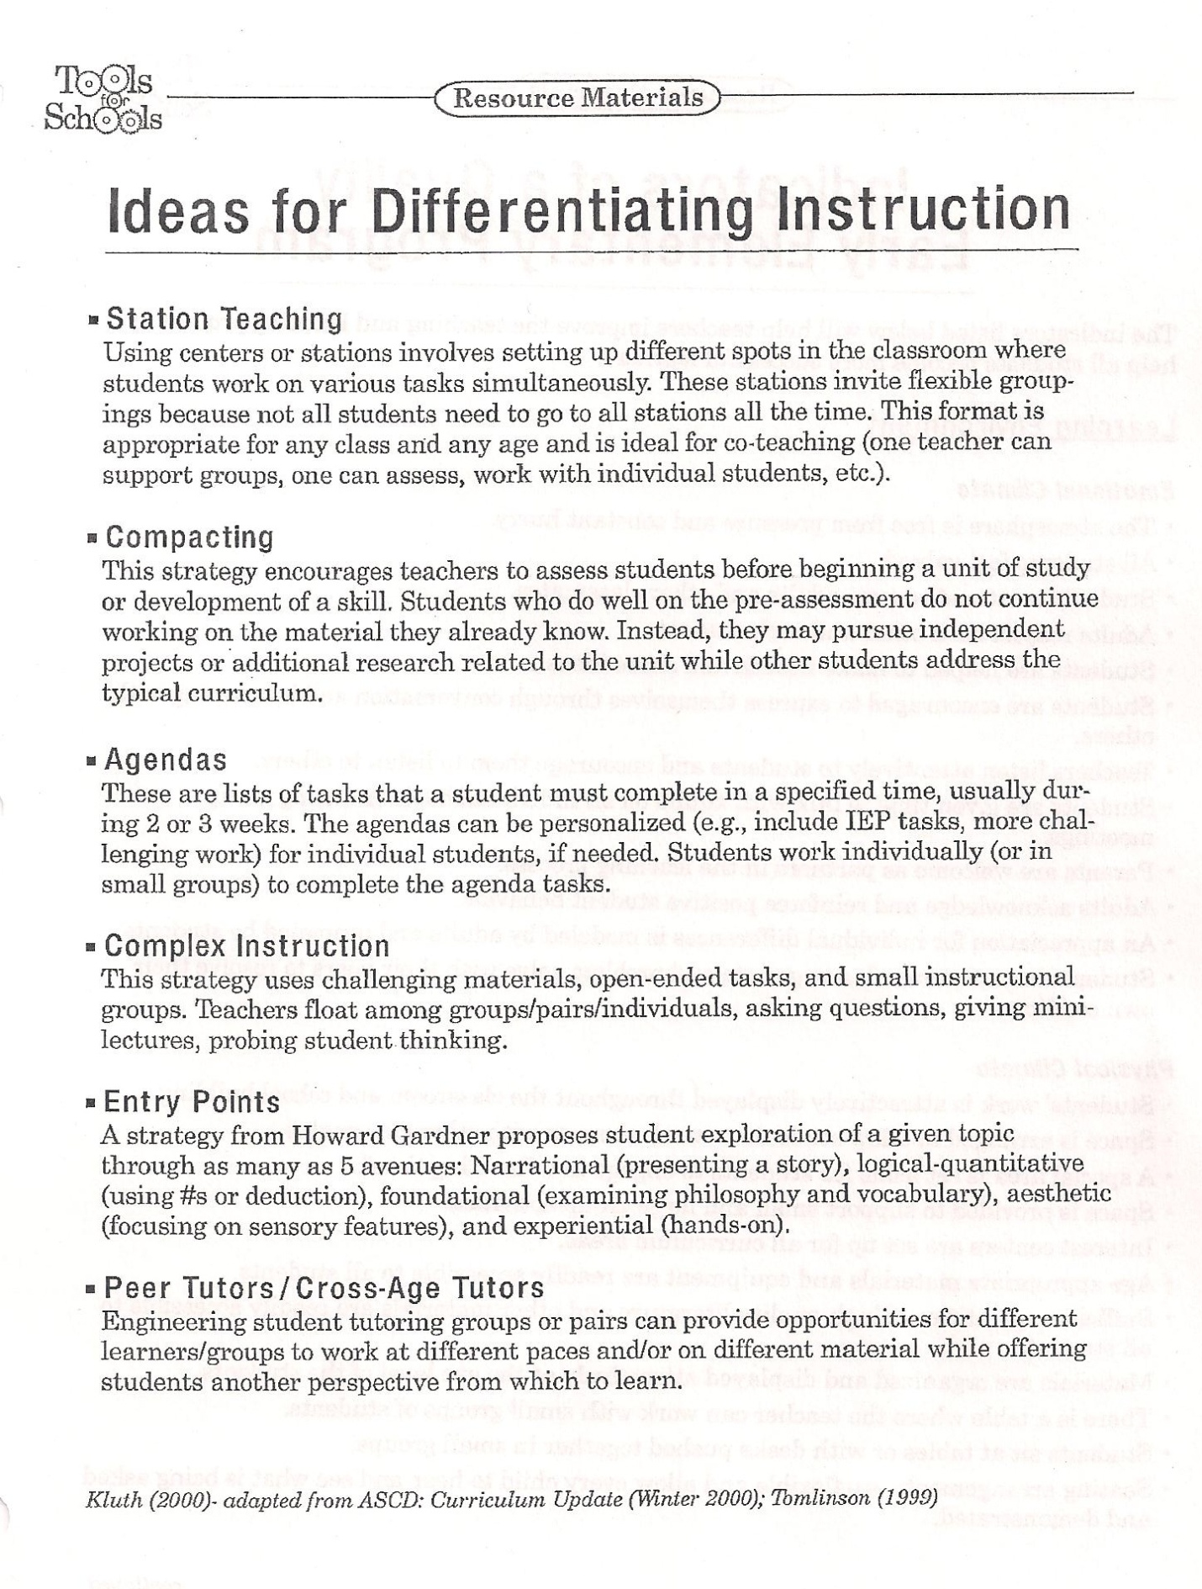
From Jennifer Katz’s (2012). Teaching to diversity: The three-block model of Universal Design for Learning. Winnipeg: Portage and Main Press.

Cognitive Domains | Examples of key words describing capability
Creating  Can the student create a new product or point of view? | Assemble, construct, create, desgin, formulate, write
Evaluating  Can the student justify a stand or decision? | Appraise, argue, defend, judge, select, support, value, evaluate
Analyzing  Can the student distinguish between the different parts? | Appraise, compare, contrast, criticize, differentiate, discriminate, distinguish, examine, experiment, question, test
Applying  Can the student use the informatin in a new way? | Choose, demonstrate, dramatize, employ, illustrate, interpret, operate, schedule, sketch, use, write
Understanding  Can the student explain ideas or concepts | Classigy, describe, discuss, explain, identify, locate, recognize, report, select, translate, paraphrase
Remembering  Can the student recall or remember information | Define, duplicate, list, memorize, recall, repeat, reproduce, state
Adapted from Bloom’s Taxonomy of Educational Objectives, Cognitive Domaines, revised by Anderson and Krathwohl, 2001

From “The Art of Differentiation and Enrichment” leadership workshop by L. Orser, A. Howe and C. Loggie. March, 2013. 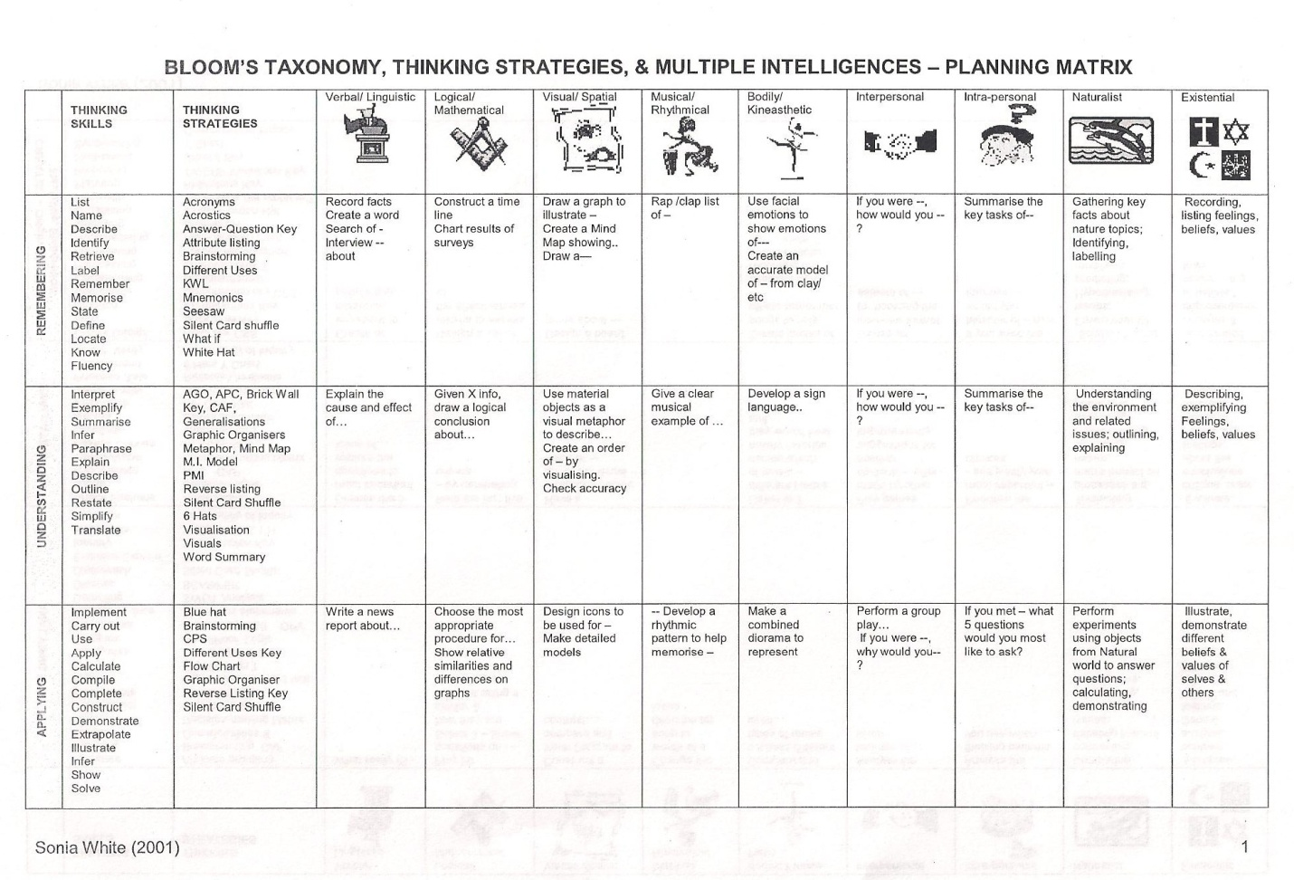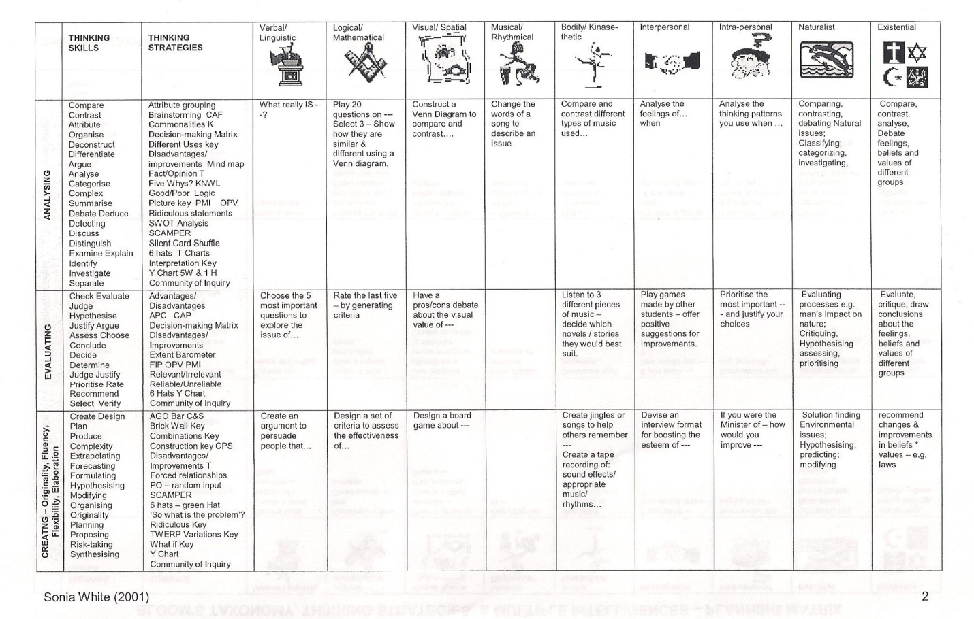
From Diane Heacox’s Differentiating Instruction in the Regular Classroom: How to Reach and Teach ALL Learners, Grades 3-12. Minneapolis, MN: Free Spirit Press, 2002.
Integration Matrix Unit/Theme: Twentieth-century American novel
Unit Questions: How does a novel reflect its times and the novelist’s personal history? How are characters developed in a novel? How are symbols used to convey meaning in a novel?
Bloom’s Taxonomy | Knowledge | Comprehension | Application | Analysis | Evaluation | Synthesis
Gardner’s Multiple Intelligences | tell, list, define, label recite, memorize, repeat, find, name, record, fill in, recall, relate | locate, explain, summarize, identify, describe, report, discuss, review, paraphrase, restate, retell, show, outline, rewrite | demonstrate, construct, record, use, diagram, revise, reformat, illustrate, interpret, dramatize, practice, organize, translate, manipulate, convert, adapt, research, calculate, operate, model, order, display, implement, sequence, integrate, incorporate | compare, contrast, classify, critique, categorize, solve, deduce, examine, differentiate, appraise, distinguish, experiment, question, investigate, categorize, infer | Judge, predict, verify, assess, justify, rate, prioritize, determine, select, decide, value, close, forecast, estimate | compose, hypothesize, design, formulate, create, invent, develop, refine, produce, transform
Verbal/Linguistic  Poetry, debate, story-telling, essay, checklist, journal | As you read your novel, records at least five phrases, word choices, sections of dialogue, or descriptions that you found interesting. Share your selections and reasons for selecting each with a partner reading the same novel. (1) | Identify the historical context of your novel. What was taking place socially, economically, and politically at the time of its publication? Write an information brief as if you were a journalist of the time. (5a) | Research the life of your author, including background, upbringing, life experiences, and personality. Write a short descriptive piece that could serve as an introduction to a review of your novel. (4a) | Select one main character to analyze in a character journal. For each chapter: 1. List 2-3 key quotations from or about the character. 2. Examine the character’s actions, behaviour, and reactions. 3. Select one word that best represents the character. (7)
Visual/Spatial  Drawing, model, poster, photograph, storyboard, illustration, board game |  | Describe your novel’s characters and their relationships to each other by creating a relationship map. (2) |  |  | Develop a visual or musical representation of your main character. Include physical characteristics, personal attributes, and change and/or growth as represented in the novel. (8) | Assess the use of symbols in your novel, looking at characters, dialogue, actions and interactions, and physical objects. On an illustrated poster, show each symbol and give your interpretation of its meaning. (11)
Logical/Mathematical  Diagram, outline, timeline, chart, critique, graph |  | Summarize the plot of your book by constructing a timeline of events, chapter by chapter. (3) |  | Diagram how your novel represents its social, economic, and political times. Include as appro-priate, characters, setting, plot, points of view. (5b) |  | Determine how your author’s life or experiences may have influenced or been represented in the novel. Chart any similarities. (4b)
Naturalist  Classification, collection, solution to problem, display, observation, forecast, investigation, simulation, exhibit, identification |  |  |  | If your main character lived today, what kinds of things would you find in his/her backpack, briefcase, duffel bag, or purse? Collect and organize items to display to the class. Be ready to defend your selections with evidence from the novel.(9)
Musical  Song, rap, lyrics, composition, jingle/slogan, melody |  |  |  |  | Develop a visual or musical representation of your main character. Include physical characteristics, personal attributes, and change and/or growth as represented in the novel.(8)
Bodily/Kinaesthetic  Role play, skit, pantomime, dance, invention, lab, improvisation, prototype |  |  |  |  | Taking the role of your novel’s narrator, dramatize a scene or an action sequence. Audiotape or videotape your dramatization. (6)
Intrapersonal  Journal, log, goal, statement, belief, statement, self-assessment, editorial |  |  |  | Is there a message, lesson, or reflection in your novel that is applicable to your life or circumstances? In your journal, write about what you’ve learned through reading and reflecting on this novel. (10)
Interpersonal  Discussion, roundtable, service learning, conversation, group activity, position statement, interview |  |  |  | With students who read other novels, discuss similarities and differences in novels and in authors’ lives. (4c)

Integration Matrix Unit/Theme: Twentieth-century American novel
Unit Questions: How does a novel reflect its times and the novelist’s personal history? How are characters developed in a novel? How are symbols used to convey meaning in a novel.
Bloom’s Taxonomy | Knowledge | Comprehension | Application | Analysis | Evaluation | Synthesis
Gardner’s Multiple Intelligences | tell, list, define, label recite, memorize, repeat, find, name, record, fill in, recall, relate | locate, explain, summarize, identify, describe, report, discuss, review, paraphrase, restate, retell, show, outline, rewrite | demonstrate, construct, record, use, diagram, revise, reformat, illustrate, interpret, dramatize, practice, organize, translate, manipulate, convert, adapt, research, calculate, operate, model, order, display, implement, sequence, integrate, incorporate | compare, contrast, classify, critique, categorize, solve, deduce, examine, differentiate, appraise, distinguish, experiment, question, investigate, categorize, infer | Judge, predict, verify, assess, justify, rate, prioritize, determine, select, decide, value, close, forecast, estimate | compose, hypothesize, design, formulate, create, invent, develop, refine, produce, transform
Verbal/Linguistic
Poetry, debate, story-telling, essay, checklist, journal

Visual/Spatial
Drawing, model, poster, photograph, storyboard, illustration, board game

Logical/Mathematical
Diagram, outline, timeline, chart, critique, graph

Naturalist
Classification, collection, solution to problem, display, observation, forecast, investigation, simulation, exhibit, identification

Musical
Song, rap, lyrics, composition, jingle/slogan, melody

Bodily/Kinaesthetic
Role play, skit, pantomime, dance, invention, lab, improvisation, prototype

Intrapersonal
Journal, log, goal, statement, belief, statement, self-assessment, editorial

Interpersonal
Discussion, roundtable, service learning, conversation, group activity, position statement, interview

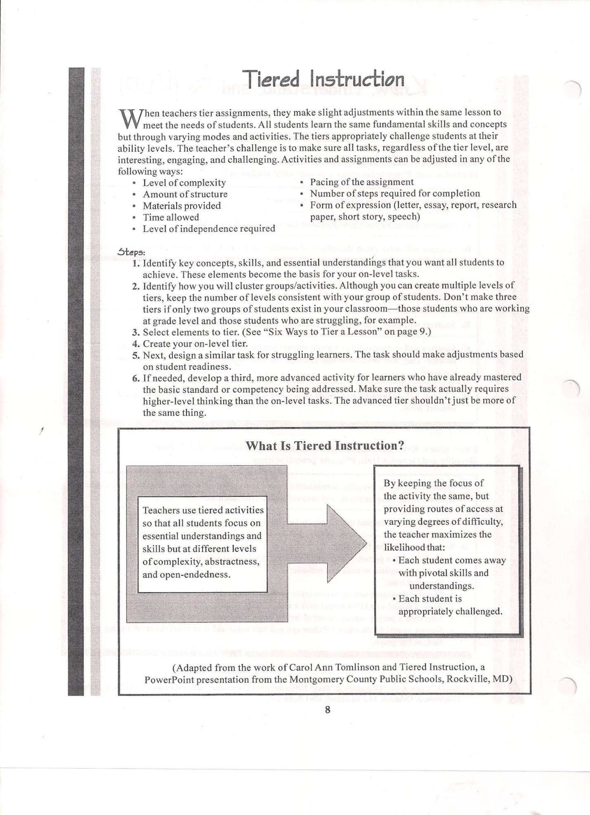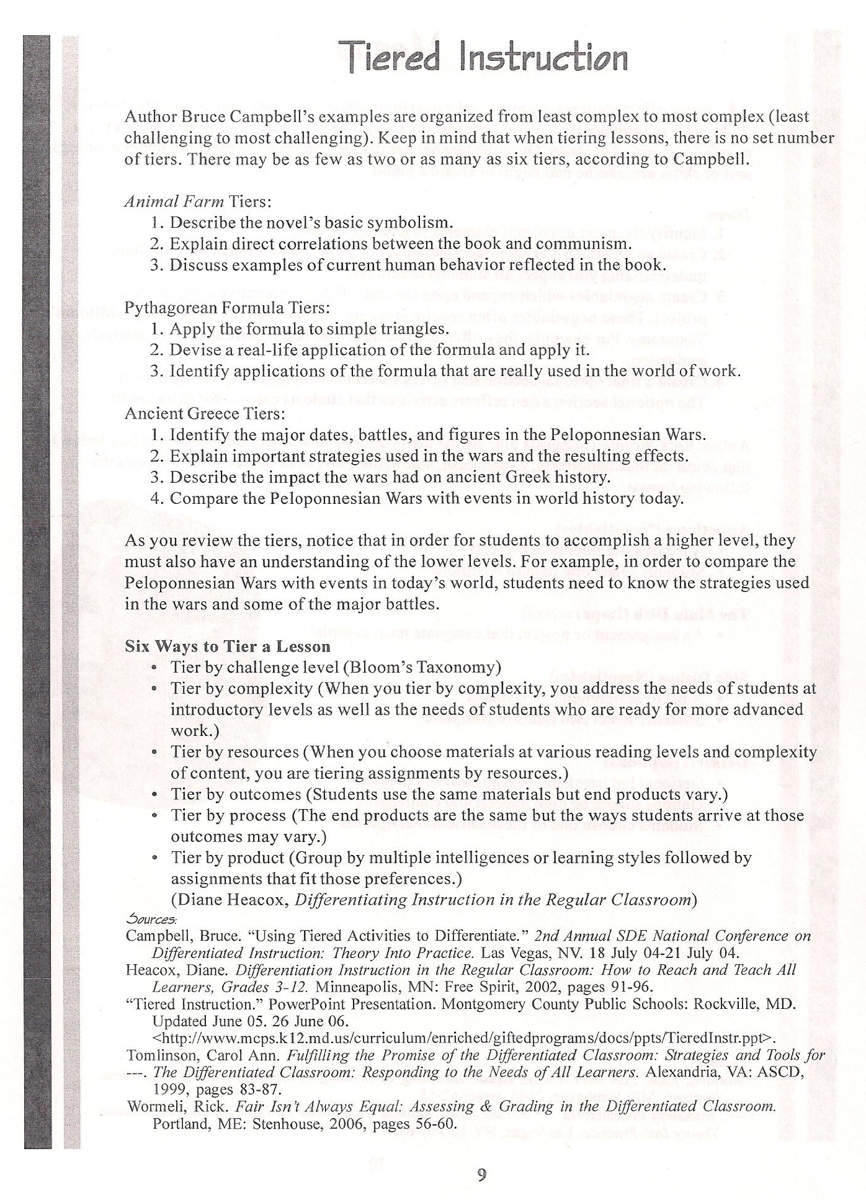

From http://differentiationcentral.com/Tools.html

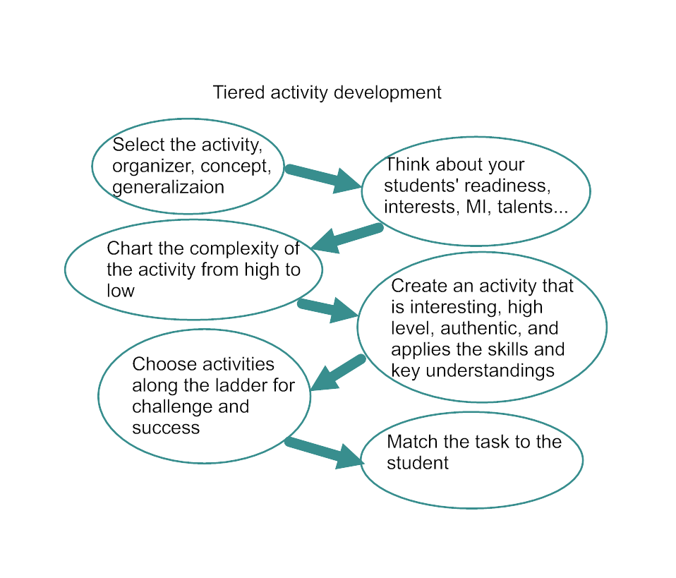
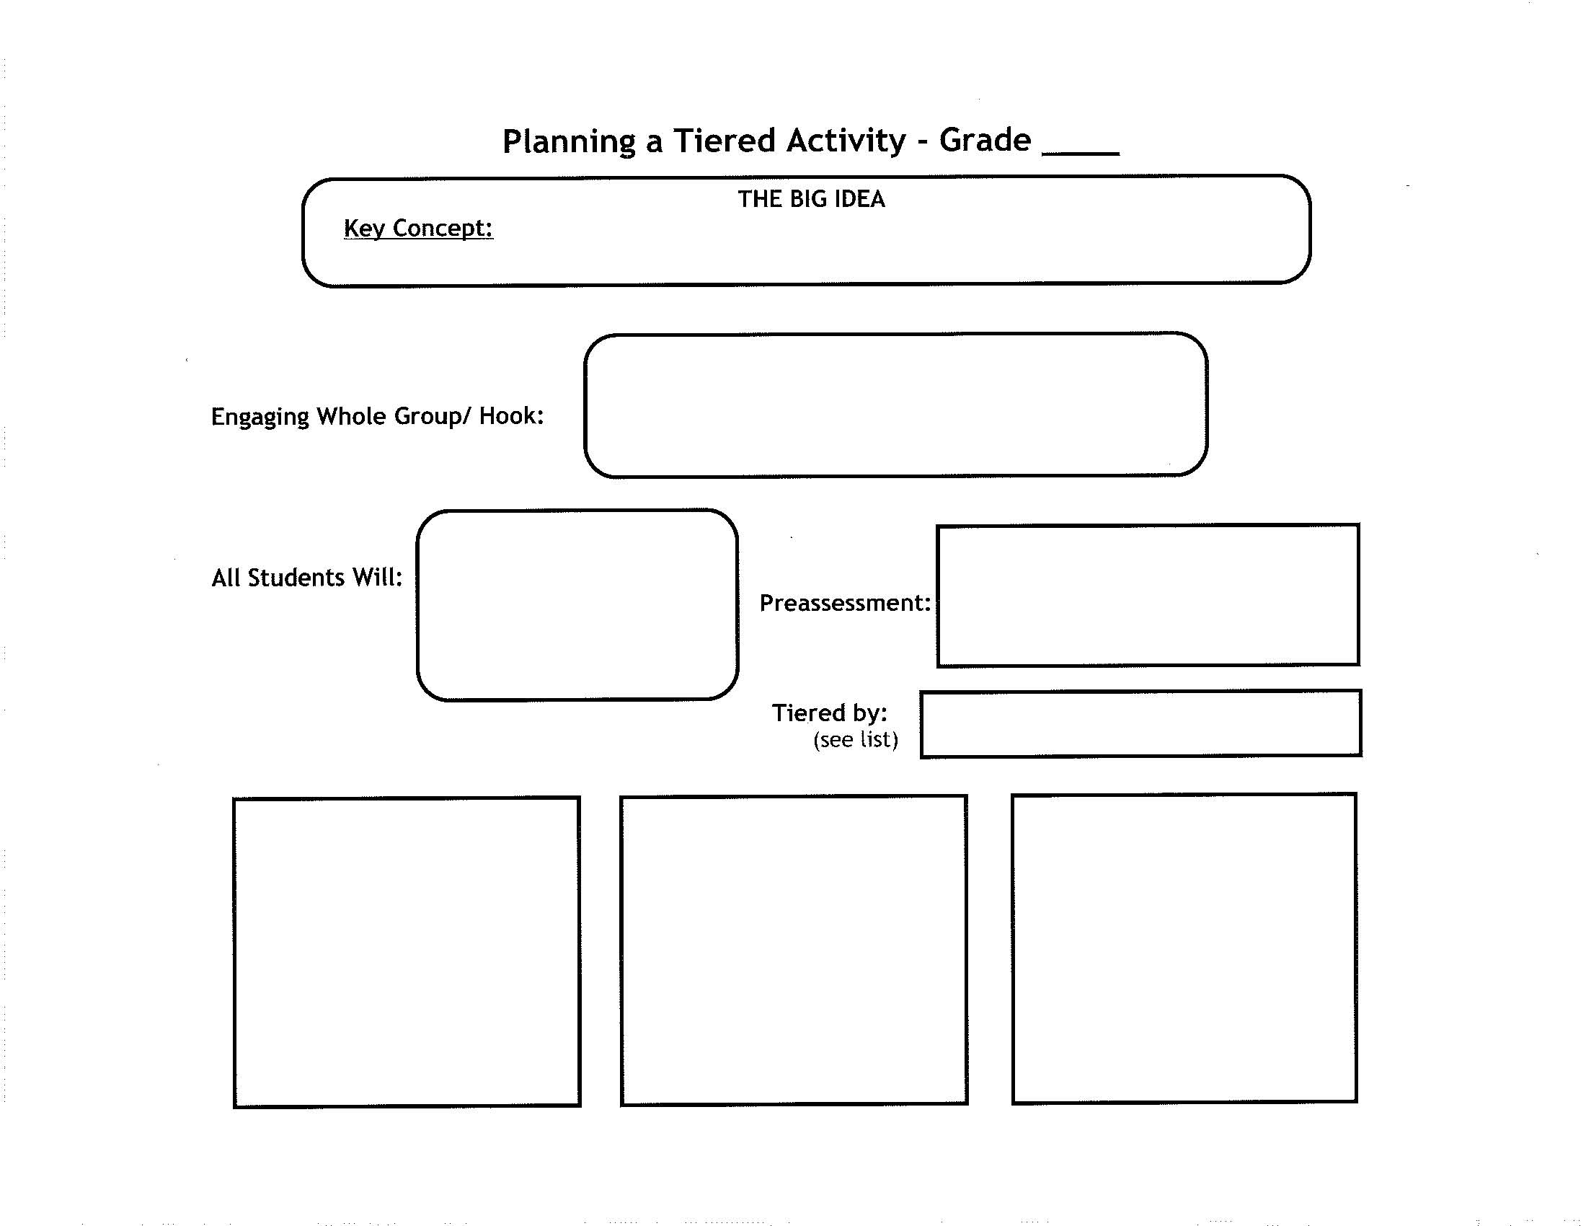

From Diane Heacox’s (2002) Differentiating Instruction in the Regular Classroom: How to Reach and Teach ALL Learners , Grades 3-12. Minneapolis, MN: Free Spirit Press.

Making tiering invisible
The more variety you use with instructional grouping, the more students accept such work teams as the norm in your classroom. With a variety of grouping and instructional strategies, tiered assignments and flexible instructional groups seem less noticeable and less novel for kids. A supportive classroom environment is also critical to your success in differentiating instruction….
From time to time, it’s important to use cooperative learning groups, student-selected groups, and groups passed on learning preferences or special interests. Students with varying abilities need opportunities to work together. Keep in mind that the membership of flexible groups is fluid. Even your advanced learners sometimes will need more time on some skills or content. Few students are equally talented in all subject areas. Similarly, students who are most frequently assigned reteaching activities may do well with advanced assignments in their area of special interest or experience. When you make it a point to get to know your students’ strengths, preferences, and interests, you can more successfully differentiate their instruction.
Make sure you introduce all tiered activities in an equally enthusiastic manner and alternate which activity is introduced first. Also, take some time to think of neutral ways to name learning teams. Try numbering them (Team 1), using color codes (Yellow Team), or even calling teams by one member’s name (Damon’s Team). Vary the team’s task assignments so that the Team 1, for example, doesn’t always get the advanced activity.
Here are criteria and examples for making tiered assignments less visible to students. Use them to see if your assignments will measure up to your students’ scrutiny. Tiered assignments should be:
Different work, not simply more or less work. The following “advanced task” isn’t really more advanced. It’s just more work and will be perceived as such by students”
Basic task: Read two American short stories set in the 20th century and compare and contrast them on a chart
Advanced task: Read three American short stories set in the 20th century and compare and contrast them on a chart.
Here’s how this assignment could be differentiated:
Basic task: Read two American short stories set in the 20th century and compare and contrast them on a chart.
Advanced task: Read two American shorts stories set in the 20th century and determine how each story might be told if it were set during this millennium. What would be the same? What would be different? Why? Share your ideas on a chart.
Equally active. Students will be justifiably unhappy if one activity involves active learning, such as a role play or debate, and the other activity is paper-and=pencil. Plan activities that, while different, allow the same level of activity. Of course, if you’re grouping by product or learning preference, one group may indeed be best=suited and happiest making a chart and the other delighted with performing a skit.
Equally interesting and engaging. Think about your assignments from the students’ perspective. If one calls for drill and practice and the other calls for a creative groups activitly (such as a simulation) which would you choose? You need to make activities equally desirable so students won’t fell they’re being treated unfairly. Interesting and engaging activities offer another benefit: they are much more likely to motivate students.
Fair in terms of work expectations. The following two assignments are not well designed:
Basic task: Use your text and class notes to create a visual way to illustrate key facts about cells. Include vocabulary words and the topics and issues we studied related to cell biology.
Advanced task Research a current topic or issue related to cell biology that we did not discuss in class. Create a visual way to inform us about the topic.
Students assigned to the advanced task would immediately question why they’re expected to do research while other students are simply collecting information from the text and their notes. Although the tasks may respond to differences in content knowledge- the students assigned to the basic task are being rerouted through foundational content while the advanced students are being introduced to new content – the assignments feel unfair.
Think about the work time needed to complete each of the tiered assignments. Are the time commitments comparable? Tasks can be different, based on instructional needed, yet comparable in the time and effort needed to complete them successfully. For example:
Basic task: Using your text and class notes, create either a visual or a musical way (a poster or a rap) to illustrate important vocabulary words related to cells.
Advanced task: Using your text and class notes, invent a way to help others remember the work of the cell. Include important aspects of its purpose and functions related to the human body. Come up with a rap, poster, riddle, or rock song to tell your cell’s story.
Require the use of key concepts, skills, or ideas. When you ask students to carry our tiered assignments, you should, at minimum, be asking them to use what they know or are learning. Such assignments constitute the wisest use of the students’ class time.

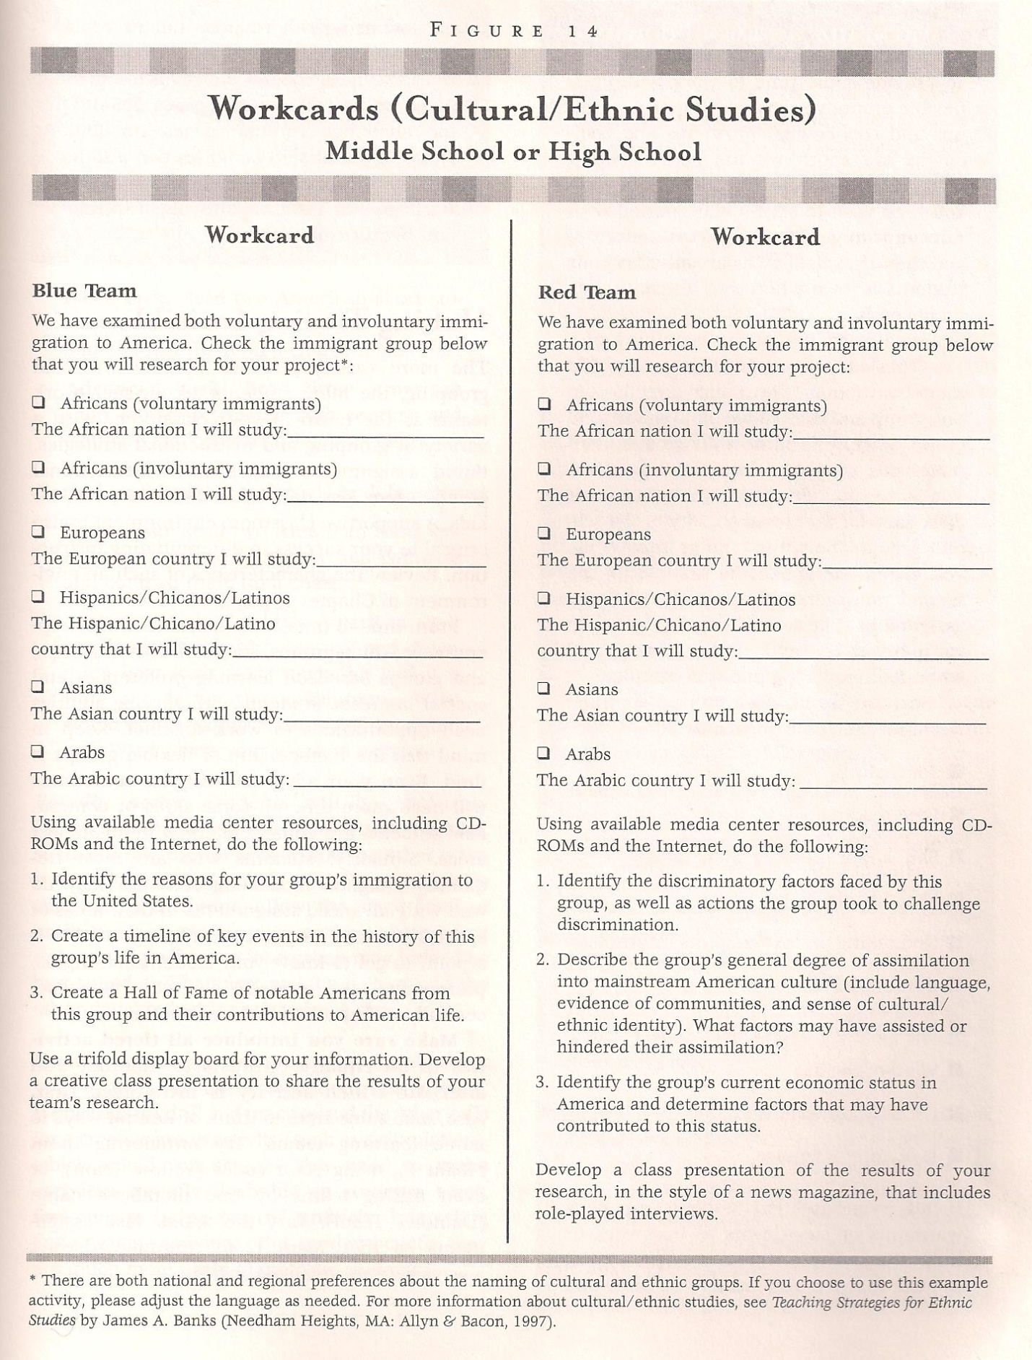

High school example of tiering by depth and complexity within a standard

Chemistry - Structure and Function:

- Describe the atomic model and explain how electron configuration is related to the Periodic Table and to chemical properties.

- Compare and contrast the atomic model, electron configuration and chemical properties of an alkali metal, halogen, and noble gas and explain the placement of each in the periodic table.

- Based on the atomic model, electron configuration and chemical properties of an alkali metal, halogen, and noble gas, explain the placement of each in the periodic table and create a method for describing the chemical properties of other elements based on their relative position to these elements in the periodic table.

Menus
From Rick Wormelik’s (2006) Fair Isn’t Always Equal: Assessing & Grading in the Differentiated Classroom. Portland, ME: Stenhouse.

A menu offers students a way to make decisions about what they will do in order to meet class requirements. A menu could be for a single lesson, a week-long lesson, or even a month-long period of study. Once the teacher has decided on what the essential understandings and/or skills are, she/he can begin to create a menu.

Steps:
- Identify the most important elements of a lesson or unit.
- Create an imperative or required assignment or project that reflects the minimum understanding you expect all students to achieve.
- Create negotiable which explain upon the main dish or imperative assignment or project. These negotiable often require students to go beyond the basic levels of Bloom’s Taxonomy. For example, they often include activities that require synthesis, analysis, or evaluation.
- Create a final optional section that offers students the opportunity for enrichment. The optional section often reflects activities that students can use for extra credit.

Author Rick Wormeli suggests placing the menu options in a restaurant menu style (see below) that could include appetizers, a main dish, side dishes, and even desserts. He suggests the following format.

Appetizers (Negotiables)
- A list of assignments or projects
- Students select one item to complete

The Main Dish (Imperatives)
- An assignment or project that everyone must complete

Side Dishes (Negotiables)
- A list of assignments or projects
- Students select two items to complete

Desserts (Options)
- Optional but irresistible assignments or projects
- Options should be high interest and challenging
- Students choose one of these enrichment options

MENU PLANNER

Menu for: Algebra 1 – “Probability” Due: __________________________________

All items in the main dish and the specified number of side dishes must be complete by the due date. You may select among the side dishes and you may decide to do some of the desserts items, as well.

Main Dishes (complete all)

- Complete the “meteorology simulation” on p.88-89 of your textbook.
- Create a list of 10 pairs of events. 5 pairs should contain events that are dependent. 5 pairs should contain events that are independent. Explain each classification.
- Complete the “frequency table” assignment on p. 506-507 of your textbook.
- Examine the attached list of functions and determine which functions represent probability distributions.

Side Dishes (Select 2)

- Work with a partner to analyze the game of “Primarily Odd.” See your teacher for game cubes and further instructions.
- Design a “game spinner” that has this probability distribution: P(red) – 0.1; P(green) – 0.2; P(blue) – 0.3; P(yellow) – 0.4.
- Suppose a dart lands on a dartboard made up of four concentric circles. For the center of the board (the “bull’s eye”), -1.5; the remaining rings have a width of 1.5. Use your understanding of area and probability to determine the probability of 1) hitting a “bull’s eye” and 2) landing in the outermost ring.

Desserts (Optional)

- Figure the probability of “Murphy’s Law” and make a case for whether or not it should indeed be a “law.”
- Use a frequency table to chart the colours that your classmates wear for a week. Then, the probability to predict how many students will wear a certain color on a given day.
From “The Art of Differentiation and Enrichment” leadership workshop by L. Orser, A. Howe and C. Loggie. March, 2013.

Subject: Mathematics - Statistics Grade: Twelfth

Standard: Data Analysis and Probability from the National Council of Teachers of Mathematics Principles and Standards for School Mathematics

Key Concept: Students are knowledgeable, analytical, thoughtful consumers of data.

Generalization: Students formulate a question that can be addressed with data and collect, organize, and display the data.

Background: This lesson would be an end-of-course culminating activity and should be completed in groups consisting of two to four students. Students choose a tier according to interest in a question and decide to use a survey, observational study, or experiment to answer the question. Directions for all the tiers are the same. Students determine a question they would like to answer, decide on a appropriate means for data collection, and prepare a presentation of the information to share with the class. The presentation should include a complete analysis of the data and the answer to the question of interest. However, a variety of presentation methods would be appropriate, e.g., a poster, a PowerPoint display, a written report, or a radio/TV show interview. This lesson will take a number of days to complete as students will need time to decide on a question, collect the data, analyze the data, and prepare the presentation. You will also need 1-2 days for students to make their presentations.

This lesson is tiered in process and product according to interest.

The tiers could be based on the questions or the products. Those listed here represent the products produced.
Tier 1: Poster Tier II: Power Point Tier III: Written report Tier IV: Radio/TV

Assessment: A rubric for each product should be based primarily on neatness, organization, accuracy of the information, and accuracy of the statistical analysis. The rubrics should be given to the students at the beginning the lesson since the decision on which product will be made after selecting a question.

Subject: Science Grade: Eleventh – Physics
Key Concept: Understanding how things work and designing solutions to problems of almost any kind can be facilitated by systems analysis
Generalization: Principles of physics can help us understand everyday phenomenon.
Background: Students have studied mechanics and properties of matter. As a comprehensive check for understanding about these principles, students will be placed in groups according to readiness. Their task is to analyze the given phenomenon, demonstrate it, and identify and explain all the physics principles involved. The results must be shared with the class. The presentation style is left to the group but must include both demonstration and explanation.
Many books and materials will give directions for these phenomena. One that is quite comprehensive in both the directions for the demonstration and the explanation of why it works is How Things Work: The Physics of Everyday Life, by Louis Bloomfield (ISBN: 0-471-59473-3).
This lesson is tiered in content according to readiness.
Tier I: Basic
Pulling a Tablecloth from a Table Set with Dishes (Laws of Motion)
Tier II: Grade Level
Swinging Water Overhead in a Bucket without Spilling the Water (Acceleration, Circular motion)
Tier III: Advanced
The Cartesian Diver (Density, Pressure)
Assessment: Teacher observation and student interviews during the investigation will serve as formative assessments. Summative assessment includes accuracy of explanation and successful demonstration of the phenomenon. Students’ presentation skills may be assessed with a rubric. If possible, you might wish to consider sharing the demonstrations with younger students.

Subject: Mathematics Grade: Eighth
Standard: Computation, estimation, and algebra
Key Concept: Students practice mental calculations by recognizing patterns and relationships among integers.
Generalization: Students do mental calculations using symmetry and looking for visual patterns.
Background: This lesson could be an activity for anytime of the year. Each tier provides a fun way of practicing mental addition, looking for visual patterns, and recognizing symmetry. Consequently, students should be adept at mental addition and familiar with recognizing patterns.
This lesson is adapted from the book Math for Humans, ISBN#0-9656414-7-3.
This lesson uses magic squares which originated in China and have mainly been studied since the seventeenth century. These activities are designed to reinforce mental calculations as students total various arrangements that make 34. Begin the lesson as a whole class but have the students arranged in their tiers and do the first part of “The Code Square” found on page 4-2 of the reference. This forms the basis for all the other activities as students become familiar with and recognize the patterns found in a 4-by-4 Magic Square. Students may work in pairs or individually within the tiers.
This lesson is tiered in process according to Howard Gardner’s Multiple Intelligences.
Tier I: Linguistic Learners Students continue using the Magic “Code Square” to play the word and code game using the rules found on page 4-2 of the reference.
Tier II: Logical-Mathematical Learners Pairs of students complete “A Box of Patterns” on page 4-6 of the reference. You might also have some of these learners create new Magic Squares by following the directions on page 4-8 of the reference.
Tier III: Spatial Learners Students play the “Rune Square” game following the rules found on page 4-4 of the reference. You might also have some of these learners follow the directions for making a design surprise on page 4-7 of the reference.
Assessment: Use observation and questioning as you visit each tier to assess this lesson.

From Carolyn Chapman and Rita King’s (2005) Differentiated Strategies: One Tool Doesn’t Fit All Thousand Oaks, CA: Corwin Press

Assessments
Bus Stop Center

Directions: Create a Bus Stop Center, or checking station, as a designated area where students can check their work with a grading key. Provide directions and the answer key for students to use to check their own papers. Include specific directions that tell the students where to turn in their corrected work.

Stock the station with answer keys, coloured pens, answer sheets, rubrics, and labelled baskets. The only writing implements allowed at the station are the ones placed there by the teacher.

Match the special checking tools with the topic of study. For example, in a study of plants, supply green gel pens to represent growth. In a study of historical documents, attach a feather to represent a quill.

Example:

Green = My corrections
Purple = My opinion
Yellow = Spotlights my best work on this assignment

