Open the following website / URL and study the terms included:
Do the “Learn” section and “Test” section: No translators during tests!!
http://quizlet.com/996950/french-numbers-1-100-flash-cards/
All the numbers from 1 – 100 included; practice writing each!!

http://quizlet.com/477179/ncea-level-2-french-vocabulary-flash-cards/

First you need to Copy & Paste is URL or hold the “Control” Button and left click on the Link: http://quizlet.com/
A website/webpage like this should open:
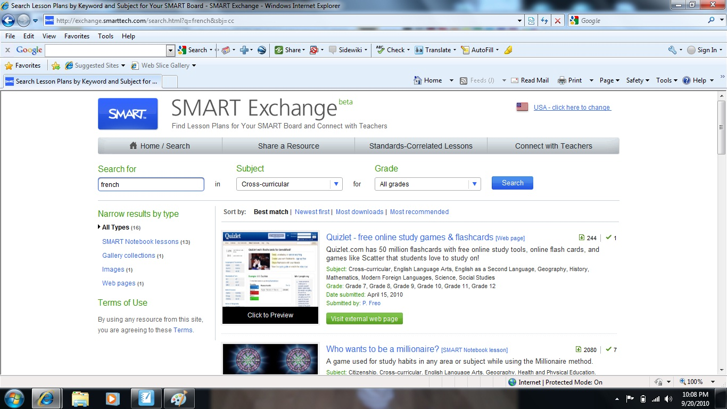
Please notice the “Search for is French”; “Subject is Cross-Curricular” and “Grades – All Grade”.
Find and Click on “Quizlet” – visit external Source.
A website/webpage like this should open:
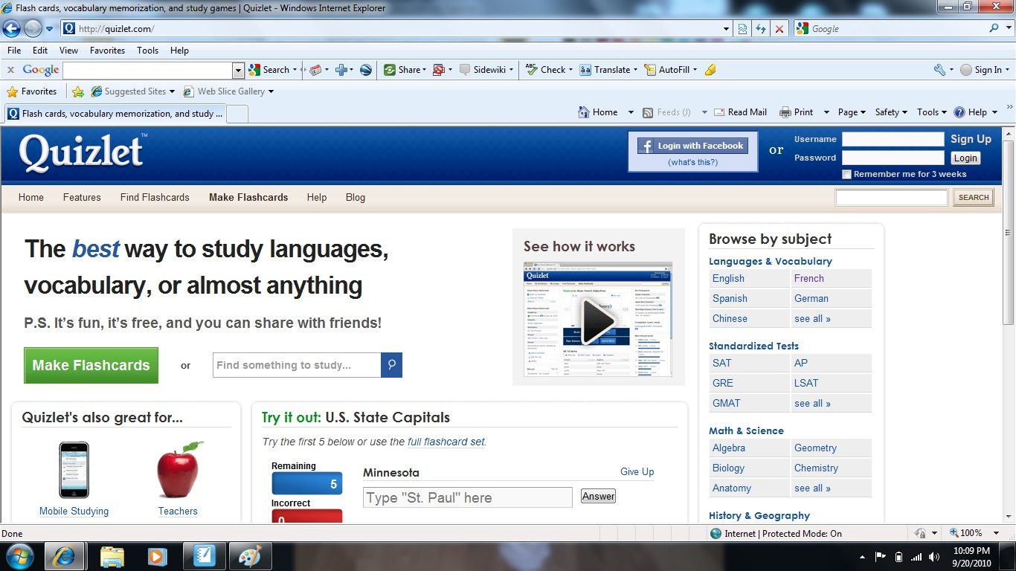
Now Click on “French” in the “Browse by Subject” area upper right hand side.
A website/webpage like this should open:
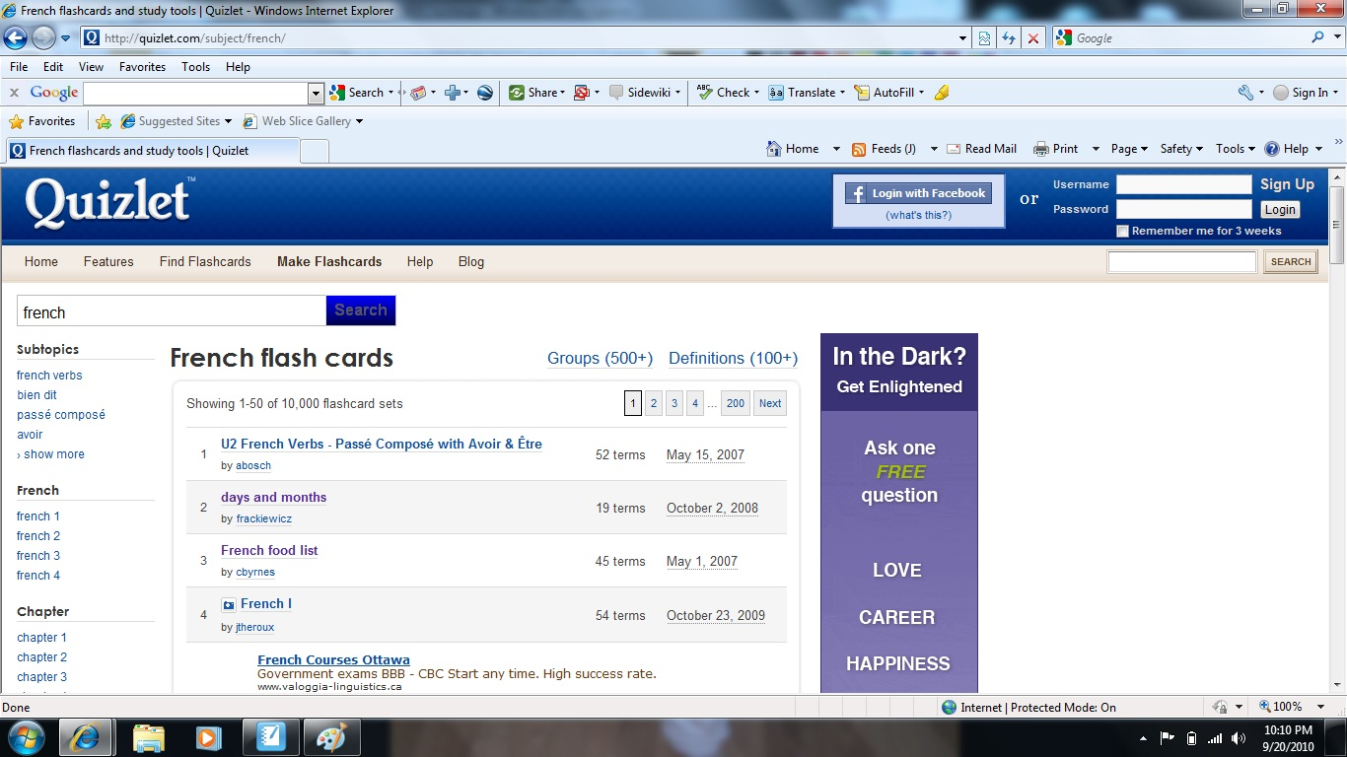
A website/webpage like this should open:
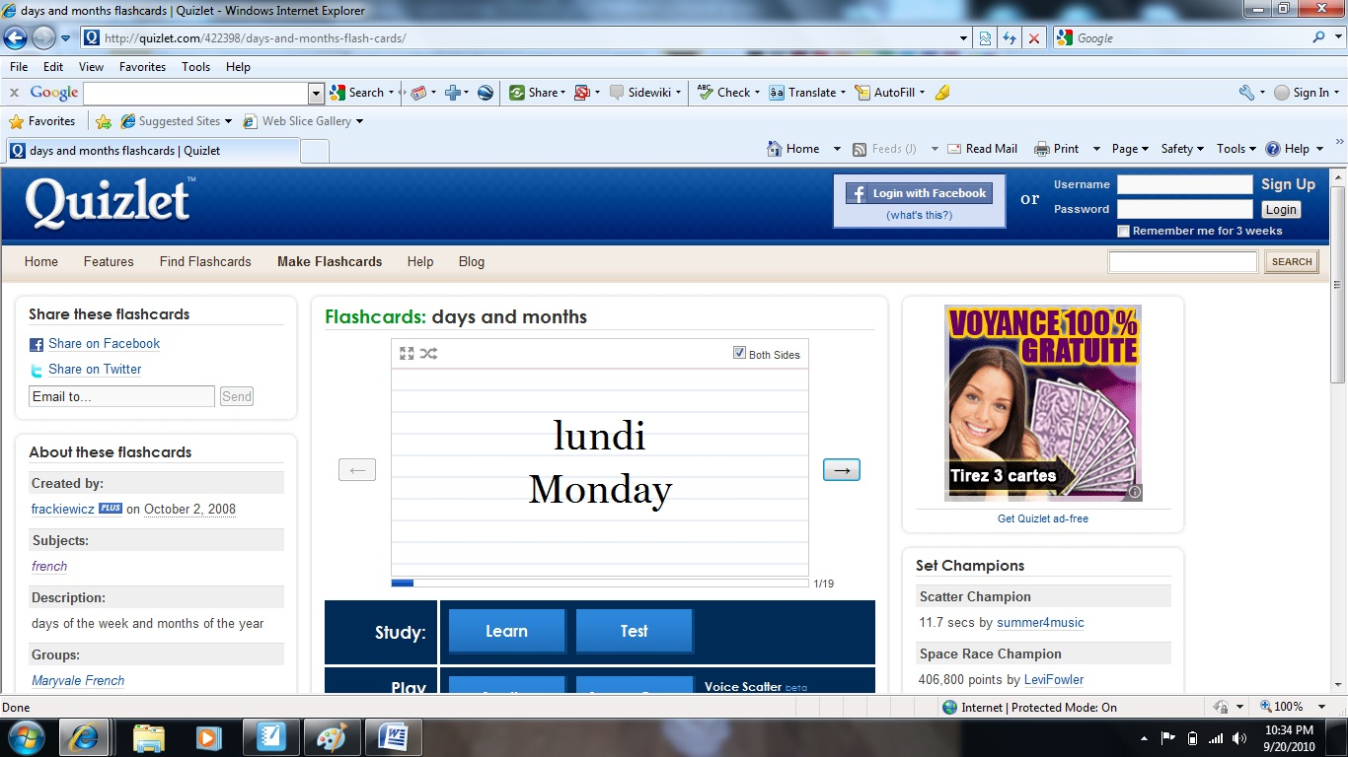
First click on “Assignment – Days & Months”.
Click on Learn first; after you have gone through several time; you are ready to take the test. When you complete the test; ask Mr. Mundle to come over and record your score/mark!!
A website/webpage like this should open:
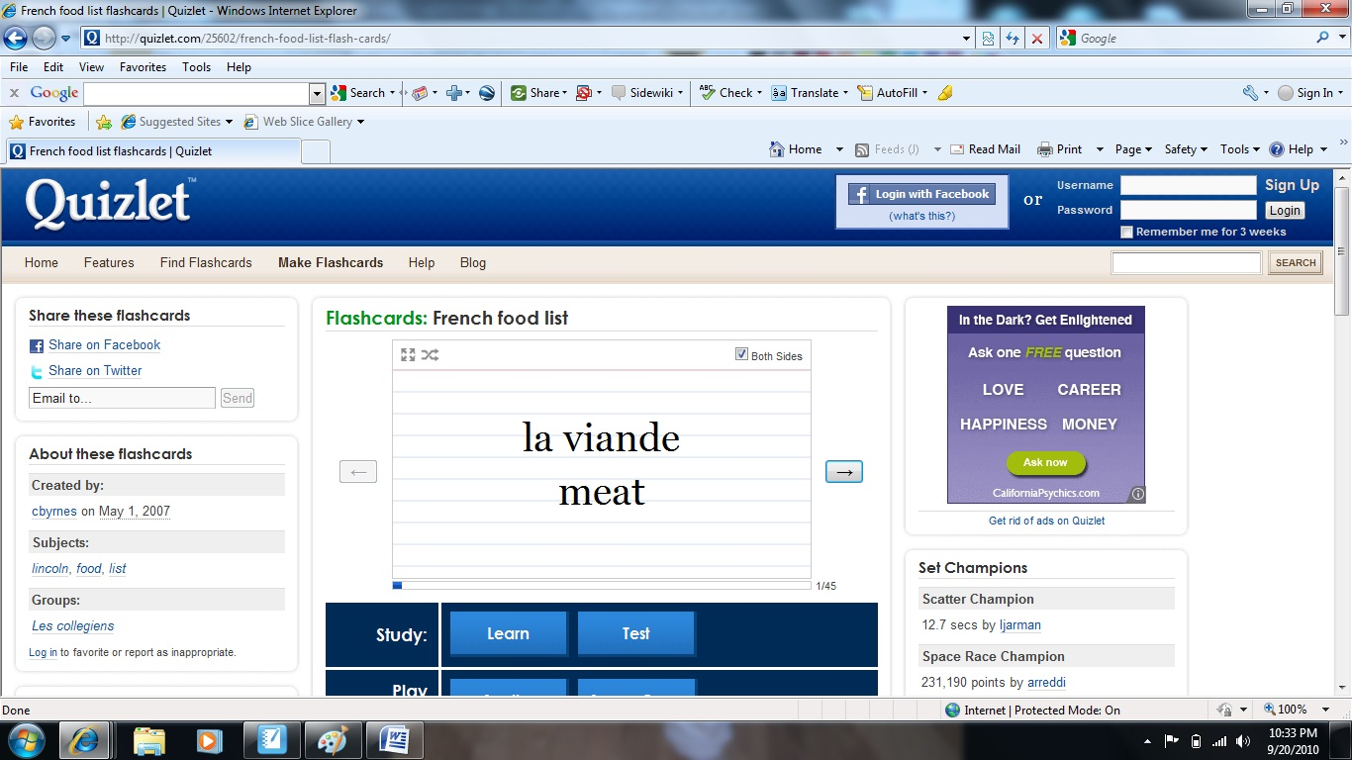
Second click on “Assignment – French Food List”.
Click on Learn first; after you have gone through several time; you are ready to take the test. When you complete the test; ask Mr. Mundle to come over and record your score/mark!!

